Date: February 2016

Precise Semantics of UML State Machines (PSSM)

Initial Submission
In response to the Precise Semantics of UML State Machines RFP (ad/2015-03-02)
__________________________________________________
OMG Document Number: ad/2016-02-01
Machine Readable File(s):
PSSM Syntax Metamodel XMI, ad/2016-02-02
PSSM Semantics Model XMI, ad/2016-02-03
_________________________________________________
Submitted by:
BAE Systems
Model Driven Solutions
No Magic, Inc.
Supported by:
Airbus Group
Commissariat á l'Energie Atomique et Alternatives (CEA)
LieberLieber Software
Simula Research Laboratory

Copyright © 2016 Airbus Group
Copyright © 2016 BAE Systems
Copyright © 2016 Commissariat á l'Energie Atomique et Alternatives (CEA)
Copyright © 2016 Data Access Technologies, Inc. (Model Driven Solutions)
Copyright © 2016 LeiberLeiber Software
Copyright © 2016 No Magic, Inc.
Copyright © 2016 Simula Research Laboratory

COPYRIGHT WAIVER
Each of the entities listed above: (i) grants to the Object Management Group, Inc. (OMG) a nonexclusive, royalty-free, paid up, worldwide license to copy and distribute this document and to modify this document and distribute copies of the modified version, and (ii) grants to each member of the OMG a nonexclusive, royalty-free, paid up, worldwide license to make up to fifty (50) copies of this document for internal review purposes only and not for distribution, and (iii) has agreed that no person shall be deemed to have infringed the copyright in the included material of any such copyright holder by reason of having used any OMG specification that may be based hereon or having conformed any computer software to such specification.

Table of Contents

0 Submission Introduction vii
0.1 Overview vii
0.2 Submitters vii
0.3 Mandatory Requirements vii
0.4 Non-Mandatory Features xi
0.5 Issues To Be Discussed xii
1 Scope 1
2 Conformance 1
2.1 General 1
2.2 Conformance Levels 1
2.2.1 PSSM-only Conformance 1
2.2.2 Joint PSSM and PSCS Conformance 2
2.3 Genericity of the Execution Model 2
3 Normative References 3
4 Terms and Definitions 3
5 Symbols 4
6 Additional Information 5
6.1 Changes to Adopted OMG Specifications 5
6.2 Acknowledgments 5
7 Abstract Syntax 6
7.1 Overview 6
7.2 Common Structure 8
7.2.1 Overview 8
7.2.2 Constraints 9
7.3 Values 9
7.3.1 Overview 9
7.3.2 Constraints 10
7.4 Classification 10
7.4.1 Overview 10
7.4.2 Constraints 11
7.5 Common Behavior 11
7.5.1 Overview 11
7.5.2 Constraints 12
7.6 State Machines 12
7.6.1 Overview 12
7.6.2 Behavior State Machines 12
7.6.2.1 Overview 12
7.6.2.2 Constraints 14
7.6.3 State Machine Redefinition 16
7.6.3.1 Overview 16
7.6.3.2 Constraints 17
8 Execution Model 18
8.1 Overview 18
8.2 Values 21
8.3 Structured Classifiers 21
8.4 Common Behavior 22
8.5 State Machines 23
8.5.1 Overview 23
8.5.2 Behavior State Machines 24
8.5.2.1 State Machine Execution 24
8.5.2.1.1 Overview 24
8.5.2.1.2 Semantics 25
8.5.2.2 State Machine Semantic Visitors 26
8.5.2.2.1 Overview 27
8.5.2.2.2 Semantics 27
8.5.2.3 State Machine Configuration 31
8.5.2.3.1 Overview 31
8.5.2.3.2 Semantics 31
8.5.2.4 State Activations 32
8.5.2.4.1 Overview 32
8.5.2.4.2 Semantics 32
8.5.2.5 “doActivity” Behavior Execution 36
8.5.2.5.1 Overview 36
8.5.2.5.2 Semantics 36
8.5.2.6 Pseudostate Activations 38
8.5.2.7 Transition Activations 39
8.5.2.7.1 Overview 39
8.5.2.7.2 Semantics 39
8.5.3 State Machine Redefinition 40
8.5.3.1 Background 40
8.5.3.2 Extending State Machine Execution 43
8.6 Loci 44
9 Test Suite 45
9.1 Overview 45
9.2 Utilities 45
9.2.1 Overview 45
9.2.2 Architecture 45
9.2.2.1 Architecture Concepts 45
9.2.2.2 Architecture Class Descriptions 47
9.2.2.2.1 Tester 47
9.2.2.2.2 Target 47
9.2.2.2.3 SemanticTest 48
9.2.2.2.4 SemanticTestSuite 49
9.2.3 Protocol 51
9.2.3.1 Protocol Overview 51
9.2.3.2 Synchronization Signal Descriptions 52
9.2.3.2.1 Start 52
9.2.3.2.2 End 52
9.2.3.2.3 TestEnd 53
9.2.4 Tracing 53
9.3 Tests 54
9.3.1 Overview 54
9.3.2 Behavior 54
9.3.2.1 Overview 54
9.3.2.2 Test Behavior 001 54
9.3.2.3 Test Behavior 002 56
9.3.2.4 Test Behavior 003 – A 57
9.3.2.5 Test Behavior 003 – B 59
9.3.2.6 Test Behavior 004 61
9.3.3 Transition 62
9.3.3.1 Transition 001 62
9.3.3.2 Transition 007 63
9.3.3.3 Transition 010 65
9.3.3.4 Transition 011 – A 67
9.3.3.5 Transition 011 – B 68
9.3.3.6 Transition 011 – C 70
9.3.3.7 Transition 011 – D 71
9.3.3.8 Transition 011 – E 73
9.3.3.9 Transition 015 75
9.3.3.10 Transition 016 76
9.3.3.11 Transition 017 77
9.3.3.12 Transition 019 79
9.3.3.13 Transition 020 81
9.3.3.14 Transition 022 83
9.3.4 Event 84
9.3.4.1 Overview 84
9.3.4.2 Event 001 84
9.3.4.3 Event 002 86
9.3.4.4 Event 008 87
9.3.4.5 Event 009 88
9.3.4.6 Event 010 90
9.3.4.7 Event 015 91
9.3.4.8 Event 016 – A 93
9.3.4.9 Event 016 – B 95
9.3.4.10 Event 018 97
9.3.5 Entering 99
9.3.5.1 Overview 99
9.3.5.2 Entering 004 99
9.3.5.3 Entering 005 101
9.3.5.4 Entering 009 102
9.3.5.5 Entering 010 103
9.3.5.6 Entering 011 105
9.3.6 Exiting 106
9.3.6.1 Overview 106
9.3.6.2 Exiting 001 106
9.3.6.3 Exiting 002 108
9.3.6.4 Exiting 003 110
9.3.6.5 Exiting 004 111
9.3.6.6 Exiting 005 112
9.3.7 Exit 114
9.3.7.1 Overview 114
9.3.7.2 Exit 001 114
9.3.7.3 Exit 002 115
9.3.7.4 Exit 003 117
9.3.8 Entry 118
9.3.8.1 Overview 118
9.3.8.2 Entry 002 – A 118
9.3.8.3 Entry 002 – B 120
9.3.8.4 Entry 002 – C 121
9.3.8.5 Entry 002 – D 122
9.3.8.6 Entry 002 – E 124
9.3.9 Choice 125
9.3.9.1 Overview 125
9.3.9.2 Choice 001 125
9.3.9.3 Choice 002 126
9.3.9.4 Choice 003 128
9.3.10 Fork 129
9.3.10.1 Overview 129
9.3.10.2 Fork 001 129
9.3.10.3 Fork 002 131
9.3.11 Join 132
9.3.11.1 Overview 132
9.3.11.2 Join 001 132
9.3.11.3 Join 002 134
9.3.12 Terminate 135
9.3.12.1 Overview 135
9.3.12.2 Terminate 001 135
9.3.12.3 Terminate 002 137
9.3.12.4 Terminate 003 138
9.3.13 Final 140
9.3.13.1 Overview 140
9.3.13.2 Final 001 140
9.3.14 Deferred 141
9.3.14.1 Overview 141
9.3.14.2 Deferred 001 142
9.3.14.3 Deferred 002 143
9.3.14.4 Deferred 003 145
9.3.14.5 Deferred 004 – A 147
9.3.14.6 Deferred 004 – B 149
9.3.15 Standalone 151
9.3.15.1 Overview 151
9.3.15.2 Standalone 001 151
9.3.16 Other Tests 153
9.3.16.1 Overview 153
9.3.16.2 Transition Execution Algorithm Test 153
9.4 Test Coverage and Traceability 155
A Protocol State Machines 156
A.1 Overview 156
A.2 Abstract Syntax 156
A.3 Semantics 157
A.3.1 Controlled Events 157
A.3.2 Protocol States Configuration 157
A.3.3 Protocol Violation 158
B State Machines for Passive Classes 159
B.1 Background and Rationale 159
B.2 Semantics 160

Submission Introduction

Overview
This is OMG document ad/2016-92-xx, entitled Precise Semantics of UML State Machines, which may be abbreviated “PSSM”. It is submitted in response to the RFP for Precise Semantics of UML State Machines (PSSM) (ad/2015-03-02). Similarly to previous Executable UML specifications on the Semantics of a Foundational Subset for Executable UML Models (fUML) and the Precise Semantics of UML Composite Structures (PSCS), the proposed PSSM specification defines the subset of the UML abstract syntax relevant to UML state machines, as an extension of the fUML abstract syntax subset (see Clause 7), and an operational semantics for that subset, as an extension to the fUML/PSCS execution model (see Clause 8). In addition, as required in the RFP, the proposed specification includes a suite of tests that may be used to validate the conformance of an execution tool to the specification (see Clause 9).

Submitters
The following OMG member organizations (with the given contact individuals) are jointly submitting this proposed specification.
- BAE Systems (Jeffery Smith, jeffrey.smith5@baesystems.com)
- Model Driven Solutions (Ed Seidewitz, ed-s@modeldriven.com)
- No Magic, Inc. (Nerijus Jankevicius, nerijus@nomagic.com)
The following OMG members organizations are supporters of and contributors to this proposed specification, but not formal submitters. All have licensed any contributed material as necessary to one of the formally submitting organizations.
- Airbus
- Simula Research Laboratory
- LieberLieber
- CEA

Mandatory Requirements
The following table describes how this proposed specification responds to each of the mandatory requirements of the PSSM RFP.
Requirement | Response
6.5.1a Proposals shall provide precise semantics for UML behavior state machines, including the following underlying metaclasses:  - FinalState  - Pseudostate (all kinds)  - Region (except for redefinition)  - State (except for redefinition and submachine states)  - StateMachine (except state machine extension)  - Transition (except for redefinition), including completion transitions (with no triggers) and transitions with triggers for the following kinds of events:  - Call Event  - Signal Event  - Vertex | This initial proposal provides precise semantics for all required elements, as captured in the execution model described in Clause 8, except for the following:  - Junction, shallow history and deep history pseudostates  - Triggers with call events
6.5.1b Proposals shall define how data associated with event occurrences shall be accessed by transition guards and passed to transition effect behaviors and state behaviors during the process of event dispatching and transition triggering. | The approach for passing event data to and from transition and state behaviors is discussed in 8.5.2.4 and 8.5.2.7. However this approach has not yet been incorporated into the formal execution model. In addition, an approach for passing data to guards has not yet been defined.
6.5.1c The precise semantics shall cover at least the cases of the standalone execution of state machines (i.e., with no other behaviored classifier as context) and state machines used as classifier behaviors of active classes. | The abstract syntax for state machines is currently restricted in this proposal to just the two cases of standalone state machines and state machines used as classifier behaviors (see the pssm_state_machine_context constraint in 7.6.2.2). Both of these cases are covered by the precise semantics described in 8.5.
6.5.1d The precise semantics for state machines shall include the meaning of specifying a port on a trigger in a state machine. The proposed semantics for this (and any other potential touch points with UML composite structure as identified by submitters) shall be consistent with the semantics of composite structures as defined in the Precise Semantics of UML Composite Structures (PSCS) specification. This consistency shall be such that there would be no conflict in a tool conforming to both the proposed state machine semantics and PSCS. However, proposals shall not require that a tool necessarily formally conform to the entire PSCS specification in order to conform to the precise semantics for state machines. | The semantics of a trigger with an “onPort” reference is covered as part of the execution model for state machines in 8.5. The proposed PSSM execution model is defined as an extension to the PSCS execution model, in order to ensure compatibility with PSCS. However, the proposal also provides a “PSSM-only” conformance level, which does not require a tool to conform to PSCS, as well as a “Joint PSSM and PSCS” conformance level, which requires conformance to both PSSM and PSCS (see the discussion in Clause 2).
6.5.1e The semantic description shall establish explicit relationships with fUML, for example by specifying a precise formal model transformation from the metaclasses listed above to metaclasses which are part of the fUML subset and/or by extending the fUML execution model, for example with appropriate visitor classes. Whatever the way the execution semantics are actually specified, proposals shall be readable as if they are additions to fUML semantics, rather than separate specifications. | This proposal defines the precise semantics for state machines using an execution model that extends the PSCS execution model, which is itself an extension of the fUML execution model.
6.5.1f Proposals shall extend the base semantics of fUML with specific axioms for UML state machines only if necessary. These new axioms shall have explicit relationships with existing axioms of fUML base semantics. These axioms shall be expressed in Common Logic Interchange Format (as was done for fUML). Submitters shall demonstrate, through manual or automated means, that the new axioms are consistent with fUML axioms. | This proposal does not extend the fUML base semantics.
6.5.2a Proposals shall precisely identify any allowed semantic variabilities. These semantic variabilities shall be in the scope of semantic variabilities allowed by UML state machines (potentially including only a subset of allowed UML semantic variabilities, as was the case for fUML). | This proposal does not define any semantic variabilities beyond those already allowed in fUML (see also the discussion 2.3).
6.5.2b Proposals shall define rules for defining semantic variants, where a semantic variant is an internally consistent set of values for the different semantic variabilities allowed from requirement 6.5.2.a. | This proposal does not define any semantic variants beyond those already allowed in fUML.
6.5.3a Proposals shall conform to the current version of the UML 2 metamodel and notation. | The proposed PSSM syntactic subset is a subset of the UML 2.5 abstract syntax metamodel (see Clause 7).
6.5.3b Proposals shall use the current version of the fUML specification. | The proposed PSSM semantics is based on the fUML 1.2.1 execution model. However, fUML 1.2.1 is based on UML 2.4.1, which has a different syntactic package structure than UML 2.5. In order to be consistent with the UML 2.5 package structure used in the PSSM syntactic subset, this proposal presumes that the fUML abstract syntax and execution models have been reorganized into a structure consistent with fUML 2.5, as will presumably be the case in a near-future version of fUML. (See also the submission notes in 7.1 and 8.1.)
6.5.3c Proposals shall use the current version of the PSCS specification. | The proposed PSSM semantics are based on the PSCS 1.0 execution model. However, PSCS 1.0 is based on UML 2.4.1, which has a different syntactic package structure than UML 2.5. In order to be consistent with the UML 2.5 package structure used in the PSSM syntactic subset, this proposal presumes that the PSCS abstract syntax and execution models have been reorganized into a structure consistent with fUML 2.5, as will presumably be the case in a near-future version of PSCS. (See also the submission notes in 7.1 and 8.1.)
6.5.3d For any extension to the fUML base semantics using CLIF, proposals shall conform to the current version of the ISO Common Logic standard. | This proposal does not extend the fUML base semantics.
6.5.4a Proposals shall provide a suite of test cases that can demonstrate conformance to this specification. | The proposed test suite is described in Clause 9. Of the test cases currently defined in this test suite, the following three are still under discussion by the submission and may not yet correctly express the intended semantics as required in Clause 14 of the UML specification.  - Test Event 016 – B (see 9.3.4.9) provides the intended execution trace; however, the content of the RTC steps revealed an incomplete firing sequence in cases when multiple transitions can be fired using the same event occurrence.  - Test Deferred 004 – A (see 9.3.14.5) demonstrates the handling of deferred event semantics in the context of orthogonal regions. This test produces a valid execution trace; however, the assessed semantics are still under discussion and will likely be refined in the revised submission of this proposal.  - Test Deferred 004 – B (see 9.3.14.6) also addresses the handling of deferred event semantics in the context of orthogonal regions. This test produces a valid execution trace; however, the assessed semantics are still under discussion and will likely be refined in the revised submission of this proposal.
6.5.4b Proposals shall demonstrate the coverage by the test suite of all proposed state machine semantic functionality and the traceability of each test case to specific required functionality. | The test suite traces to a set of 108 semantic requirements identified from the semantic specification for state machines in Clause 14 of the UML specification [UML]. Of these, 87 (about 81%) are considered as being satisfied (i.e., supported but not tested) by the current execution model. 85 (about 79%) are considered to be both satisfied and verified (i.e., they are tested) by the execution model. Figure 0.1 summarizes this current status.
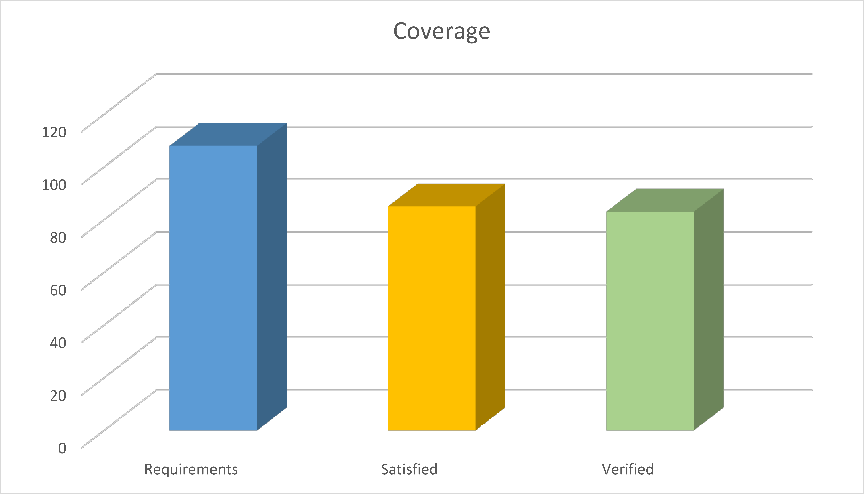
Figure 0.1 - PSSM Test Suite Coverage

Non-Mandatory Features
The following table describes whether and how this proposed specification provides the non-mandatory features listed in the PSSM RFP.
Feature | Response
6.6.1 Proposals may provide precise semantics of submachine states, as represented by the A_submachineState_submachine meta-association and including the ConnectionPointReference metaclass. | This proposal does not cover submachine states.
6.6.2 Proposals may provide precise semantics of UML protocol state machines, including the following underlying metaclasses:  - ProtocolConformance  - ProtocolStateMachine  - ProtocolTransition | The operational semantics of protocol state machines require the raising of exceptions in certain cases. However, fUML does not currently define the semantics of exceptions. Consequently, the submission team considered it inappropriate to define exception handling for all of fUML, based on just the PSSM-specific r to handle protocol state machine. Therefore, the proposal only includes a non-normative discussion of protocol state machine behavior, without a formal execution model (see Annex A).
6.6.3 Proposals may provide precise semantics for state machine redefinition, as represented by the following meta-associations:  - A_extendedRegion_region  - A_extendedStateMachine_stateMachine  - A_redefinedState_state  - A_redefinedTransition_transition  - A_redefinitionContext_region  - A_redefinitionContext_state  - A_redefinitionContext_transition | This proposal includes semantics for state machine redefinition (see 8.5.3), though functionality for this has not yet been included in the formal execution model and there are no tests for it yet in the test suite.
6.6.4 Proposals may provide precise semantics for asynchronous operation calls (which are not currently allowed in fUML). If provided, such semantics should include the handling of asynchronous calls both by call event triggers in state machines and by operation methods. Proposals may additionally provide semantics for accepting call events in activities, as covered by the AcceptCallAction and ReplyAction metaclasses. | This proposal does not provide semantics for asynchronous operation calls.
6.6.5 Proposals may provide precise semantics for triggers with ChangeEvents. | This proposal does not provide semantics for triggers with change events.
6.6.6 Proposals may use the Action language for Foundational UML (Alf) as a concrete syntax for specifying the execution semantics of state machines. | This proposal currently uses Java as the concrete syntax for specifying detailed operation behaviors (as was also done in fUML and PSCS). However, the submission team is considering the use of Alf for this purpose in the revised submission of this proposal.

Issues To Be Discussed

Proposals shall discuss how state machines may be used to specify the behavior of passive classes.
The use of state machines for describing the behavior of instances of passive classes can be found in several UML tools, notably in Rhapsody and RSA RTE (both from IBM). In fact, the original 1.x series of UML specifications explicitly discusses the case of passive state machines (e.g., section 2.12.4.7 in the UML 1.3 specification). In particular, it mentions a possible means for ensuring preservation of run-to-completion semantics for passive classes whose behavior is specified via state machines.
However, the semantics of state machines used with passive classes is not entirely consistent with the normative semantics for behavior state machines for active classes, as specified in this proposal. Nevertheless, the submitters feel that the use of state machines with passive classes will still be of interest to those applying the PSSM specification, so we have included a discussion of this usage as informative Annex B.

Proposals shall address issues with the UML abstract syntax involved in the specification of the accessing and passing of data from event occurrences, as required in 6.5.1b.
This proposal addresses the issue of passing event data to and from effect, entry, exit and doActivity Behaviors, without changing the UML abstract syntax, by allowing Parameters on such Behaviors by which such data can be passed. This covered syntactically in 7.6.2, particularly by the constraints pssm_state_behavior_parameters and pssm_transition_behavior_parameters, and semantically in 8.5.2.4 and 8.5.2.7 (though this has not yet been captured in the formal execution model).
However, the passing of data to Transition guard Behaviors has not yet been addressed. Transition guards are actually Constraints (see [UML], subclause 14.3.2, and Figure 7.6 in this proposal), and the executable Behavior for such a guard must be given as the behavior of an OpaqueExpression acting as the specification of the constraint. Since such a Behavior is not allowed to have any other Parameters than a return Parameter, it is not currently possible to use a Parameter-based mechanism for event-data passing in this case.
Enabling a consistent approach to the passing of event data to Transition guards may require a change to the UML abstract syntax, but this has not been fully determined yet. This will be resolved in the revised submission of this proposal.

Proposals shall discuss the relationship of the proposed precise semantics for UML state machines to the causality model defined for the UML Profile for MARTE.

TBD

Proposals shall discuss the relationship of the proposed precise semantics for UML state machines to the specification of a state machine ontology and, particularly, to the integration approach of OntoIOP.

This issue will be addressed in the revised submission of this proposal.

Proposals shall discuss the relationship of the proposed precise semantics for UML state machines to the semantics defined for state machines in the W3C State Chart XML (SCXML) specification.
It is fairly clear that SCXML was inspired in great part by UML. There is a significant conceptual, semantic, and even terminological overlap. However, there are also some important differences.
- No structural context. The general environment of SCXML state machines is completely different from that of UML state machines. In SCXML, a state machine is an independent self-contained entity that can interact with other, or external, entities located in a Web-based environment (e.g., external entities are accessed via URIs). External entities can be other SCXML state machines or any other kind of Web-based application. This interaction can be either synchronous or asynchronous. In other words, unlike UML, in SCXML there is no explicit structural context defined in which a state machine is defined; i.e., the (single) state machine is the top-level concept.
- No support for certain kinds of pseudostates. SCXML only supports three kinds of pseudostates: initial, deep history, and shallow history. This means that it does not support exit and entry points, fork and join points, or terminate pseudostates. Also, there is no support for submachine states or state machine redefinition.
- No support for “doActivity” behaviors. The UML concept of “doActivity” behaviors associated with states is not directly supported in SCXML. The SCXML “invoke” is a somewhat similar capability, however, in the case of SCXML, the invoked service is "external" rather being limited to the context of the state machine or its owning classifier. Further, the semantics of when the invocation actually occurs and how the invoked service may communicate with its invoking state machine are not the same as for a UML “doActivity” behavior.
- No support for protocol state machines. (But protocol state machines are only covered informatively in this PSSM proposal anyway.)
- No support for submachines. (But submachines are also not included in this PSSM proposal).
- States can own local extended data variables. An SCXML document defines a single state machine as a set of states and a set of associated data (i.e., its “extended” state). States of any kind can optionally own local sets of data, something that has no equivalent in UML.
- Different data and event models. The data and event models are specific to SCXML and not equivalent to those in UML.
- More refined model of completion events. Like UML, SCXML supports completion event, but, in contrast to UML, these events are named and used to explicitly trigger completion transitions. However, their effect is the same, although it appears that SCXML gives the modeler more control over the triggering because individual completion events can be differentiated. For example, it is possible to define a trigger that refers explicitly to the completion of a particular state. This cannot be done in UML since completions event triggers are implicit.
- SCXML-specific action language. The action language of SCXML is specific to it, although most action language (executable content) elements can be mapped to standard programming language equivalents.
On the other hand, it seems that the semantics of those SCXML concepts that have UML equivalents are compatible with UML semantics. Because of this semantic consistency, it is possible to define a mapping from a subset of the UML state machine abstract syntax into SCXML, such that a mapped state machine model will execute according to the SCXML specification with semantics that conform to those given in this proposal for UML state machines. The submitters plan to provide an annex that describes such a mapping in the revised submission of this proposal.

Proposals shall describe a proof of concept implementation that can successfully execute tests from the conformance test suite, without violating any tests from the PSCS conformance test suite.
CEA has developed a prototype proof-of-concept implementation of the execution model defined in Clause 8 of this specification. It is integrated to the Papyrus model execution framework Moka as a specific execution engine. Papyrus and Moka tooling are based on the Eclipse implementation of the UML 2.5 metamodel. Therefore, models that can be interpreted by the prototype must conform to this metamodel implementation.
The execution model implemented by the prototype is built on top of the one defined to capture the PSCS semantics. The prototype is able to execute any model conforming to subset that is covered both by fUML and PSCS. In addition it also able to execute models including syntax elements that are covered by the subset of behavior state machines identified in this specification (see 7.6.2).
The PSSM execution model does not conflict with PSCS execution model. Both execution models can be used jointly. To demonstrate the absence of conflicts, the PSCS test suite was executed using the PSSM execution model. No regressions were detected. Execution traces generated by PSCS and PSSM during test suite execution are the same.
As required, this proposal also includes a conformance test suite, which is intended to validate conformance to the execution model (see Clause 9). It is currently composed of 64 tests. Among these tests, 63 are currently executed successfully by the proof-of-concept implementation. It is expected that additional tests will be included in the test suite for the revised submission of this proposal and, at that time, the proof-of-concept implementation will successfully execute all tests.

Scope
This specification is an extension of the Semantics of a Foundational Subset for Executable UML Models standard (known as “Foundational UML” or “fUML”) [fUML] that defines the execution semantics for UML state machines. Syntactically, this specification extends fUML by with a (large) subset of the abstract syntax of state machines as given in the OMG Unified Modeling Language specification [UML] (Clause 14, for UML 2.5 and later). Semantically, this specification extends the fUML execution model in order to specify the operational execution semantics of the state machine abstract syntax subset.
The semantic model defined in this specification is actually an extension of the model from the Precise Semantics of UML Composite Structures (PSCS) standard [PSCS], which is itself an extension of fUML. This is done in order to ensure that the semantics given in this specification are compatible with the extensions defined in PSCS and to allow for the definition of the semantics of triggers with an “onPort” reference. However, this latter feature is the only point for which the semantics of state machines presented here depends in any way on the PSCS semantic extensions, and it is possible for an execution tool to conform to this specification without also conforming to the PSCS specification (see Clause 1).

Conformance

General
This specification defines a precise semantics for a subset of UML 2 concepts associated with the notion of a state machine. This definition is based on the Foundational UML Subset (henceforth referred to as “fUML” in the remainder of this clause), which is specified in [fUML]. Hence, except where explicitly noted in this clause, the definitions, interpretations (meaning), and types of conformance and related terms in this specification fully match their corresponding definitions, interpretations, and types in fUML. Thus, as in fUML, conformance to this specification has two aspects:
- Syntactic Conformance – A conforming model must be restricted to the abstract syntax subset defined in Clause 7 of this specification.
- Semantic Conformance – A conforming execution tool must provide execution semantics for a conforming model consistent with the semantics specified in Clause 8 of this document.

Conformance Levels
The semantic model in Clause 8 is specified as an extension to the semantic model given in [PSCS]. However, the only point at which the semantics given in this specification actually depend on the PSCS semantics is for triggers with an “onPort” reference (see TBD). There are two levels of conformance defined for this specification, depending on whether an execution tool conforms only to PSSM or conforms to PSSM and PSCS, including the semantics for triggers with “onPort”. Both of these have syntactic and semantic aspects, as specified in the following subclauses.

PSSM-only Conformance
- Syntactic Conformance – A conforming model must be restricted to the abstract syntax subset defined in Clause 7 of this specification, including the satisfaction of all additional constraints.
Note. The abstract syntax subset defined in Clause 7 is a superset of the subset defined in [fUML]. Thus, every syntactically conforming fUML model is also a syntactically conforming PSSM model. The PSSM subset does not itself include Ports, so a model syntactically conforming to only the PSSM subset cannot have “onPort” references on any triggers.
- Semantic Conformance – A conforming execution tool must provide execution semantics for a conforming model consistent with the semantics specified in Clause 8 of this specification. Demonstrating semantic conformance to fUML (as defined in Clause 2 of [fUML] and passing all the tests of the test suite in Clause 9 of this specification, except for those related to onPort (see TBD), is sufficient to demonstrate semantic conformance at this level.

Joint PSSM and PSCS Conformance
- Syntactic Conformance – A conforming model must be restricted to the abstract syntax subset defined by the union of the subset defined Clause 7 of this specification and the subset defined in Clause 7 of [PSCS]. The model shall satisfy all constraints as specified in this specification and in [PSCS].
- Semantic Conformance – A conforming execution tool must provide execution semantics for a conforming model consistent with the semantics specified in Clause 8 of this specification and the semantics specified in Clause 8 of [PSCS]. Demonstrating semantic conformance to fUML (as defined in Clause 2 of [fUML]) and passing all the tests of the test suite in Clause 9 of this specification and all the tests in Clause 9 of [PSCS] is sufficient to demonstrate semantic conformance at this level.

Genericity of the Execution Model
To support a variety of different execution paradigms and environments, the specification of the execution model incorporates a degree of genericity. This is achieved in two ways: (1) by leaving some key semantic elements unconstrained, and (2) by defining explicit semantic variation points. A particular execution tool can then realize specific semantics by suitably constraining the unconstrained semantic aspects and providing specifications for any desired variation at semantic variation points.
The semantic areas that are not explicitly constrained by the execution model in this specification are the same as the ones defined in subclause 2.3 of [fUML]. Different execution tools may semantically vary in these areas in executing the same model, while still being conformant to the semantics specified by the execution model in this specification. Additional semantic specifications or constraints may be provided for a specific execution tool in these areas, so long as it remains, overall, conformant to the execution model. For instance, a particular tool may be limited to a single centralized time source such that all time measurements can be fully ordered.
In contrast to the above areas, subclause 2.3 of [fUML] defines a set of explicit semantic variation points. The execution model as given in this specification by default fully specifies the semantics of these items. However, it is allowable for a conforming execution tool to define alternate semantics for them, so long as this alternative is fully specified as part of the conformance statement for the tool. This specification does not define any further semantic variation points in addition to those defined in fUML. Note, however, that the default event dispatching strategy defined for fUML is replaced by the default strategy given in subclause 8.4.1.2.1 of [PSCS], but this is only relevant for Joint PSSM and PSCS Conformance (see 2.2.2).
If a conforming execution tool wishes to implement a semantic variation in one of the above areas, then a specification most be provided for this variation via a specialization of the appropriate execution model class as identified above. This specification must be provided as a fUML model in the “base UML” subset interpretable by the base semantics of Clause 10 of [fUML]. Further, it must be defined in what cases the variation is used and, if different variants may be used in different cases, when each variant applies, and/or how what variant to use, is to be specified in a conforming model accepted by the execution tool.

Normative References
The following normative documents contain provisions which, through reference in this text, constitute provisions of this specification. For versioned references, subsequent amendments to, or revisions of, any of these publications do not apply.
[fUML] Semantics of a Foundational Subset for Executable UML Models (fUML), Version 1.2.1, http://www.omg.org/spec/FUML
[PSCS] Precise Semantics of UML Composite Structures (PSCS), Version 1.0, http://www.omg.org/spec/PSCS
[UML] OMG Unified Modeling Language (OMG UML), Version 2.5, http://www.omg.org/spec/UML
Note. The semantics of state machines given in this specification are intended to be consistent with the syntax and semantics given in UML 2.5. However, fUML and PSCS are currently formally based on UML 2.4.1 (though PSCS incorporates UML 2.5 clarifications of the semantics of composite structures). For consistency, it is expected that the normative references given here for fUML and PSCS will be updated to versions consistent with UML 2.5, as soon as these become available.
[UTP] UML Testing Profile (UTP), Version 2, Initial Submission, OMG document ad/2014-05-01
Note. UTP v2 is expected to be adopted and finalized before the finalization of PSSM.

Terms and Definitions
For the purposes of this specification, the following terms and definitions apply.

Base Semantics
A definition of the execution semantics of those UML constructs used in the execution model, using some formalism other than the execution model itself. Since the execution model is a UML model, the base semantics are necessary in order to provide non-circular grounding for the execution semantics defined by the execution model. The base semantics provide the “meaning” for the execution of just those UML constructs used in the execution model. The execution model then defines the “meaning” of executing any UML model based on the full foundational subset. Any execution tool that executes the execution model should reproduce the execution behavior specified for it by the base semantics. (The base semantics for this specification are as specified in [fUML].)

Behavioral Semantics
The denotational mapping of appropriate language elements to a specification of a dynamic behavior resulting in changes over time to instances in the semantic domain about which the language is making statements.

Execution Model
A model that provides a complete, abstract specification to which a valid execution tool must conform. Such a model defines the required behavior of a valid execution tool in carrying out its function of executing a UML model and therefore provides a definition of the semantics of such execution.

Execution Semantics
The behavioral semantics of UML constructs that specify operational action over time, describing or constraining allowable behavior in the domain being modeled.

Execution Tool
Any tool that is capable of executing any valid UML model that is based on the abstract syntax subset defined in this specification and expressed as an instantiation of the UML 2 abstract syntax metamodel. This may involve direct interpretation of UML models and/or generation of equivalent computer programs from the models through some kind of automated transformations. Such a tool may also itself be concurrent and distributed.

Static Semantics
Possible context sensitive constraints that statements of a language must satisfy, beyond their base syntax, in order to be well-formed.

Structural Semantics
The denotational mapping of appropriate language elements to instances in the semantic domain about which the language makes statements.

Syntax
The rules for how to construct well-formed statements in a language or, equivalently, for validating that a proposed statement is actually well-formed.

Symbols
There are no symbols or abbreviated terms necessary for the understanding of this specification.

Additional Information

Changes to Adopted OMG Specifications
As specified in 7.6.2.2, the PSSM abstract syntax subset for behavior StateMachines requires that the source and target Vertexes of any Transition be contained in the same StateMachine as the Transition. As discussed in 8.5.3.1, this constraint means that, when a new Transition is added to an extending StateMachine with the intention of having an existing Vertex in the extended StateMachine as its source or target, then that source or target Vertex actually needs to be redefined in the extending StateMachine. This, in turn, implies that any kind of Vertex, whether State or Pseudostate, must be redefinable. However, the UML abstract syntax currently defines State as a RedefinableElement, but not Pseudostate (see [UML], subclause 14.3.2). The UML abstract syntax shall therefore be changed to make Vertex a specialization of RedefinableElement instead of State, and a redefinedPseudostate association shall be added to Pseudostate, with the constraint that the redefining and redefined Pseudostates shall be of the same kind.
Submission Note. It may also be necessary to alter the abstract syntax for Transition guards to allow for event data to be passed into the evaluation of the guard expression. However, this has not been determined yet. (See also 0.5, issue 2.)

Acknowledgments
The following people directly contributed to the development of this specification.
- Yves Bernard, Airbus
- Nerijus Jankevicius, No Magic
- Ed Seidewitz, Model Driven Solutions
- Bran Selic, Simula Research Laboratory
- Daniel Siegl, LieberLieber
- Jeffery Smith, BEA Systems
- Jérémie Tatibouet, CEA

Abstract Syntax

Overview
This clause defines the subset of the UML abstract syntax [UML] for which precise semantics are provided in this specification. Models that syntactically conform to this subset (see 2.1) are simply UML models constructed from the limited set of UML abstract syntax metaclasses included in the PSSM subset defined here. The definition of the subset thus consists of identifying exactly which metaclasses are included.
The subset definition is captured in the package PSSM_Syntax::Syntax, which imports into its namespace exactly those UML metaclasses included in the PSSM subset (see Figure 7.1). A UML model that syntactically conforms to this subset shall have an abstract syntax representation that consists solely of instances of metaclasses that are (imported) members of the PSSM_Syntax::Syntax package. For simplicity, meta-associations from the UML abstract syntax metamodel are not explicitly imported into the PSSM_Syntax::Syntax package, but it is, nevertheless, permissible for the model elements of a conforming model, within the PSSM subset, to be involved in any meta-associations consistent with both the UML metamodel and any further constraints as defined in this specification.
Note. This approach for defining a subset of the UML abstract syntax is similar to the approach used for defining the metamodel subset covered by a UML profile, in which specially identified PackageImports (metamodelReferences) and ElementImports (metaclassReferences) are used to import the metaclasses from the subset into the namespace of the Profile (see Clause 12 of [UML]).
The PSSM subset is an extension of the fUML subset (as specified in Clause 7 of [fUML]), and PSSM_Syntax::Syntax directly includes (via package import) all metaclasses from the Classification, SimpleClassifiers, StructuredPackages, Activities and Actions packages from the fUML subset model. It also includes all metaclasses in the CommonStructure, Values and CommonBehavior packages from the fUML subset, but, in these cases the PSSM subset also includes additional metaclasses from the corresponding UML abstract syntax packages that are not included in the fUML subset. Therefore, the PSSM_Syntax::Syntax package contains CommonStructure, Values and CommonBehavior subpackages that import all the metaclasses from the corresponding fUML packages, plus the additional required metaclasses from the UML abstract syntax metamodel (as further described in 7.2, 7.3, and 7.5, respectively), and the content of these subpackages is then further imported into the top-level Syntax package. Finally, the major extension provided by the PSSM subset is the inclusion of metaclasses from the UML StateMachines abstract syntax metamodel package (as described in 7.6), which are first grouped into the PSSMSyntax::Syntax::StateMachines subpackage and then imported into the top-level Syntax package.
Submission Note. As of fUML 1.2.1, fUML is stilled based on UML 2.4.1, and the fUML subset is defined by creating a copy of a portion of the UML abstract syntax metamodel, such that a package merge of the fUML subset metamodel back into the UML metamodel results in metamodel that is isomorphic to the original UML metamodel (hence validating that the fUML “subset” is, indeed, a proper subset). Since PSSM is required to be based on UML 2.5 (or later), the subsetting approach used here presumes that fUML will migrate to UML 2.5 in its next revision and adopt a similar subsetting approach.
The PSSM subset specified here is not an extension of the PSCS subset. To satisfy the requirements of the “Joint PSSM and PSCS” conformance level (see 2.2.2), the relevant abstract syntax subset is the union of the PSSM subset specified here and the PSCS subset specified in Clause 7 of [PSCS].
In addition to being representable within the PSSM abstract syntax subset, as described above, a UML model that syntactically conforms to PSSM shall also satisfy all relevant constraints defined in the UML abstract syntax metamodel [UML] and the additional syntactic constraints specified here for PSSM. The PSSM semantics specified in Clause 8 are only defined for well-formed PSSM models that meet all the necessary constraints. In the case of “Joint PSSM and PSCS” conformance (see 2.2.2), a well-formed model must further meet all the syntactic constraints required for PSCS (see Clause 7 of [PSCS]).
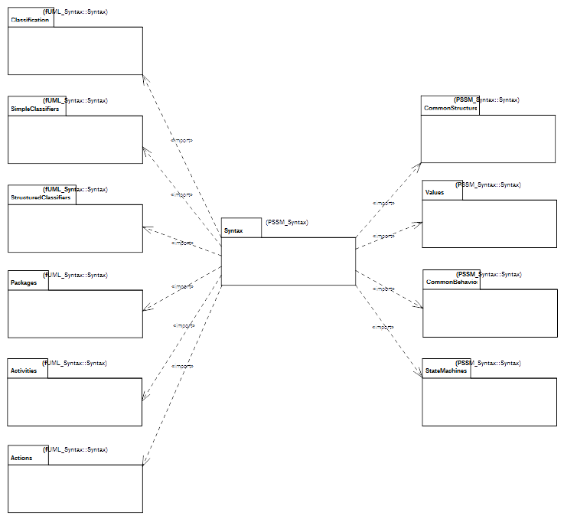
Figure 7.1 - PSSM Syntax Package
The constraints specified for PSSM are all those that are imported members of the PSSM_Syntax::Constraints package (see Figure B.1). Each of these constraints has as its single constrained element the UML abstract syntax metaclass to which the constraint applies.
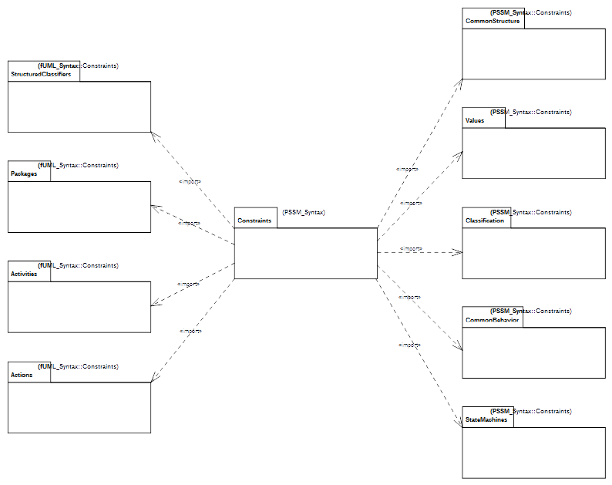Illustration 1 - PSSM Constraints
The PSSM_Syntax::Constraints package includes (via package import) all the constraints from the fUML constraints packages for StructuredClassifiers, Packages, Activities and Actions (see Clause 7 of [fUML]). It also includes all the fUML constraints for CommonStructure, Values and CommonBehavior, but includes additional constraints for the additional metaclasses in the PSSM subset in those areas (see 7.2, 7.3, and 7.5, respectively). In addition, in one case (for Classification::Operation), a constraint from fUML is replaced in PSSM with a less restrictive constraint (see 7.4). Finally, additional constraints are included for the StateMachine abstract syntax specific to PSSM.

Common Structure

Overview
In addition to all the metaclasses included in the fUML subset CommonStructure package, PSSM includes the Constraint metaclass (see Figure 7.2). This metaclass is included in PSSM because the guard of a StateMachine Transition is given as a Constraint (as shown in Figure 7.6). There is also an additional syntactic constraint specified for Constraint, as shown in Figure 7.2 and formally defined in 7.2.2.
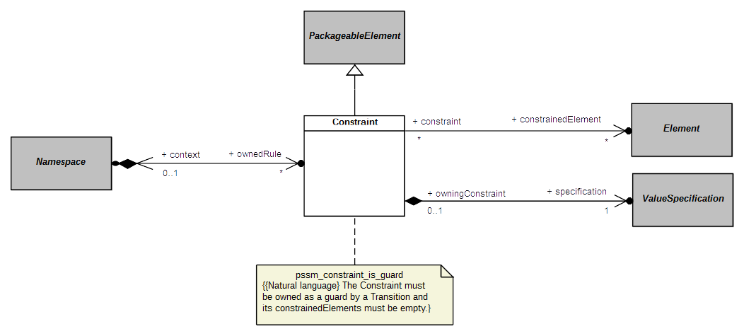Figure 7.2 - Constraints

Constraints

pssm_constraint_is_guard
A Constraint must be owned as a guard by a Transition and its constrainedElements must be empty.
context UML::CommonStructure::Constraint inv:
self.owner.oclIsKindOf(UML::StateMachines::Transition) and
self.constrainedElement->isEmpty()

Values

Overview
In addition to all the metaclasses included in the fUML subset Values package, PSSM includes the OpaqueExpression metaclass (see Figure 7.3). This metaclass is included in PSSM in order to provide a way to specify the specification of a Constraint (as shown in Figure 7.2). However, in order for such a specification to be precise, an OpaqueExpression is constrained to have a behavior that may be executed to provide the result value of the expression (as shown in Figure 7.3 and formally defined in 7.3.2).
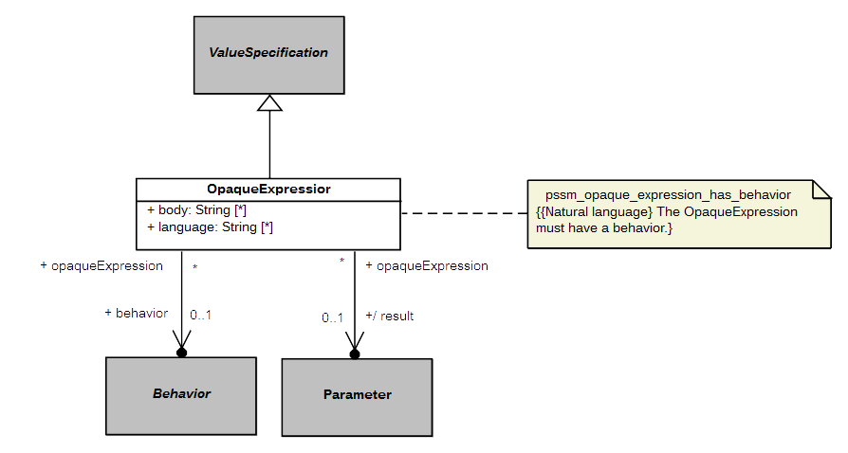Figure 7.3 - OpaqueExpressions

Constraints

pssm_opaque_expression_has_behavior
The OpaqueExpression must have a behavior.
context UML::Values::OpaqueExpression inv:
self.behavior <> null

Classification

Overview
The PSSM subset includes all the metaclasses in the fUML subset Classification package and does not include any additional ones in this area. However, the fUML constraint zero_or_one_method requires that a concrete Operation have a single associated method. This constraint is too restrictive for PSSM, because PSSM allows an Operation to be handled via a CallEvent trigger on a StateMachine Transition, in which case the Operation cannot have a method (see 7.5). Therefore, the PSSM_Syntax::Constraints::Classification package imports all the constraints from the corresponding fUML package except for the zero_or_one_method constraint, which is replaced with the pssm_operation_has_at_most_one_method constraint (as shown in Figure 7.4 and formally defined in 7.4.2).
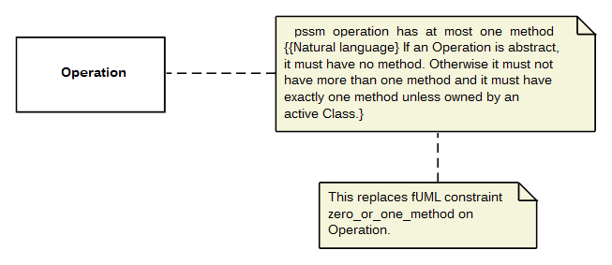Figure 7.4 - Operations

Constraints

pssm_operation_has_at_most_one_method
If an Operation is abstract, it must have no method. Otherwise it must not have more than one method and it must have exactly one method unless owned by an active Class.
context UML::Classification::Operation inv:
if self.isAbstract then self.method->isEmpty()
else
self.method->size() <= 1 and
((self.class = null or not self.class.isActive) implies
self.method->size() = 1)
endif

Common Behavior

Overview
In addition to all the metaclasses included in the fUML subset CommonBehavior package, PSSM includes the CallEvent metaclass (see Figure 7.5). Including CallEvent in the PSSM subset provides the ability for an Operation of a Class in a PSSM conformant model to be handled by a CallEvent trigger on a Transition of a StateMachine acting as the classifierBehavior of that class (see 7.6.2), rather than be implemented by a method. Since the UML specification specifies that having a method on an Operation means all calls on the Operation are handled by executing that method (see [UML], 13.3.3.2), even if there may also be executing Behaviors with CallEvent Triggers for the Operation, Operations on CallEvents in PSSM are constrained not to have a method, in order to avoid confusion. This constraint is shown in Figure 7.5 and formally defined in 7.5.2.
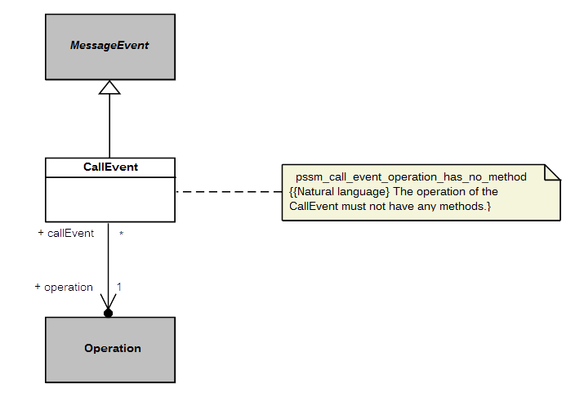Figure 7.5 - CallEvents

Constraints

pssm_call_event_operation_has_no_method
The operation of the CallEvent must not have any methods.
context UML::CommonBehavior::CallEvent inv:
self.operation.method->isEmpty()

State Machines

Overview
Not surprisingly, the largest extension to fUML provided by PSSM is in the area of StateMachines. Within this area, the PSSM subset includes abstract syntax for behavior StateMachines (see 7.6.2) and StateMachine redefinition (see 7.6.3). The formal PSSM subset does not include ProtocolStateMachines, they are discussed non-normatively in Annex A.

Behavior State Machines

Overview
A behavior StateMachine may be used in a PSSM-conformant model either stand-alone or as the classifierBehavior of an active Class. As shown in Figure 7.6, the PSSM subset includes the full UML abstract syntax for behavior StateMachines, except for the ConnectionPointReference metaclass. ConnectionPointReferences are used only in relation to submachine States, and such states are not allowed in a PSSM. Figure 7.6 shows various additional constraints on StateMachines required for PSSM, including the constraints on the usage of StateMachines and the prohibition on submachine States, all of which are formally defined in 7.6.2.2.
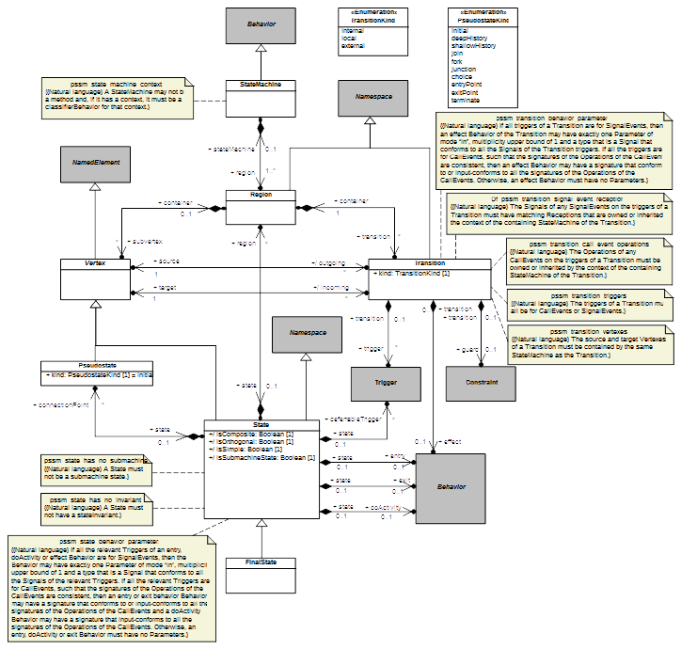Figure 7.6 - Behavior StateMachines

Constraints

pssm_state_machine_context
A StateMachine may not be a method and, if it has a context, it must be a classifierBehavior for that context.
context UML::StateMachines::StateMachine inv:
self.specification = null and
self.context <> null implies self.context.classifierBehavior = self

pssm_state_has_no_submachine
A State must not have a submachine.
context UML::StateMachines::State inv:
not self.isSubmachineState

pssm_state_has_no_invariant
A State must not have a stateInvariant.
context UML::StateMachines::State inv:
self.stateInvariant = null

pssm_state_behavior_parameters
If all the relevant Triggers of an entry, doActivity or effect Behavior are for SignalEvents, then the Behavior may have exactly one Parameter of mode “in”, multiplicity upper bound of 1 and a type that is a Signal that conforms to all the Signals of the relevant Triggers. If all the relevant Triggers are for CallEvents, such that the signatures of the Operations of the CallEvents are consistent, then an entry or exit behavior Behavior may have a signature that conforms to or input-conforms to all the signatures of the Operations of the CallEvents and a doActivity Behavior may have a signature that input-conforms to all the signatures of the Operations of the CallEvents. Otherwise, an entry, doActivity or exit Behavior must have no Parameters.
context UML::StateMachines::State inv:
-- TBD

pssm_transition_vertexes
The source and target Vertexes of a Transition must be contained by the same StateMachine as the Transition.
context UML::StateMachines::Transition inv:
let stateMachine = self.containingStateMachine() in
self.source.containingStateMachine() = stateMachine and
self.target.containingStateMachine() = stateMachine

pssm_transition_triggers
The triggers of a Transition must all be for CallEvents or SignalEvents.
context UML::StateMachines::Transition inv:
self.trigger.event->forAll(
oclIsKindOf(UML::CommonBehavior::CallEvent) or
oclIsKindOf(UML::CommonBehavior::SignalEvent)
)

pssm_transition_call_event_operations
The Operations of any CallEvents on the triggers of a Transition must be owned or inherited by the context of the containing StateMachine.
context UML::StateMachines::Transition inv:
let stateMachine = self.containingStateMachine() in
let context =
if stateMachine.context = null then stateMachine
else stateMachine.context
endif in
context.allFeatures()->includesAll(
self.trigger->select(oclIsKindOf(UML::CommonBehavior::CallEvent)).
oclAsType(UML::CommonBehavior::CallEvent).operation
)

pssm_transition_signal_event_receptions
The Signals of any SignalEvents on the triggers of a Transition must have matching Receptions that are owned or inherited by the context of the containing StateMachine of the Transition.
context UML::StateMachines::Transition inv:
let stateMachine = self.containingStateMachine() in
let context =
if stateMachine.context = null then stateMachine
else stateMachine.context
endif in
context.allFeatures()->select(oclIsKindOf(UML::SimpleClassifiers::Reception)).
oclAsType(UML::SimpleClassifiers::Reception).signal->includesAll(
self.trigger->select(oclIsKindOf(UML::CommonBehavior::SignalEvent)).
oclAsType(UML::CommonBehavior::SignalEvent).signal
)

pssm_transition_behavior_parameters
If all triggers of a Transition are for SignalEvents, then an effect Behavior of the Transition may have exactly one Parameter of mode “in”, multiplicity upper bound of 1 and a type that is a Signal that conforms to all the Signals of the Transition triggers. If all the triggers are for CallEvents, such that the signatures of the Operations of the CallEvents are consistent, then an effect Behavior may have a signature that conforms to or input-conforms to all the signatures of the Operations of the CallEvents. Otherwise, an effect Behavior must have no Parameters.
context UML::StateMachines::Transition inv:
-- TBD

State Machine Redefinition

Overview
The capability for StateMachine redefinition actually does not require any other metaclasses than those already included for behavior StateMachines. However, for clarity, the diagram for StateMachine redefinition from the UML specification is repeated here, showing the additional meta-associations involved (Figure 7.7). This diagram also shows the additional constraint (formally defined in 7.6.3.2) required for the PSSM semantics, which only support the ability of a StateMachine to extend at most one other StateMachine.
Note. Per the discussion in 6.1, the abstract syntax in Figure 7.7 needs to be updated to make Vertex a specialization of RedefinableElement, rather than State.
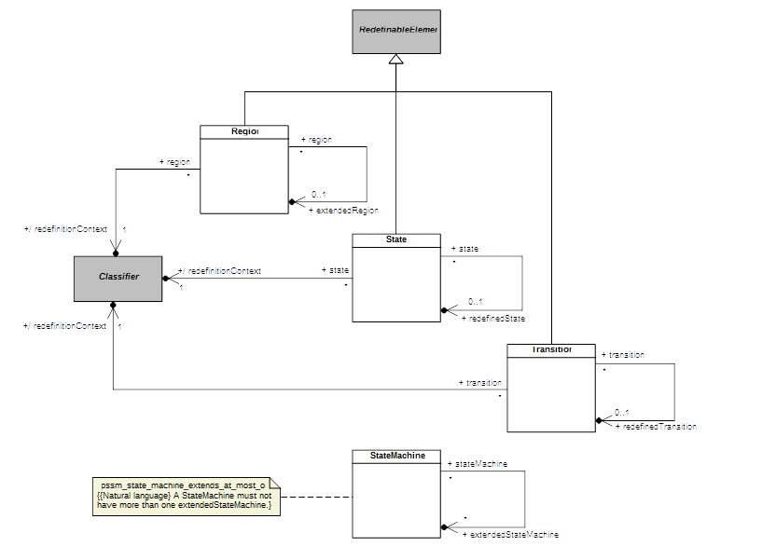Figure 7.7 - StateMachine Redefinition

Constraints

pssm_state_machine_extends_at_most_one
A StateMachine must not have more than one extendedStateMachine.
context UML::StateMachines::StateMachine inv:
self.extendedStateMachine->size() <= 1
Submission Note. Additional constraints need to be defined to enforce the consistency of redefining StateMachine elements with their redefined elements, because the UML 2.5 specification currently only provides default bodies of “true” for the isConsistentWith operations of these elements, which should be enforcing such consistency (see [UML], subclauses 14.5.8, 14.5.9,14.5.10 and 14.5.11).

Execution Model

Overview
This clause defines the precise semantics of the abstract syntax subset specified in Clause 7. This semantic definition is given as an extension to the semantic model for PSCS (see [PSCS], Clause 8), which is itself an extension of the execution model for fUML (see [fUML], Clause 8). This clause includes only the extensions to the PSCS model necessary for PSSM. However, the full semantics for PSSM are given by the fUML execution model as extended for both PSCS and PSSM, which is then a complete, executable fUML model of the operational semantics for the combined PSCS and PSSM subset.
The PSSM execution model is given as an extension of the PSCS model in order to ensure that PSSM semantics are compatible with PSCS semantics. However, the only point at which the PSSM semantic functionality actually depends on PSCS is in the definition of the behavior of Triggers that reference a specific Port, using the Trigger onPort property (see TBD). An execution tool that conforms at the “PSSM-only Conformance” level (see 2.2.1) is not required to implement the onPort functionality (since the PSSM-only abstract syntax subset does not include Ports), and none of the reset of the semantic functionality for PSSM depends on the functionality provided by the PSCS execution model extensions. Therefore, a tool conforming at the “PSSM-only” level can effectively treat the PSSM execution model as directly extending the fUML execution model, ignoring all inherited PSCS-specific functionality. A tool conforming at the “Joint PSSM and PSCS Conformance” level (see 2.2.2), on the other hand, must implement the semantics as specified in the entire extension of the fUML execution model by both PSCS and as given for PSSM in this clause.
The circularity of defining PSSM semantics by extending the fUML execution model, which is itself an fUML model, is broken, as it is in fUML. That is, the execution model is defined using only the further subset of fUML whose semantics are separately specified by the fUML base semantics (see [fUML], Clause 10), which do not need to be extended further for the purposes of PSSM. This further subset, known as Base UML (or “bUML”) includes a subset of UML activity modeling that is used to specify the detailed behavior of all concrete operations in the execution model. However, rather than using activity diagram notation to represent such activity models, they are specified in the execution model extensions for PSSM using the Java-syntax textual notation whose mapping to UML is given in Annex A of [fUML].
Submission Note. The Java snippets included in the formal execution model for this initial submission do not fully conform to the limitations of the Java subset as specified in Annex A of [fUML]. The submitters intend to either bring the Java-based textual notation used in the PSSM execution model into complete conformance with the required bUML-subset Java notation or to, instead, defined an Alf-subset notation that can be similarly mapped to bUML.
The PSSM extensions to the PSCS execution model are organized into five packages, which are named according to corresponding UML abstract syntax packages. Figure 8.1 shows each of these packages and their dependencies on packages from the fUML, PSCS and PSSM syntactic and semantic models, These dependencies are represented as package-import relationships, which also make the unqualified names of the necessary syntactic and semantics elements visible for use in the detailed behavioral code of each of the PSSM semantics packages. Each PSSM semantic package also publicly exports all its imported members, allowing those packages to be organized in a layered fashion. This layering starts with the small semantic extensions defined in the Values, StructuredClassifiers and CommonBehavior packages, which are used in defining the primary PSSM semantics in the StateMachines package, which are then fully integrated into the semantic infrastructure of the fUML execution model in the Loci package.
Submission Note. Just as the PSSM abstract syntax model in Clause 7 is defined assuming that the fUML abstract syntax model has been reorganized according to UML 2.5, the PSSM execution model presented in this clause presumes that both the fUML and PSCS execution models have been similarly reorganized in a parallel fashion. However, the cross-references given in this clause to fUML and PSCS are to the current specifications documents ([fUML] and [PSSM]), which, at this time, are still organized according to the structure of UML 2.4.1.
The subsequent subclauses in this clause describes each of the PSSM semantics packages in turn. The description includes a class model for the contents of the package and an explanation of the operational semantics defined by the functionality of the classes in the model. The detailed behavior code for the operations of the classes is not included in this document, but can be found in the associated normative XMI file for the PSSM semantic model that is described in this clause.
Submission Note. The detailed behavior code for the operations of the PSSM execution model may be included in the revised submission document, similarly to how such code was included in the fUML and PSCS specification documents.
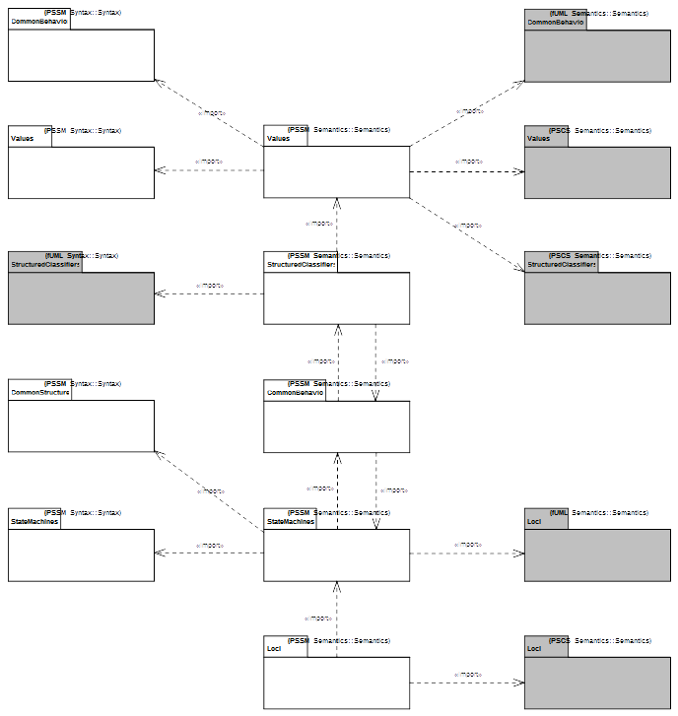Figure 8.1 - PSSM Semantics Package

Values
The Values package in the PSSM abstract syntax subset extends the Values package from the fUML abstract syntax by adding the OpaqueExpression metaclass (see 7.3). As shown in Figure 8.2, the semantics for OpaqueExpressions in PSSM is defined by the corresponding semantic visitor class SM_OpaqueExpressionEvaluation. This class is a specialization of the CS_OpaqueExpressionEvaluation class defined in the PSCS semantics (see [PSCS], 8.3.1.2.2).
An OpaqueExpression in PSSM is required to have an associated behavior. As in PSCS, the evaluation of an OpaqueExpression consists in executing its associated behavior. The functionality for this is provided by the executeExpressionBehavior operation defined in the CS_OpaqueExpressionEvaluation class. The PSSM SM_OpaqueExpressionEvaluation adds a new context attribute and redefines the executeExpressionBehavior operation such that the OpaqueExpression behavior is executed with the given context Object. This extension is necessary to allow an OpaqueExpression used as the specification of a guard Constraint on a StateMachine Transition to be evaluated in the proper context for that StateMachine (see 8.5.2.7).
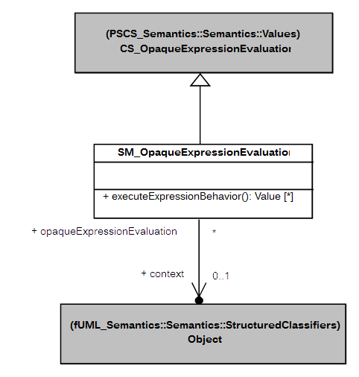Figure 8.2 - Values Extension

Structured Classifiers
The PSSM abstract syntax subset does not extend the StructuredClassifiers package from the fUML abstract syntax. However, the PSSM execution model StructuredClassifiers package includes a specialization of the semantics of Objects, as shown in Figure 8.3. The SM_Object class redefines the startBehavior operation from the fUML Object class (which is inherited without change by the PSCS CS_Object class) such that, when the Behavior of an active Object is started, a SM_ObjectActivation (as defined in 8.3) is instantiated for it, rather than the usual fUML ObjectActivation.
SM_Object also redefines the destroy operation from the fUML Object class to ensure that, when an Object is destroyed, any EventOccurrences remaining in the eventPool of the ObjectActivation are also removed, before carrying out the functionality of stopping the ObjectActivation for the Object and removing the Object from its Locus. This avoids the possibility of the event-dispatch loop of the ObjectActivation still getting a next event even once the Object has been removed from the Locus.
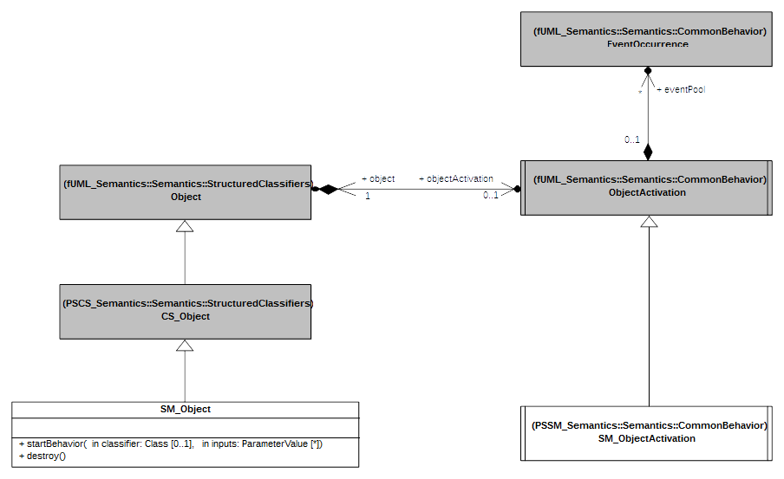
Figure 8.3 - StructuredClassifiers Extension

Common Behavior
The CommonBehavior package in the PSSM abstract syntax subset extends the CommonBehavior package from the fUML abstract syntax by adding the CallEvent metaclass (see 7.5). However, the semantics of CallEvent is defined as part of the semantics of the triggering of StateMachine Transitions (see 8.5.2.7), not in the CommonBehavior semantics. Instead, as shown in Figure 8.4, the CommonBehavior package in the PSSM execution model includes the SM_ObjectActivation class, which specializes the ObjectActivation class from fUML (see [fUML], 8.4.3.2.7). The SM_Object class in the StructuredClassifiers package of the PSSM execution model provides the functionality for instantiating an SM_ObjectActivation instead of a regular ObjectActivation when the Behavior of an active Object is started (see 8.3).
The SM_ObjectActivation class adds the registerCompletionEvent operation, which is used to add a CompletionEventOccurrence to the eventPool of the SM_ObjectActivation when the activation of a StateMachine State completes (see 8.5.2.4). The class also defines a new deferredEventPool of DeferredEventOccurrences, which is used in the specification of the semantics for the deferredEvents of a State (as also given in 8.5.2.4).
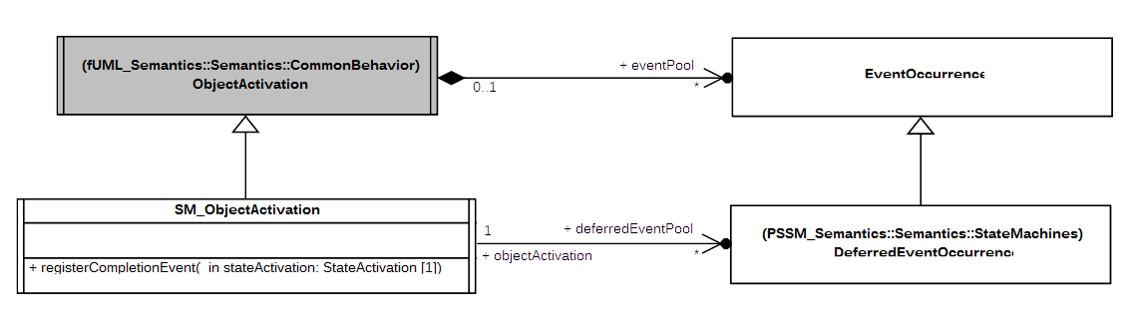
Figure 8.4 - CommonBehavior Extension

State Machines

Overview
The StateMachines package of the PSSM abstract syntax (see 7.6) defines the subset of the UML abstract syntax for StateMachines that is covered by the PSSM semantics. This is subset includes primarily the syntax for so-called behavior StateMachines (see 7.6.2), the primary kind of executable StateMachine included in UML. The semantics for behavior StateMachines are modeled in the StateMachines package of the PSSM execution model, which is described in 8.5.2.
The PSSM subset also includes the additional meta-associations from the UML abstract syntax required in models that use StateMachine redefinition (see 7.6.3). The semantics for StateMachine redefinition is included in the functionality provided by the classes in the StateMachines package of the PSSM execution model. However, in order to clearly describe the interpretation of StateMachine redefinition captured in the PSSM semantics, these semantics are discussed separately in 8.5.3.
Finally, the UML abstract syntax also includes the syntax for ProtocolStateMachines (see [UML], 14.4). However, the operational execution of ProtocolStateMachines requires the raising of exceptions when the protocol defined by the StateMachine is violated, and the semantics of exceptions are not currently included in fUML. Therefore, the PSSM execution model does not include formal operational semantics for ProtocolStateMachines. Instead, Annex A gives a non-normative description of the semantics that is more precise then that given in the UML specification, but without a formal execution model.

Behavior State Machines

State Machine Execution
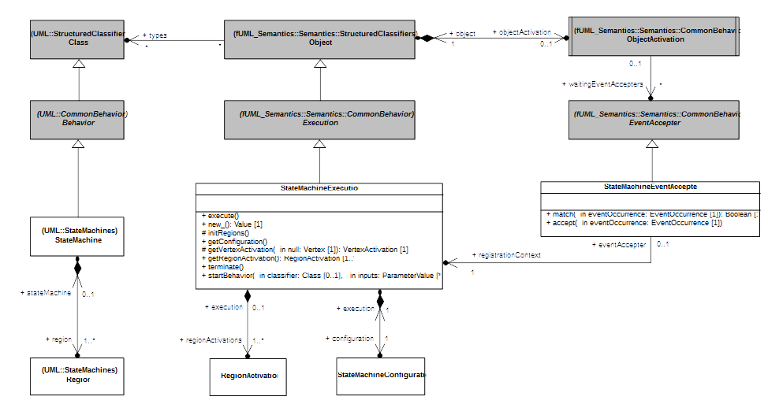Figure 8.5 - StateMachineExecution

Overview
In fUML the Execution visitor is specialized by ActivityExecution. This specialized visitor defines the root visitor for the execution of an Activity. In the context of StateMachines the principle is exactly the same. StateMachineExecution defines the root visitor for the execution of state-machine.
A state-machine execution owns a set of region activations. Each region activation is a visitor for a dedicated region of the executed state-machine.
The state-machine execution status is described in a state-machine configuration. This configuration represents the hierarchy of active states in which the executed state-machine currently is. This configuration is used to evaluate how the execute state-machine is going to evolve regarding dispatched events.
The possibility for a state-machine to accept an event occurrence is determined by the state-machine event accepter. To perform its evaluation the accepter relies on the state-machine configuration attached to its registration context (see association existing between the state-machine event accepter and the state-machine execution in Figure 8.5).
Section 8.5.2.1.2 describes the semantics captured by state-machine execution and state-machine event accepter. Semantics capture by region activation and state-machine configuration are respectively described in sections 8.5.2.2.2 and 8.5.2.3.2.

Semantics

StateMachineExecution
A state-machine execution is used to execute a specific state-machine. The type of the state-machine execution must be a state-machine. The state-machine execution is responsible for creating its regions activations which themselves creates (in cascade) visitors for their owned nodes.
The execution starts by entering concurrently all region activations directly owned by the state-machine. This semantics is captured by the execute operation (see StateMachineExecution in Figure 8.5). The initial RTC step performed in state-machine always starts through this operation.
The execution completes when all region activations owned by the state-machine execution are completed.
The execution terminates when a terminate pseudo-state is reached regardless of its level of nesting. The termination of the state-machine implies the termination of all regions directly owned by the state-machine. This semantics is captured by the terminate operation (see StateMachineExecution in Figure 8.5).
An executed state-machine is related to a state-machine event accepter only in the following situations:
- The state-machine plays the role of classifier behavior
- The state-machine has no context but it declared as being active.
The state-machine event accepter provides the possibility for such state-machine to evaluate the possible acceptance of a disptached event occurrence.

StateMachineEventAccepter
The role of the state-machine event accepter is to handle the reception of event occurrences for the state-machine.
As any other type of event accepter, the state-machine event accepter provides two operations:
- One for evaluating (see match operation owned by StateMachineEventAccepter in Figure 8.5) if the current state-machine configuration enables the dispatched event occurrence to trigger a chain of reaction in the executed state-machine.
- One for accepting (see accept operation owned by StateMachineEventAccepter in Figure 8.5) the dispatched event occurrence and so initiate a run-to-completion step which will trigger a chain of reaction within the executed state-machine.
The matches and acceptance phases relies on the evaluation of the state-machine configuration attached to the state-machine execution that registered this event accepter.
In the context of state-machines semantics, the state-machine event accepter matches in two situations:
- The dispatched event occurrence is deferred in the current state-machine configuration.
- The dispatched event occurrence can triggers one or more transitions.
In the case where the executed state-machine is active or plays the role of the classifier behavior then the context object (which is either the state-machine execution or the instance of the class for which the state-machine is a classifier behavior) has an object activation (see fUML 1.2 section 8.4.3.2.7). It exists at most in an object activation event accepter list a single state-machine event accepter. This is different from activity semantics where a single activity execution may have multiple event accepter registered by different accept event actions.
The difference can be explained by the fact that the possibility to accept an event occurrence is dependent from the analysis (priorities, conflicts, etc) of the state-machine configuration that is attached to the executed state-machine. Hence the state-machine event accepter is not related to a specific transition but to the state-machine configuration representing the hierarchy of active states in which the executed state-machine is currently placed.

State Machine Semantic Visitors
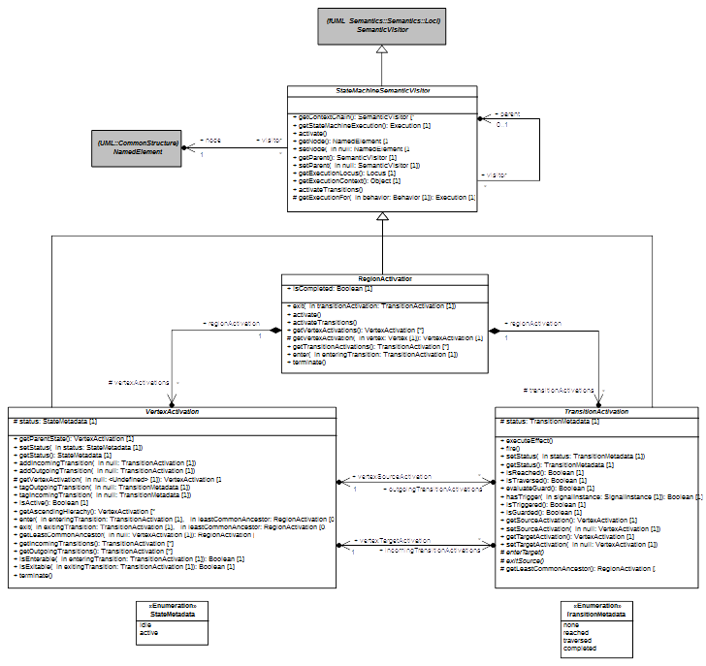
Figure 8.6 - StateMachine SemanticVisitors

Overview
Base semantic visitor introduced by the PSSM semantic model are shown in Figure 8.6.
Vertex activation captures the basic semantics for Vertex and transition Activation the basic semantics for Transition. These visitors are both specialized in the semantic model to respectively capture semantics of vertex specializations as well the semantics for the different kind of transitions.
Vertex activations and transition activations are always owned by a region activation which encodes the region semantics.

Semantics

StateMachineSemanticVisitor
A state-machine semantic visitor visits a specific model element (see association between StateMachineSemanticVisitor and NamedElement in Figure 8.6). It is the common base class for visitors (exception made for StateMachineExecution – see Figure 8.5) that captures state-machine semantics.
The purpose of this base class twofold.
- It introduces the parent-children relationships existing between state-machine semantic visitors. This implies that at run-time a state-machine is executed thanks to hierarchy of visitors organized as a tree.
- It provides a set of basic operation that is inherited by all specializing semantic visitors. These operations such as getStateMachineExecution and getExecutionLocus enable respectively each visitor to access the executed state-machine and the locus (see fUML 1.2 8.2.2.2.6) in which the state-machine execution is registered.
Semantics captured within a specialization of a state-machine semantic visitor is always split in two distinct parts:
- The first part are semantics related to the instantiation. These semantics are capture in redefinitions of both activate and activateTransitions operations (see Figure 8.6).
- All other operations are related to the behavioral semantics attached to the visited element.

RegionActivation
All state-machines semantics visitors are always contained by a region activation. A region activation captures region semantics.
The region activation is responsible for the instantiation of all visitors required to execute model elements contained in that region. Hence during the execution a region activation owns a set of vertex and transition activations which are visitors for vertexes and transitions locate in the executed region.
A region activation can be entered (see enter in RegionActivation in Figure 8.6) or exited (see exit in RegionActivation in Figure 8.6).Region can be entered / exited implicitly or explicitly.

Entering a region activation
A region activation can be entered either implicitly or explicitly. These cases only happen if the region activation is owned by a state activation (see StateActivation in Figure 8.8). Note that the owning state activation is always entered before any of its region activations is actually started.
- An implicit entry consists in starting the region execution using the initial pseudo state (if any) and to fire its continuation transition. Note that if the initial pseudo state does not exist then the region activation is considered as being completed. This leads the execution to properly ignore the execution of that particular region activation.
- An explicit entry (i.e., the target vertex activation of the entering transition is located within the region activation) does not start the region execution using the initial pseudo state. The region execution is considered as being started when the internal vertex activation is entered.

Exiting a region activation
- An implicit exit of one or more region activations occurs when a transition activation exits a state activation. In such case the semantics leads all region activations currently executing in the state activation to be exited. This implies that all activations for vertex located within the regions activation that are referenced in the state-machine configuration are exited. The exiting sequence for each region activation start by exiting the more nested vertex activation.
- An explicit exit of a region activation occurs when a transition activation exits a vertex activation located in that region activation and the target vertex activation is located outside this latter. In that case the region activation which is exited explicitly starts the exiting sequence using the source vertex activation (note that if the state activation is for a composite state then active vertex activation(s) located are exited first). Other regions activation (if any) start their exiting phase using their innermost vertex activations.
The final point of exiting either implicitly or explicitly on or more region activations owned by a state activation consist in executing the exit behavior (if any) attached to the visited state and to traverse the exiting transition.

Completion of a region activation
Region activations never reach completion by being exited either implicitly or explicitly. There are two ways to complete the execution of a region.
- The general rule is that region activation can only complete if the final state activation (see FinalStateActivation in Figure XX) owned by this latter is executed. This leads the region activation to be marked as being completed (see isCompleted attribute in RegionActivation in Figure 8.6).
- The general rule is violated only in the situation where a vertex activation owned by a region activation is exited and the transition activation that exits that vertex activation as for target the state activation owning the region activation. In the case and only in that case the region activation which owns the exited vertex activation completes.

Termination of a region activation
A region activation can be terminated (see terminate operation in RegionActivation in Figure 8.6). The termination of a region activation occurs in result of the termination of the state-machine execution which itself was triggered by the execution of a Terminate pseudo-state activation. It consists in terminating all vertex activations owned by the region. Finally the terminated vertex activation are destroyed.

VertexActivation
A vertex activation is the base class for all kind of visitors that are responsible for capturing semantics of specializations of Vertex (i.e., State and all kinds of Pseudostate).
- A vertex activation is always owned by a region activation.
- A vertex activation knows about its outgoing transition activations.
- A vertex activation knows about its incoming transition activations.

Vertex activations and state-machine configuration
A vertex activation captures the status of a vertex. The vertex is either idle of active. Basically if the vertex is a state then to be active the state must be in the state-machine configuration. Conversely if the state is not in the state-machine configuration it is idle.

Vertex activation entry and exit
The vertex activation semantic visitor defines the common way to enter and exit all kind of vertex.
- A vertex can only be exited if its prerequisites (specific to each kind of vertex – see operation isEnterable in VertexActivation in Figure 8.6) have been fulfilled. In that case and only in that case the vertex activation can be entered (see operation enter in VertexActivation in Figure 8.6). The exit semantics is specific to each kind of vertex. Nevertheless each specialized vertex is entered using a given entering transition and knows about the common ancestor it shares with source vertex activation. The exited vertex activation always takes advantage of the common ancestor (a region activation) information to identify if parent vertex activation must also be exited.
- A vertex can only be entered if its prerequisites (specific to each kind of vertex – see operation isExitable VertexActivation in Figure 8.6) have been fulfilled. In that case and only that the case the vertex activation can be exited (see operation exit VertexActivation in Figure 8.6). The exit semantics is specific to each kind of vertex. Nevertheless each specialized vertex is exited using a given exiting transition and knows about the common ancestor it shares with the target vertex activation. The exited vertex activation always takes advantage of the common ancestor (a region activation) information to identify if parent state must be entered before.

Vertex activation termination
The vertex activation semantic visitor does not enforce a particular termination semantics. These semantics are specific to each type of vertex activation. They are captured through the different redefinitions of the terminate operation (see VertexActivation in Figure 8.6).

TransitionActivation
A transition activation is the base class for all visitors capturing transition semantics. Transition activations have the responsibility to link vertex activations that capture vertex semantics.
- A transition activation knows about its source and target vertex activations.
- A transition has a status. This status defines the current situation of the transition. For instance reach means that the transition activations originates from a vertex activation that is currently active.

Evaluation
A transition activation is able to evaluate a guard placed (see evaluateGuard in TransitionActivation in Figure 8.6) on the visited transition. It also capable of determining if the visited transition can be triggered by a specific event occurrence (see canFireOn operation). These evaluation semantics are common by all kinds of transitions activation.

Firing
The firing (see fire in TransitionActivation in Figure 8.6) sequence is also common to all kind of transitions activations. It always consists in the following steps:
- The source may be exited. This depends on the kind of the transition that is actually executed (i.e., fired). The exiting sequence performed by the source vertex activation is dependent of the type of the executed vertex.
- The effect behavior of the executed transition is always executed.
- The target may be entered. This depends on the kind of the transition that is actually executed (i.e., fired). The entered sequence performed by the target vertex activation is dependent of the type of the executed vertex.
A firing sequence can be viewed as a chain of calls.
fire()
exit(exitingTransition, commonAncestor)
exit(exitingTransition, commonAncestor)
…
executeEffect()
enter(enteringTransition, commonAncestor)
enter(enteringTransition, commonAncestor)
end
The fire operation of the transition initiate the exit sequence of the source vertex activation. This exit sequence consists (if the prerequisites for exiting the source vertex activation are fulfilled) in a call to the exit operation of the source vertex activation. This exit sequence can nest a number of exit calls. These nested calls propagate the exiting sequence to parent vertex activations while the common ancestor of the source and the target vertex activations is not reached. As soon as the exit sequence is terminated, if the transition has an associated effect behavior then it is executed. After the execution of this behavior the target vertex activation is entered via a call to its enter operation (if the prerequisites for entering the target vertex activation are fulfilled). This call can as for exit lead to a number of nested calsl used to enter parent vertex activations before that the actual target vertex activation is entered. The call nesting ends when the common ancestor between the source and the target vertex activations is reached.
Notes. The triggering of the exit / entry sequence of a vertex activation depends of the transition kind. Each specialization of a transition activation is intended to provide the semantics capture within operation to exitSource and enterTarget (see TransitionActivation in Figure 8.6).

State Machine Configuration
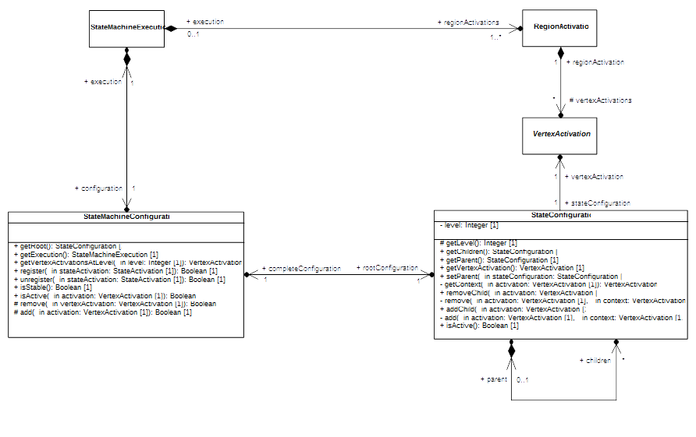Figure 8.7 - StateMachineConfiguration

Overview
A state-machine execution always has an attached state-machine configuration. This configuration represents the hierarchy of active states in which the currently executed state-machine is.
The state-machine view that is provided through the state-machine configuration offers a simple way to evaluate transition that can be fire or event occurrence that can be deferred. The state-machine configuration is intensively used by the event accepter attached to the executed state-machine to determine the behavior that need to be performed regarding a dispatched event occurrence.

Semantics

StateMachineConfiguration
The state-machine configuration attached to a state-machine execution is modified either when a state activation is entered or when a state activation is exited (see register and unregister operations of class StateMachineConfiguration in Figure 8.7).
It is important to note that the state-machine configuration does not evolve between two run-to-completion steps. The only way to make the state-machine configuration to evolve is to initiate a run-to-completion step via the acceptance of an event occurrence dispatched from the event pool.
The internal structure of the state-machine configuration is represented as a hierarchy of state configurations. Each state configuration included in the hierarchy actually references a vertex activation that is active in the currently executed state-machine.
Notes. Level of nesting introduced by the presence of region activations is not captured by the state-machine configuration.

StateConfiguration
A state configuration is a base unit of the state-machine configuration. It specifies the membership of a vertex activation to the configuration of the executed state-machine.
A state configuration knows its parent state configuration (if any) as well its children state-configuration(s).

State Activations
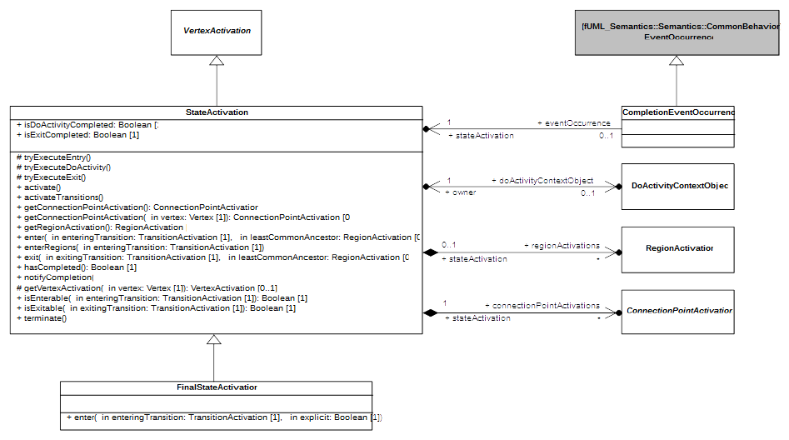
Figure 8.8 - StateActivations

Overview
Figure 8.8 shows two semantic visitors: StateActivation and FinalStateActivation. StateActivation captures simple and composite states semantics while FinalStateActivation captures FinalState semantics.

Semantics

StateActivation
A state activation is used to execute a state that is either simple or composite.
- A state activation can have connect point activations. These connections point activations are visitors for either entry points or exit points (see association between StateActivation and ConnectionPointActivation in Figure 8.8).
- A state activation can own none or many region activations depending if it executes a simple or a composite state (see association between StateActivation and RegionActivation in Figure 8.8).
- A state activation can have a running doActivity behavior (see association between StateActivation and DoActivityContextObject in Figure 8.8).

State activation entry
The common ancestor rule applies. This implies that all parent vertex activations are entered recursively until the common ancestor (which is a region activation) existing between the entered state activation and source vertex activation is reached. Only after this sequence of entry was executed then the state activation can be entered. The entrance of a state activation is divided into the following set of actions that occur sequentially:
- If an entry behavior is specified for the executed state then it is executed synchronously.
- If a doActivity behavior is specified for the executed state then it is invoked. The invocation means the doActivity starts asynchronously. When the invocation is realized a do activity context object is created and associated to the state activation. The do activity context object is the context object for the execution that is used to execute the specified doActivity behavior.
- If the executed state is a composite state then all regions starts concurrently. The way each region is started depend if it was entered explicitly or implicitly.
Note that when a state is entered then it now registered in the state-machine configuration attached to the executed state-machine.

State activation exit
The exiting state activation is divided into the following set of actions that occur sequentially:
- If the state owns regions activations the these latter are exited.
- If the state as a running doActivity the this latter is aborted.
- If an exit behavior is specified for the executed state then this behavior is executed.
The common ancestor rule also applies during exit. All parent vertex activation located at a more nested level than the common ancestor exiting between the exited state activation and the target vertex activation are exited.
Note that when a state is exited then it leaves the state-machine configuration attached to the executed state-machine.

State activation completion
The completion of a state means that a completion event is generated by that state and placed in the event pool handled by the object activation attached to the context object of the executed state-machine.
The completion of a state activation occurs in the following situation:
- The executed state is simple and this state has no associated entry or doActivity behavior. The state activation generates a completion as soon as the state is entered.
- The executed state is simple and it has an associated entry behavior but no doActivity behavior. The state activation generates a completion event upon the termination of the entry behavior behavior execution.
- The executed state is simple and it has an associated doActivity behavior. The state activation generates a completion event only when the doActivity behavior has completed.
- The executed state is composite and has no entry or doActivity associated. The state activation can only generate a completion event when all regions of the composite state have completed.
- The executed state is composite and has an associated doActivity. The state activation can only generate a completion event when all regions of the composite state have completed as well as the doActivity behavior.

State activation and deferred events
A state activation can defer an event occurrence when the following conditions are met:
- At least one state in the active state machine configuration indicates the type of the dispatched event occurrence as being deferred.
- No transition with a higher priority and able to react to the event occurrence could be found in the state-machine configuration.
When deferred the event occurrence is “captured” by the deferring state. This means it is placed to a deferred event pool and will only that pool to return to the regular event pool when the state that deferred it leaves the state-machine configuration.
Notes. One can argue that this contradicts UML 2.5 specification. Indeed UML 2.5 clearly states in section 14.2.3.4.4 that “A State may specify a set of Event types that may be deferred in that State. This means that Event occurrences of those types will not be dispatched as long as that State remains active. Instead, these Event occurrences remain in the event pool”. However fUML common behavior semantics defines a dispatching strategy that does not account for deferred events that are state-machine specific. Hence each event that is taken out from the pool as to be accepted because if it is not the event is lost. This not the semantics that is expected here. In order to preserve events that are detected as being deferred these latter are placed within the deferrent event pool owned by the SM_ObjectActivation (see Figure 8.4 in section 8.4). This solution has the side effect to not be compatible with all dispatching strategies.

FinalStateActivation
A final state activation captures semantics of a final state.
The common ancestor rule applies when a final state is entered. This means that parent vertex activations are entered recursively until the common ancestor existing between the source vertex activation and the final state activation is reached.
When the final state activation is finally entered it completes the execution of the region activation in which it is located. If all regions owned by a state activation have completed then a completion event is generated for that state activation.

CompletionEventOccurrence
A completion event occurrence is a specific type of event occurrence.
- A completion event knows the state activation from which it was generated (see association between CompletionEvent and StateActivation in Figure 8.8).

Scope of completion events
The scope of the completion event is limited to the state activation from which it was generated. This means that when dispatched and accepted the completion event can only be used to trigger a completion transition originating from the state which generated the completion event.
In the case where the state that generated the completion event has no completion transition then the completion will be lost during dispatching phase.

Priority of completion events
When generated a completion event is placed in the event pool handled by the object activation attached to the state-machine execution context object. Completion event added in the event pool have priority over all other event except completion events. This means that if the event pool (rightmost event is first to be dispatched) contains a signal event occurrence and a completion event [S, CE(S1)] then completion event that is currently generated will be placed in the pool after the existing signal event occurrence but before the existing completion event. In short the event pool will contain the following event occurrences: [S, CE(S2), CE(S1)].

DeferredEventOccurrence
A deferred event occurrence is a specific type of event occurrence.
- A deferred event occurrence knows the event occurrence that is currently deferred (see association between DeferredEventOccurrence and EventOccurrence in Figure 8.8).
- A deferred event occurrence knows the state activation that is responsible for the deferral of the event occurrence (see association between DeferredEventOccurrence and EventOccurrence in Figure 8.8)
A deferred event occurrence is created each time an event occurrence is deferred by a state activation. This deferred event occurrence is registered within the deferred event pool of the object activation.
The deferred event (i.e., the one referenced by the deferred event occurrence) returns to the regular event pool when the deferring state activation leaves the state-machine configuration.

“doActivity” Behavior Execution

Overview
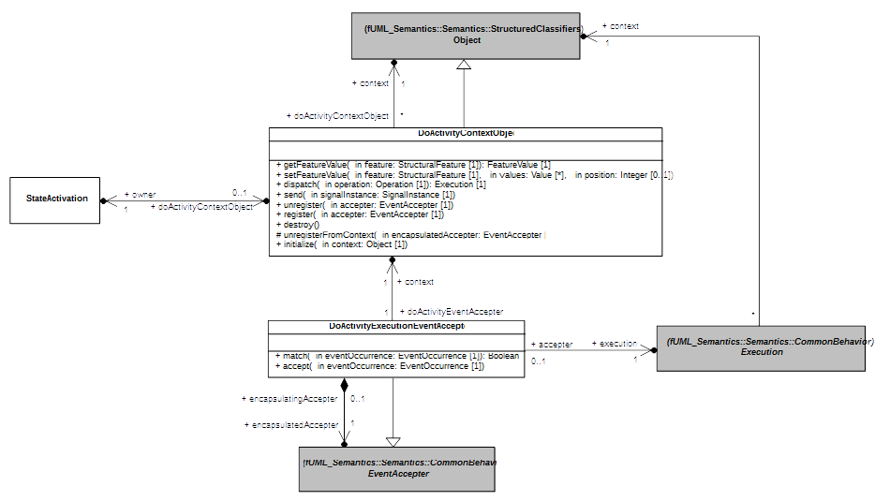
Figure 8.9 - doActivity Behavior Execution
Figure 8.9 shows part of the PSSM execution model capturing the semantics related to the execution of a doActivity behavior. In section 8.5.2.5.2 the focus is in presenting semantics that is captured both in DoActivityContextObject as well as DoActivityExecutionEventAccepter.

Semantics

DoActivityContextObject
A do activity context object is a specialized object (from the fUML standpoint).
- A do activity context object has itself a context. This context is the context object of the state-machine execution from which the doActivity behavior was invoked (see association between DoActivityContextObject and Object in Figure 8.9).
- A doActivity context object knows the state activation which realized the invocation to the doActivity behavior (see association between DoActivityContextObject and StateActivation 8.9).
A doActivity behavior needs to be executed on its own thread of execution. This requirement is introduced by the asynchronous nature of the doActivity behavior. The purpose of the do activity context object is to define the context object in which the doActivity behavior will be executed.

Feature access context
Although the doActivity behavior is executed on its on thread of execution (i.e., in its own active object), it still requires to have access to the same context than the state-machine from which it was invoked. Indeed the doActivity must be able to access features (e.g. an operation, a property) of the state-machine context object.
To satisfy this requirement the do activity context object has a reference to a context. This context is the context object of the state-machine execution. A do activity context object redefines object operations to route features accesses, features updates, operation calls and signal sending to the context object of the do activity context object. This way it is transparent for the doActivity behavior executed asynchronously that it is executed on own thread of execution.

Event registration context
An executing doActivity behavior is likely to register event accepters. To have these event accepters triggered by the acceptance of dispatched event occurrences they need to be registered in the object activation attached to the state-machine execution context. This means the do activity context object redefines register and unregister to make sure the addition and the removal of event accepters is made in the state-machine execution context. As soon as the event accepters registered by the executed doActivity behavior are placed in the state-machine execution context, they get a change to be elected to accept dispatched event occurrences.
Note that although the event accepters are registered in the state-machine execution context, they are also registered within the doActivity context object. In addition when an event accepter register by the do activity context object is used to accept an event occurrence it is removed both from the state-machine execution context object as well as from the event accepter list owned by the do activity context object.

Completion of the doActivity
The completion of an invoked do activity is detected by the absence of registered event accepters within the do activity context object. In this situation, the state activation from which the do activity behavior was invoked completes (i.e., it generates a completion event) if it ready to do so (see situations in which a state activation is ready to complete in section ).

Do activity destruction
In the case where the state activation that invoked the doActivity is exited before the behavior execution actually completes then the do activity context object of that behavior is destroyed. This result in having the doActivity aborted and the all event accepters registered by its context object removed from state-machine execution context.

DoActivityExecutionEventAccepter
A do activity execution event accepter is a specialized event accepter.
- A do activity event accepter knows its original creation context. This context is the do activity context object.
- A do activity event accepter knows the original event accepter that was registered by the executed doActivity in the do activity context object.
A do activity event accepter is automatically registered in the context of the do activity context object when the executed doActivity behavior registers an event accepter. This do activity event accepter will be elected to fire using an event occurrence dispatched from the event pool of the state-machine execution context object. When an event is accepted using this accepter is delegates the acceptance to the encapsulated event accepter. This one actually trigger a chain of reaction in the doActivity behavior. Each time an event accepter is removed from the do activity context object is removed, the completion of the do activity behavior is evaluated.

Pseudostate Activations
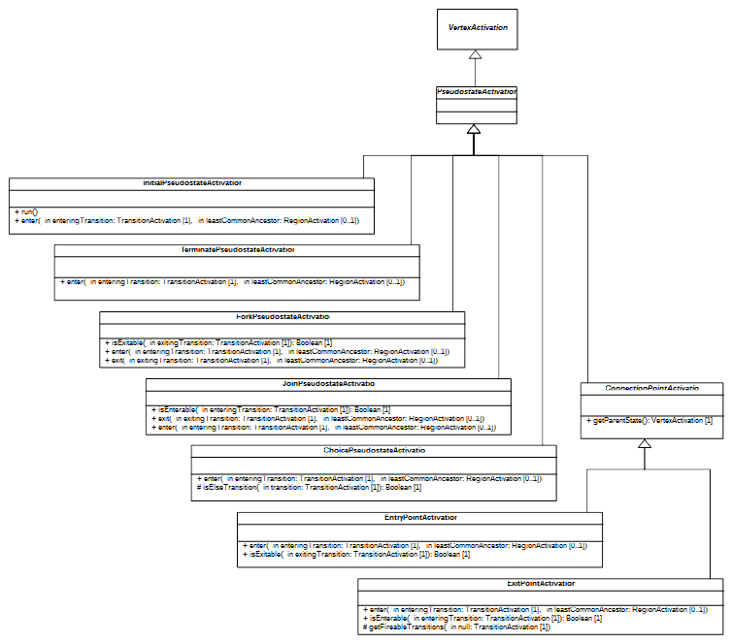Figure 8.10 - PseudostateActivations

Transition Activations
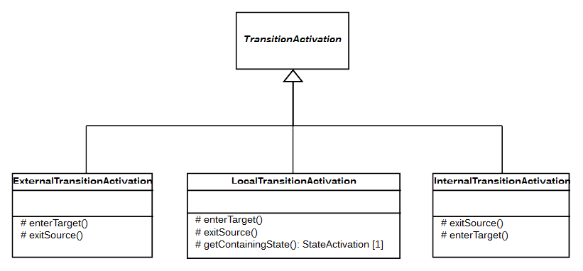Figure 8.11 - TransitionActivations

Overview
Figure 8.11 shows the three specializations of the transition activation semantic visitor. These specializations respectively capture semantics related to external transitions, local transitions and internal transitions. The different semantics of this kind of transitions are inherent to the way the source vertex activation is exited and the way the target vertex activation is entered.

Semantics
The different specializations of transition activation keep the base semantics for guard evaluation and evaluation of the reactivity to a particular event occurrence.

ExternalTransitionActivation

Exit source
In the case of an external transition the source vertex activation is exited only if all of its prerequisites to be exited are fulfilled (e.g., a fork pseudo state activation can only be exited when all its outgoing transitions except the on currently used have been traversed) otherwise it is not exited.
The way of the source vertex activation is exited also depends on the possibility to enter the target vertex activation. If this latter is not ready to be entered then the exit sequence of the source vertex activation is limited to itself. Otherwise if the target vertex activation is ready to be entered then the exit sequence of the source vertex activation account for the common ancestor rule. This can imply the propagation of the exit sequence to parent vertex activations until the common ancestor existing between the source and the target until the common ancestor is reached.

Enter target
If the prerequisites to enter the target vertex activation are fulfilled then this latter is entered and the entering sequence accounts for the common ancestor rule. This means that the entering sequence can be propagate to parent vertex activation until the common ancestor existing between the source vertex activation and the parent vertex activation is reached.
If the prerequisites are not fulfilled (e.g., the target state is not already active) the target vertex is not entered. Nevertheless if this target is a state activation for a composite state, then the region activation owning the source vertex activation completes. This may lead to the generation of a completion event for the executed composite state (see situations in which a state activation is ready to complete in section ).

LocalTransitionActivation

Containing state
The exiting of the source vertex activation and the entering of the target vertex activation are conditioned by the identification of the so-called containing state. The containing state of a local transition can be determined in the following manner:
- If the source vertex activation of the local transition is an entry point activation then the containing state is the owner of this entry point (i.e., a state activation for a composite state).
- If the source vertex activation contains the target vertex activation then the containing state is the source vertex activation. Otherwise the containing state is the target vertex activation.

Exit source
If the source vertex activation has fulfilled its requirements to be exited the two execution cases are possible:
- The source is an entry point activation. The exit sequence is trivial, only the entry point is exited through one or more continuation transitions.
- The source is a state activation for a composite state and the target of this transition activation is a vertex activation located in a region activation owned by the source vertex activation. In that situation the source vertex activation cannot be exited since it is also the containing state for the local transition. If there is already a state activation that is active in the same region than the target vertex activation then the state activation is exited.

Enter target
If the target vertex activation has fulfilled its requirement to be entered and this latter is not the containing state of the local transition then the entering sequence starts and the common ancestor rule applies.

InternalTransitionActivation

Exit source
An internal transition never exits its source vertex activation.

Enter target
An internal transition never enters its target vertex activation

State Machine Redefinition

Background
It is common in UML to use StateMachines to describe the classifierBehavior of complex active Classes, and it is natural to expect to be able to specialize UML Classes whose behaviors happen to be specified by StateMachines.
Consider, for example, the StateMachine shown in Figure 8.12, which represents the classifierBehavior of some (active) Class (not shown explicitly in the diagram). Being a classifierBehavior means that this StateMachine is a member of the Namespace of that Class. Because the classifierBehavior qualifies as an inheritableMember of its owning Class (see [UML], subclause 9.9.4.7), it will be inherited by any subclass of that Class.
Note. Although UML does not provide an explicit notation for Regions (only for Region separators), for the purposes of this discussion, they have been represented explicitly using a dashed box with rounded corners, which encloses the Region’s States and Vertexes.
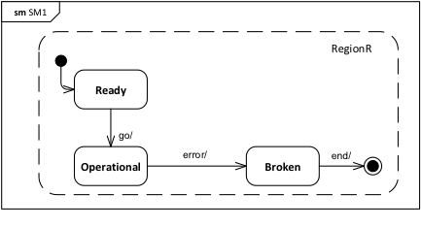Figure 8.12 - An "abstract" StateMachine behavior
Assume that, in this particular case, the Class that owns this StateMachine is an abstract Class and that its classifierBehavior StateMachine describes a general high-level (i.e., “abstract”) behavior intended to be shared by all subclasses of that Class. Starting with this basic behavior, each subclass will need to refine the high-level behavior depending on its particular purpose. For example, each subclass may specify different behavior for its instances when they are in the Operational state.
To achieve this, instead of directly inheriting the StateMachine of its parent, a subclass needs to redefine the parent StateMachines and refine some of its States and Transitions, while also adding new ones to suite the specific needs of the subclass. Figure 8.13 depicts a prototypical example of such refinement for the case of the StateMachine in Figure 8.12.
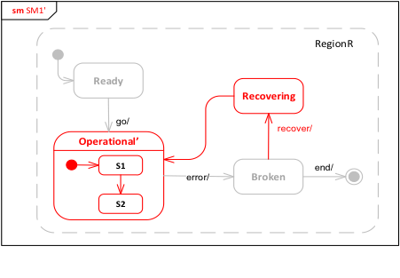
Figure 8.13 - A redefinition and refinement of the "abstract" StateMachine
In this case, the original, simple Operational state from the general StateMachine is refined into a composite state, Operational’, with an internal States and Transitions of its own. Note that, to retain behavioral compatibility, the refined StateMachine retrains the two original Transitions (“go” and “error”) between the Operational State and the Ready and Broken States in the general StateMachine. In addition, the refine StateMachine includes one additional State (Recovering) along with its associated Transitions.
Note. For clarity, the inherited elements are rendered using lighter-colored lines and text, while the new subclass-specific elements are drawn in red.
The UML abstract syntax for StateMachine redefinition given in 7.6.3 supports the kind of refinement shown in Figure 8.13. Figure 8.14 shows schematically how this mechanism is applied to achieve the refinement sketched in Figure 8.13. First, the refined StateMachine SM1' is identified as having SM1 as its extendedStateMachine (StateMachine “extension” in this sense is really an adaptation of the general UML redefinition mechanism for StateMachines) and includes the additional State Recovering, with its incoming and outgoing Transitions. Further, as one might expect, the State Operational' is identified as having as its redefinedState the State Operational in the original StateMachine. However, this is still not sufficient to fully define the desired refinement.
To see why, consider the Transition triggered by “recover” in Figure 8.13, which originates on State Broken and terminates on State Recovering. While Recovering is defined in the extending StateMachine (SM1’), Broken is defined in the extended StateMachine (SM1). However, the constraint pssm_transition_vertexes in 7.6.2.2 precludes Transition from connecting vertexes that belong to two different StateMachines, as would be the case here. To avoid this problem, it is therefore necessary to add a new source state for the transition (called Broken’ in Figure 8.14). This new state has to redefine the original state Broken that, along with the new Transition, is be owned by a Region of the same StateMachine. This requires that a new Region R must be defined in SM1' that redefines the Region in SM1 (as also shown in Figure 8.14).
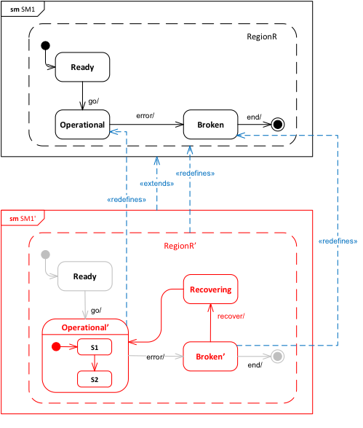Figure 8.14 - Using the StateMachine redefinition mechanism
The result is that, whenever a new member (e.g., Region, Vertex, or Transition) is added, all the containers in the transitive closure of container elements in which that element is defined have to be redefined, up to the top-level StateMachine container, which is “extended”. Furthermore, if a Transition is added, its source and target vertexes need to be either redefined or added (if they are new elements), so that they have the proper incoming and outgoing Transition collections.
Note. As shown in Figure 7.7, State is defined in the UML abstract syntax as a RedefinableElement, but not Pseudostate. However, since a Transition may have a Pseudostate as its source or target instead of a State, it is actually necessary for that Vertex be a RedefinableElement, allowing both States and Pseudostates to be redefined, rather than just States. This requires a change in the UML abstract syntax as currently defined (see 6.1).

Extending State Machine Execution
The execution of an extending StateMachine proceeds under the assumption that the StateMachine satisfies all the necessary constraints, as discussed in 8.5.3.1. In this case, execution is carried out according to the general model for behavior StateMachines described in Error: Reference source not found. The semantics of StateMachine redefinition are captured entirely in how the appropriate SemanticVisitors are instantiated for Vertexes and Transitions during that execution.
- If a Region has a redefinedRegion, then, in addition to VertexActivations and TransitionActivations being instantiated for any Vertexes and Transitions that it owns, VertexActivations and TransitionActivations are also instantiated for any Vertexes and Transitions that are inherited from the redefinedRegion (and that are not themselves redefined).
- When a TransitionActivation is instantiated, if the source and/or target Vertex of its Transition is redefined (directly or indirectly) by a Vertex in the StateMachine containing the Transition, then the corresponding vertexSourceActivation and/or vertexTargetActivation of the TransitionActivation is set to the VertexActivation for the redefining Vertex, rather than the original vertex.
Once all SemanticVisitors are instantiated for an extending StateMachineExecution per the above, the execution proceeds exactly as if the StateMachine being executed was the effective StateMachine resulting from merging all directly and indirectly extended StateMachines into the extending StateMachine (e.g., in the case of the example given in 8.5.3.1, the StateMachine SM1' shown in Figure 8.14 executes as if all the lightly-colored Vertexes and Transitions were all actually contained in SM1').
Submission Note. The above semantics covering StateMachine redefinition have not been incorporated into the formal execution model yet.

Loci
The Loci package in the PSSM execution model includes specializations of the CS_Locus and CS_ExecutionFactory classes from the Loci package of the PSCS execution model. The PSCS classes are specialized, rather than the corresponding fUML execution model classes, so that the PSSM execution model can also handle the SemanticVisitor classes that provide the operational semantics for PSCS, which is necessary to execute a model at the “Joint PSSM and PSCS Conformance” level (see 2.2.2). However, a model at the “PSSM-only Conformance” level, that strictly adheres to the PSSM subset specified in Clause 7, will not include any PSCS-specific elements and, therefore, can be executed without the PSCS functionality inherited by the PSSM Loci classes.
The SM_Locus class redefines the instantiate operation such that, if the given type is not a Behavior, then it is instantiated as an SM_Object (see 8.3), rather than a regular fUML Object. The SM_ExecutionFactory class redefines the instantiateVisitor operation in order to instantiate the new SemanticVisitors for StateMachine elements (as defined in 8.5) and to instantiate the PSSM-specific SM_OpaqueExpressionEvaluation SemanticVisitor for OpaqueExpression (as defined in 8.2).
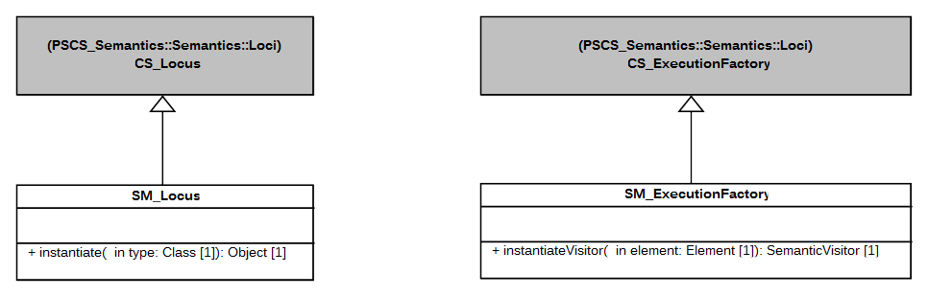
Figure 8.15 - Loci Extensions

Test Suite

Overview
This clause presents a test suite to be used to validate that an execution tool conforms to the semantic model presented in Clause 8 (see also Clause 2 on the requirements for conformance). The test suite is an fUML, PSCS and PSSM conformant model comprising a set of test cases that, when executed by an execution tool, report on whether the expected results are obtained.
The definition of the test suite is based on an analysis of the UML specification of the semantics of state machines ([UML], Clause 14) that identified a set of requirements to be validated by the test cases in the suite. Each requirement is a textual statement about one specific part of the semantics of state machines. Each test case then verifies whether or not an execution tool meets one particular requirement, as formally interpreted according to the semantic model defined in Clause 8.
The test suite is separated into two parts.
- The first part defines the abstract architecture of a test case. This architecture is specialized (in the UML sense) for each test case. A detailed presentation of this part of the test suite model is given in 9.2.
- The second part of the test suite is a set of packages, where each package refers to a particular test category. For example, one test category in the test suite captures all test cases related to transition semantics. Each test case in this category asserts a specific part (identified in the requirements) of the transition semantics. All test cases in the test suite are described in 9.3. Each description includes a statement of the requirement covered by the test case, a model of the state machine being tested and a description of the expected result of running the test.
The purpose of having a strong coupling between the semantic requirements for state machines is to be able to (as in any software development) identify quickly and precisely what is covered by the semantic model in terms of semantics and what is not. Coverage of UML state machines by the PSSM semantic model and test suite is discussed in Error: Reference source not found.

Utilities

Overview
One objective of the PSSM test suite is to define a base architecture to simplify the definition of executable tests cases. This architecture (structure and behavior) is presented in 9.2.2. The communications that take place between the different elements of the architecture are presented in 9.2.3. Finally, 9.2.4 explains the process of generating a trace that captures information about the state machine execution. This trace is used to compare the execution expected for the state machine against the trace actually generated at execution time.

Architecture

Architecture Concepts
This subclause presents the architecture that was defined to describe test cases to assess the PSSM semantic model. The base architecture of the PSSM test suite is inspired by concepts identified by the UML testing profile. The UML testing profile was built to provide “a standardized language based on OMG's Unified Modeling Language for designing, visualizing, specifying, analyzing, constructing, and documenting the artifacts commonly used in and required for various testing approaches, in particular model-based testing (MBT) approaches” [UTP]. The UTP concepts used in the PSSM test suite are:
- TestComponent: “Test components are part of the test environment and are used to communicate with the system under test (SUT) and other test components. The main function of test components is to drive a test case by stimulating the system under test through its provided interfaces and to evaluate whether the actual responses of the system under test comply with the expected ones.” (see subclause 8.2.2.2 of [UTP] to read the complete description of this concept).
- TestCase: “A test case is a behavioral feature or behavior specifying tests. A test case specifies how a set of test components interact with an SUT to realize a test objective. Test cases are owned by test contexts, and therefore have access to all parts of the test configuration, other global variables (e.g., data pools, etc.) or further behavioral features (e.g., auxiliary methods). A test case always returns a verdict.” (see subclause 9.2.2.4 of [UTP] to read the complete description of this concept).
- TestContext: “A test context acts as a grouping mechanism for a set of test cases. The composite structure of a test context is referred to as test configuration. The classifier behavior of a test context may be used for test control” (see subclause 8.2.2.3 of [UTP] to read the complete description of this concept).
Figure 9.1 shows how these concepts are used in the context of the definition of the abstract architecture of a test. Figure 9.2 shows the structure of the semantic test container for such tests. These classes, and their behavior, is described in 9.2.2.2.
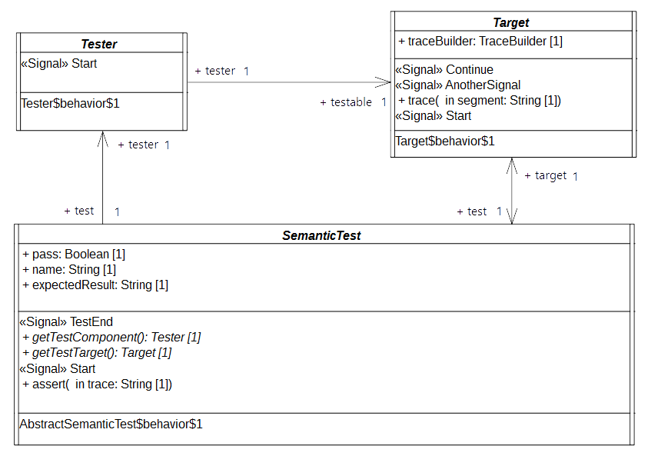Figure 9.1 - Architecture of an Abstract Semantic Test
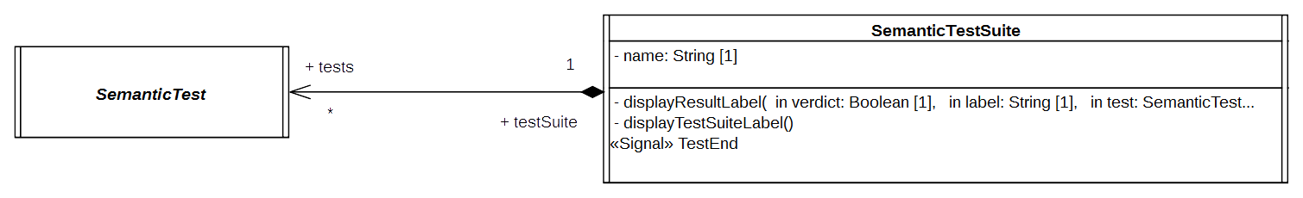Figure 9.2 - SemanticTest and SemanticsTestSuite

Architecture Class Descriptions

Tester

Description
The tester is an abstract active class which encodes in its classifier behavior the stimulation sequence (i.e, a set of event occurrences) that will be sent to the target (i.e., the system under test).
Note that this role matches what is intended for a TestComponent in UTP. This class has the stereotype “TestComponent” applied.

Association Ends
- testable: Target [1] – The SUT (System Under Test) to which the stimulation sequence is sent.
- test: SemanticTest [1] – The test case which controls the tester.

Receptions
- Start – A tester can receive a Start signal

Classifier Behavior
The classifier behavior of the abstract tester is empty. Specializations are intended to provide a new classifier behavior which will encode the user defined stimulation sequence.

Target

Description
The target defines the system under test. Specializations of this class have to provide their classifier behaviors specified as a state machine.
The target receives the stimulation sequence produced by the tester. The dispatching of the events will enable transitions of the state machine playing the role of a classifier behavior to be triggered.
Throughout its execution the state machine generates an execution trace. This trace is stored by the target and finally provided as the result of the execution to the test which controls the target.

Attributes
- traceBuilder: TraceBuilder [1] – Each test target owns a trace builder. It enables the classifier behavior of a target to build a trace of its execution.

Association Ends
- test: SemanticTest [1] - The test case which controls the target.

Operations
- trace(in segment: String[1]) – The operation enables the addition of “segment” (i.e., a new part) to the execution trace. It can be called at any time in the classifier behavior of the target to capture information relative to the executed state machine.

Receptions
- Start – The target is able to receive Start signals
- Continue – The target is able to receive Continue signals
- AnotherSignal – The target is able to receive AnotherSignal signals.

Classifier Behavior
The classifier behavior of the abstract Target is empty. All specializations are intended to provide a new classifier behavior which will be the state machine whose execution is performed by the execution model defined for PSSM.

SemanticTest

Description
A SemanticTest is the main artifact of a semantic test case. It is in charge of instantiating and controlling the tester and the target (i.e. the SUT). When the execution of the SUT is done then the execution trace that was produced is provided to the semantic test case for analysis. If the trace matches one of the expected trace for the executed state machine the test pass otherwise it fails.
The classifier behavior of a semantic test has the TestCase stereotype applied.

Attributes
- name: String [1] – The name of the test case name.
- pass: Boolean [1] – The current status (pass or fail) of the test.
- expectedResult: String [1] – The execution trace that is expected for the SUT.

Operations
- getTestComponent(): Tester – Abstract operation which returns an instance of the tester controlled by the semantic test whose classifier has been started. This operation is intended to be redefined by specializations of SemanticTest.
- getTestTarget(): Target – Abstract operation which returns an instance of the target controlled by the semantic test whose classifier has been started. This operation is intended to be redefined by specializations of SemanticTest.
- assert(in trace: String[1]) – This operation updates the value of the attribute “pass” by comparing the trace given as a parameter to the expected execution trace known by the semantic test.

Receptions
- Start – The semantic test is able to receive Start signals.
- TestEnd – The semantic test is able to receive TestEnd signals.

Classifier Behavior
The classifier behavior of a semantic test is defined as a UML activity (which conforms to the fUML subset). It is presented in Figure 9.3.
The principle of the behavior is the following:
- When the classifier behavior starts it blocks, waiting for the dispatching of a Start signal
- On the reception of the Start signal it creates and instantiates both the tester and the target.
  - The links (instances of associations) are created.
  - The tester and the target receive a Start signal.
  - The semantic test finally blocks again waiting for the dispatching of a TestEnd signal.
- When the TestEnd signal is received, it computes the verdict of the test and notifies the test suite that controls it.
Note that specializations of a semantic test are not intended to override the dynamic that is captured in this classifier behavior.

SemanticTestSuite
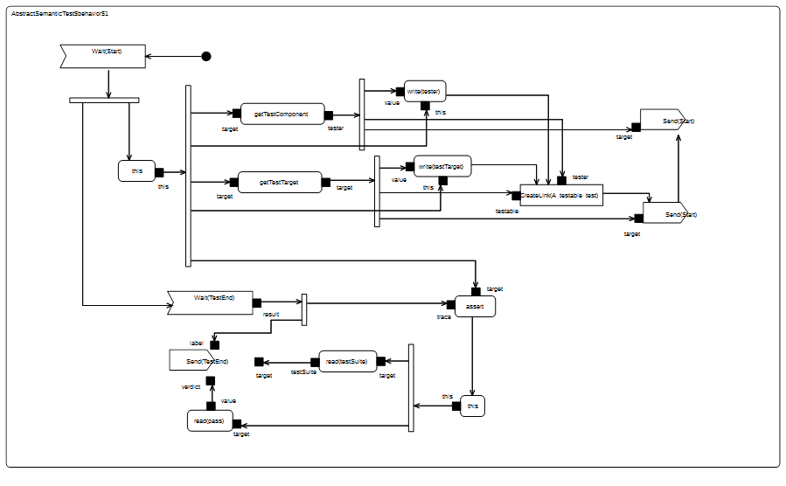Figure 9.3 - SemanticTest classifier behavior

Description
A SemanticTestSuite owns a set of SemanticTest. The execution of these tests is orchestrated by the test suite itself. Tests are executed one by one. At the end of each test the verdict is retrieved by the test suite that is charge of displaying the results. This is an active class and is not intended to be specialized.
One can notice that it matches the concept of TestContext proposed by UTP. This class has the stereotype TestContext applied.

Attributes
- name: String [1] – The name of the test suite.

Association Ends
- tests: SemanticTest [*] - the set of semantic tests that is handled by the semantic test suite.

Receptions
- TestEnd – The SemanticTestSuite class is able to received TestEnd signals.

Operations
- displayResultLabel(in verdict: Boolean [1], in label: String[1], in test: SemanticTest [1]) – A convenience operation to display the test result on an output stream.
- displayTestSuiteLabel() - A convenience operation to display the name of the name of the suite on an output stream.

Classifier Behavior
The classifier behavior of the suite encodes a sequential execution of the test known by the test suite. Each time a test that was started by the test suite terminates then the test suite gets notified. As soon as the notification (i.e., a TestEnd signal) is dispatched, the test result is displayed in the output stream chosen by the user. The classifier behavior of the semantic test suite is presented in Figure 9.4.

Protocol
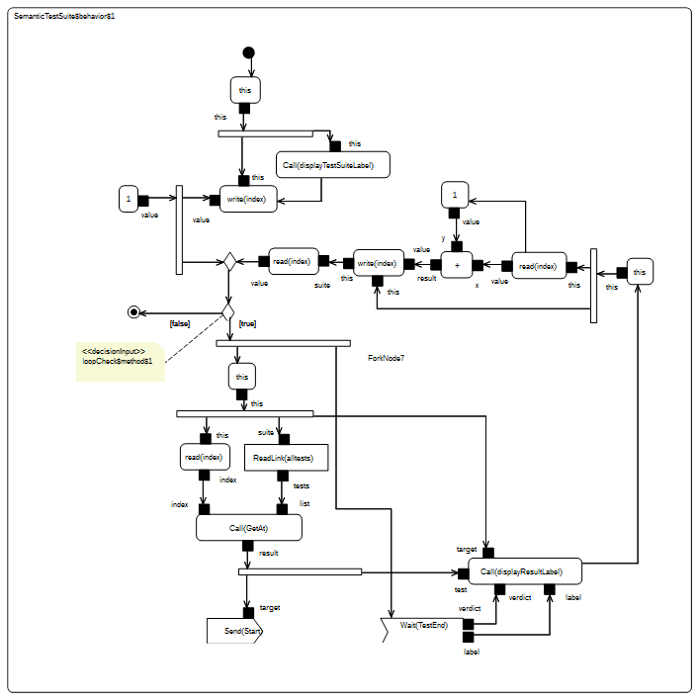Figure 9.4 - SemanticTestSuite Classifier Behavior

Protocol Overview
The Protocol package of the test suite has two subpackages: Messages and Events.
- Messages contains all signals used to communicate between the different active classes (see the model below).
namespace StateMachine_TestSuite::Util::Protocol;
package Messages {
/* -- Synchronization --*/
public signal Start {}
public signal End {
public trace: String;
}
public signal TestEnd {
public verdict: Boolean;
public label: String[0..1];
}
/* -- Synchronization --*/
/* -- Stimulations --*/
public signal Continue {}
public signal AnotherSignal {}
public signal Pending {}
/* -- Stimulations --*/
}
- Events contains the signal events (for the signals located in Messages) that can be directly used by triggers.
The synchronization signals in the Messages package (i.e., Start, End and TestEnd) are used to synchronize executions of different active objects. These signals are further described in 9.2.3.2.
The stimulation signals (i.e., Continue, Pending and AnotherSignal), on the other hand, are used by the tester to stimulate the target (i.e. the system under test). None of these signals contain data.

Synchronization Signal Descriptions

Start

Description
The Start signal is used for to two purposes in the test suite context. First it enables the test suite to start the execution of a specific semantic test. Second it enables the test to start both its tester and its target. The modeling constraint for the SemanticTest, the Tester and the Target is that they must all register an accepter for the Start signal at the beginning of the execution of their classifier behaviors. Note that Start signal does not include any data (it has no attributes).

End

Description
The End signal enables the Target to provide its controller (i.e., the SemanticTest) with a notification containing its execution trace. The semantic test takes advantage of this notification to compute the test verdict.

Attributes
- trace: String [1] – The execution trace generated by the state machine that plays the role of a classifier behavior for the Target.

TestEnd

Description
The TestEnd signal enables a semantic test to notify its test suite that it has completed. This notification encapsulates two items of information: the test verdict as well as a label indicating in case of a fail the differences between the expected trace and the trace actually produced during the execution.

Attributes
- verdict: Boolean [1] – The verdict of test that is two say pass or fail encoded as Boolean values.
- label: String [0..1] – If the test failed the label presents the difference between the trace that was expected and the one actually produced during the execution.

Tracing
At runtime the target is intended to produce an execution trace. This trace will be used to compute the test verdict by comparing the trace expected by the semantic test against the one actually generated by the target. The production of this trace relies on a small utility class TraceBuilder.
namespace StateMachine_TestSuite::Util::Tracing;
class TraceBuilder {
/*Record the trace as simple String*/
public trace: String;
/*Construction and destruction */
@Create
public TraceBuilder();
@Destroy
public destroy();
/*Add a new segment in the trace*/
public addSegment(in segment: String);
}
The execution information (state entered, behavior executed, etc.) that must be part of the trace is up to the designer of the test. To add new information in the trace, the designer must call the trace operation provided by the target. This latter will delegate to the trace builder. Such call to the trace operation must take place while the state machine is running. Consequently, there are four places at which the calls to trace might occur:
- The entry behavior of a state
- The doActivity behavior of a state
- The exit behavior of a state
- The effect behavior of a transition

Tests

Overview
This subclause presents the different test cases that are currently included in the PSSM test suite. The tests cases are grouped into categories. Each category is related to a dedicated part of the semantics.
Each test included in the test suite specializes the base test architecture presented in 9.2.2.1. Figure 9.5 illustrates such a specialization, for the case of the test Behavior 001 (which is fully described in 9.3.2.2). The Target class presented in 9.2.2.2.2 is specialized in order to provide a specific test target. This specialized class then defines a new classifier behavior, which is the state machine that is going to be executed.
The general class SemanticTest is also specialized. This enables the test to provide redefined versions of operations getTestComponent and getTestTarget. These two operations are used to instantiate (and start the classifier behaviors of) both the tester (see 9.2.2.2.1) and the test target (see 9.2.2.2.2).
All test cases in the test suite follow a similar test architecture, except for those in 9.3.15, which test the execution of “standalone” state machines. In the standalone state machine test cases, the state machine is itself the test target, rather than being the classifier behavior of another class. However, these test cases otherwise run in a similar fashion to the other test cases.
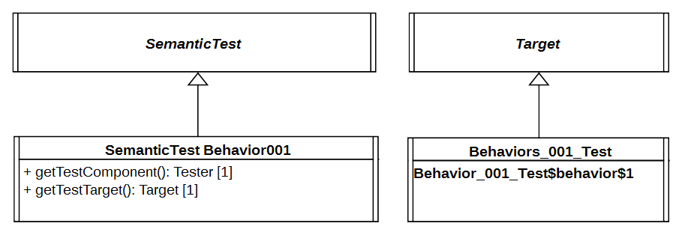
Figure 9.5 - Behavior 001 Test Architecture

Behavior

Overview
Tests presented in this subclause assess that semantics associated with state behaviors (i.e., entry, doActivity and exit) conform to what is specified in UML.

Test Behavior 001
Behavior 001 – ([UML], 14.2.3.4.3)
A State may have an associated entry Behavior. This Behavior, if defined, is executed whenever the State is entered through an external Transition.

Tested state machine
The state machine that plays the role of a classifier behavior for the class Behaviors_001_Test is presented in Figure 9.6. The entry behavior associated with the state S1 of this state machine is intended to be executed when the state is entered. When executed, the behavior will add in the execution trace a message S1(entry). If the message is not part of the trace, then the test is considered to have failed.
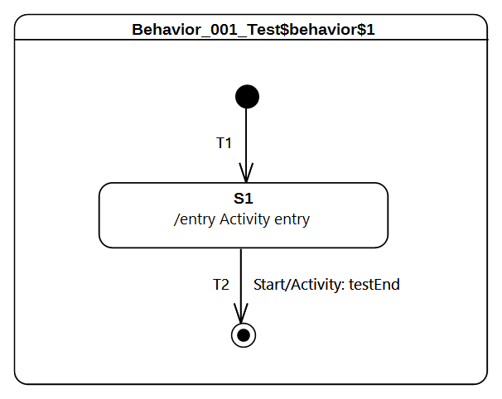Figure 9.6 - Behavior 001 Test Classifier Behavior
The behavior which is associated as an entry to to the state S1 is presented as an activity in Figure 9.7.
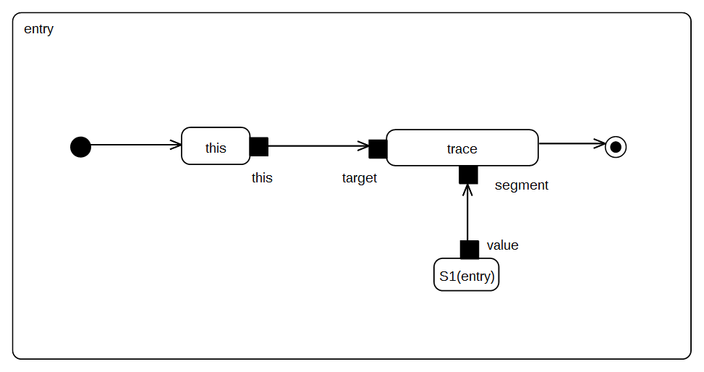Figure 9.7 - S1 entry behavior

Test execution
Received event occurrence(s)
  - Start – received when in configuration S1
Generated trace
- S1(entry)
RTC steps
Step | Event pool | State machine configuration | Fired transition(s)
1 | [] | [] - Initial RTC step | [T1]
2 | [Start, CE(S1)] | [S1] | []
3 | [Start] | [S1] | [T2]

Test Behavior 002
Behavior002 – ([UML], 14.2.3.4.3)
A State may also have an associated exit Behavior, which, if defined, is executed whenever the State is exited.

Tested state machine
The state machine that is executed for this test is presented in Figure 9.8.
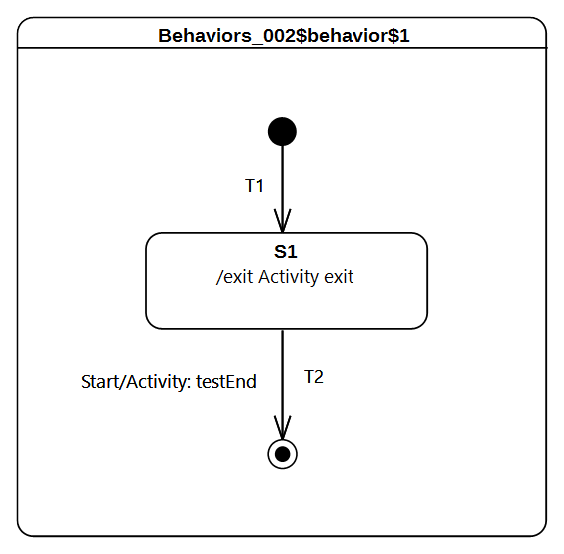
Figure 9.8 - Behavior 002 Test Classifier Behavior

Test execution
Received event occurrence(s)
- Start – received when in configuration S1
Generated trace
- S1(exit)
RTC steps
Step | Event pool | State machine configuration | Fired transition(s)
1 | [] | [] - Initial RTC step | [T1]
2 | [Start, CE(S1)] | [S1] | []
3 | [Start] | [S1] | [T2]

Test Behavior 003 – A
Behavior003 – ([UML], 14.2.3.4.3)
A State may also have an associated doActivity Behavior. This Behavior commences execution when the State is entered (but only after the State entry Behavior has completed) and executes concurrently with any other Behaviors that may be associated with the State, until it completes (in which case a completion event is generated) or the State is exited, in which case execution of the doActivity Behavior is aborted.
In this test the focus is on validating the assertion that if a doActivity is currently executed by a state and the latter is exited, then the doActivity is aborted. The second part of the requirement presented above will be asserted in section 9.3.2.5.

Tested state machine
The state machine that is executed for this test is presented in Figure 9.9.
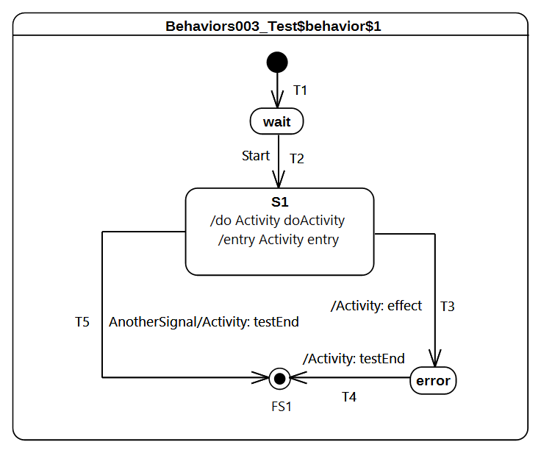
Figure 9.9 - Behavior 003 - A Test Classifier behavior
The doActivity behavior which is executed when the entry of S1 finished is presented in Figure 9.10. When started, this behavior completes the execution trace with the message S1(doActivityPartI) and blocks until the reception of a Continue signal. Only if this signal triggers the continuation of the doActivity will the execution trace be completed with the message S1(doActivityPartII).
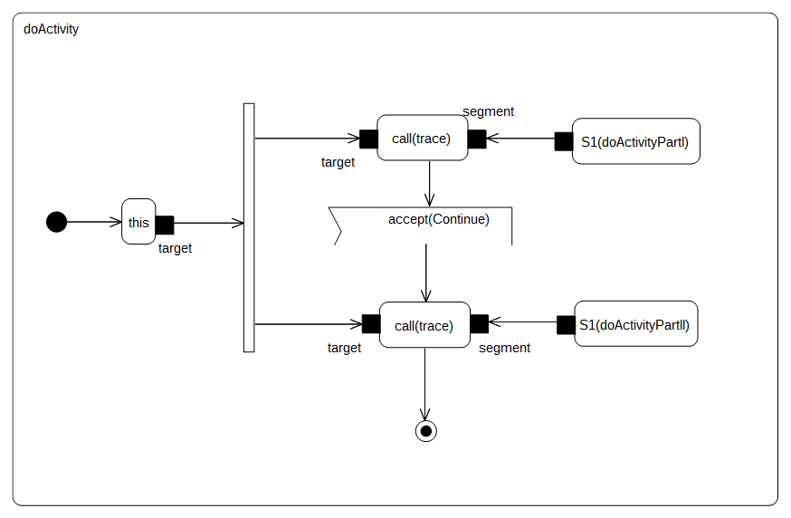
Figure 9.10 - S1 doActivity behavior

Test executions
Received event occurrence(s)
- Start – received when in configuration wait
- AnotherSignal – received when in configuration S1
Generated trace
- S1(entry)::S1(doActivityPartI)
Note. The dispatching of the event AnotherSignal triggered transition T5. The triggering of the latter implies that S1 is exited and hence its running doActivity is aborted. The state machine terminates its execution by reaching the final state.
RTC steps
Step | Event pool | State machine configuration | Fired transition(s)
1 | [] | [] - Initial RTC step | [T1]
2 | [Start, CE(wait)] | [wait] | []
3 | [Start] | [wait] | [T2]
4 | [AnotherSignal] | [S1] | [T5]

Test Behavior 003 – B
Behavior 003 – ([UML], 14.2.3.4.3)
A State may also have an associated doActivity Behavior. This Behavior commences execution when the State is entered (but only after the State entry Behavior has completed) and executes concurrently with any other Behaviors that may be associated with the State, until it completes (in which case a completion event is generated) or the State is exited, in which case execution of the doActivity Behavior is aborted.
This test focuses on validating the assertion that when the doActivity completes then, if the state is in a situation where it is ready to complete, it generates a completion event. For this test the doActivity that is related to S1 is the same as the one presented in Figure 9.10.

Tested state machine
The state machine that is executed for this test is presented in Figure 9.11.

Test execution
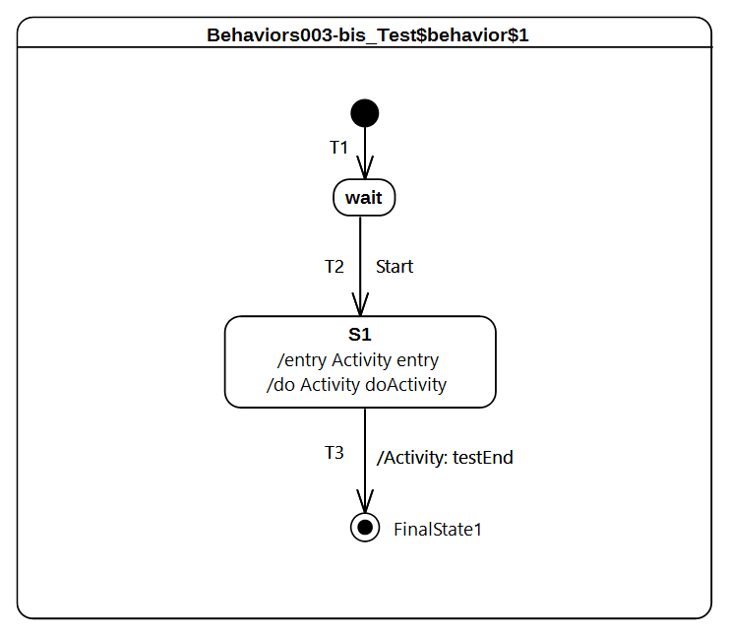
Figure 9.11 - Behavior 003 - B Test Classifier behavior
Received event occurrence(s)
- Start – received when in configuration wait
- Continue – received when in configuration S1
Generated trace
- S1(entry)::S1(doActivityPartI)::S1(doActivityPartII)
Note. In this test case the only way for the state machine to terminate its execution is to traverse the completion transition T3 using the completion event generated by S1. The completion event has to be generated so that the doActivity behavior started by S1 completes. In this case, when Continue gets dispatched, it cannot be accepted by the state machine since there is no transition that has a trigger to react to this event. However, it can be accepted by the doActivity behavior which is currently blocked waiting for a Continue event. The acceptance of this event leads to the doActivity completing, which implies that upon completion state S1 generates a completion event.
RTC steps
Step | Event pool | State machine configuration | Fired transition(s)
1 | [] | [] - Initial RTC step | [T1]
2 | [Start, CE(wait)] | [wait] | []
3 | [Start] | [wait] | [T2]
4 | [Continue] | [S1] | [] - RTC step in the doActivity
5 | [CE(S1)] | [S1] | [T3]

Test Behavior 004
Behavior 004 – (UML 2.5 section 14.2.3.4.3)
The execution of a doActivity Behavior of a State is not affected by the firing of an internal Transition of that State.

Tested state machine
The state machine that is executed for this test is presented in Figure 9.12. It is important to note that if an event does not appear on the diagram, a self internal transition T3 exists for S1. This transition can be triggered on an AnotherSignal event and has an effect behavior. For this test the doActivity that is related to S1 is the same as the one presented in Figure 9.10.
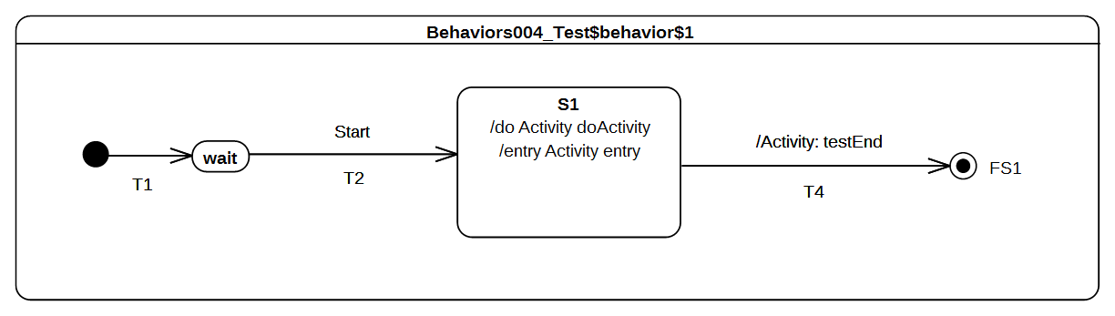
Figure 9.12 - Behavior 004 Test Classifier Behavior

Test execution
Received event occurrence(s)
- Start – received when in configuration wait
- AnotherSignal – received when in configuration S1
- Continue – received when in configuration S1
Generated trace
- S1(entry)::S1(doActivityPartI)::T3(effect)::S1(doActivityPartII)
Note. When in configuration S1, T3 is triggered by the dispatching of AnotherSignal. This triggering has no impact on the doActivity behavior that is currently running. Indeed the behavior is still blocked waiting for the Continue event occurrence. When this event is received, the doActivity consumes it and completes its execution.
RTC steps
Step | Event pool | State machine configuration | Fired transition(s)
1 | [] | [] - Initial RTC step | [T1]
2 | [Start, CE(wait)] | [wait] | []
3 | [Start] | [wait] | [T2]
4 | [Continue, AnotherSignal] | [S1] | [T3]
5 | [Continue] | [S1] | [] - RTC step in the doActivity
6 | [CE(S1)] | [S1] | [T4]

Transition

Transition 001
Transition 001 ([UML], 14.2.3.8)
It may have an associated effect Behavior, which is executed when the Transition is traversed.

Tested state machine
The state machine that is executed for that test is presented in Figure 9.13.
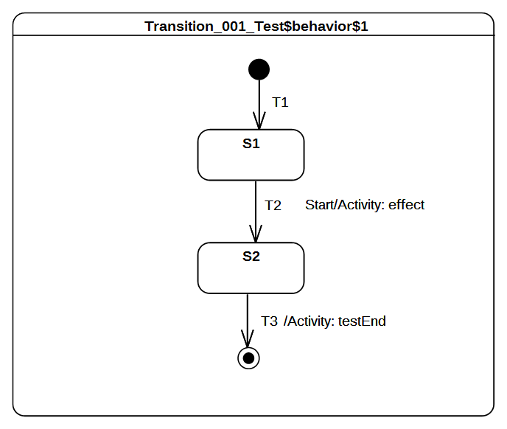Figure 9.13 - Transition 001 Test Classifier Behavior

Test executions
Received event occurrence(s)
- Start – received when in configuration S1.
Generated trace
- T2(effect)
Note. When Start is dispatched it triggers T2 whose execution includes the message T2(effect) to the execution trace.
RTC steps
Step | Event pool | State machine configuration | Fired transition(s)
1 | [] | [] - Initial RTC step | [T1]
2 | [Start, CE(S1)] | [S1] | []
3 | [Start] | [S1] | [T2]
4 | [CE(S2)] | [S2] | [T3]

Transition 007
Transition 007 ([UML], 14.2.3.8)
A Transition may own a set of Triggers, each of which specifies an Event whose occurrence, when dispatched, may trigger traversal of the Transition.

Tested state machine
The state machine that is executed for that test is presented in Figure 9.14.
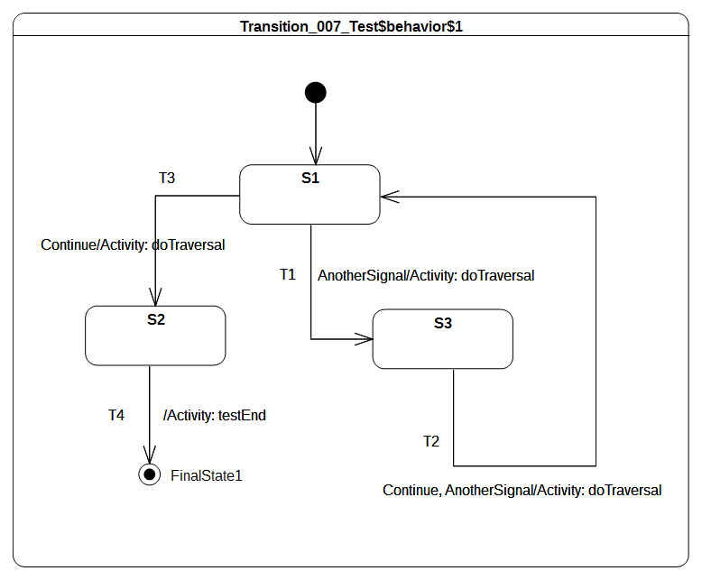Figure 9.14 - Transition 007 Test Classifier Behavior

Test executions
Received event occurrence(s)
- AnotherSignal – received when in configuration S1.
- Continue – received when in configuration S3.
- Continue – received when in configuration S1.
Generated trace
- T1(effect)::T2(effect)::T3(effect)
Note. When AnotherSignal is dispatched, transition T1 is triggered. This is due to the fact that T1 declares a trigger for the signal AnotherSignal. The state machine moves then into configuration S3. There is no difference in situations where there are multiple triggers declared for a transition (see T2 in Figure 9.26). If the dispatched event occurrence matches at least one of them, the transition is traversed. Continue triggers T2.
RTC steps
Step | Event pool | State machine configuration | Fired transition(s)
1 | [] | [] - Initial RTC step | [InitialTransition]
2 | [AnotherSignal, CE(S1)] | [S1] | []
3 | [AnotherSignal] | [S1] | [T1]
4 | [Continue, CE(S3)] | [S3] | []
5 | [Continue] | [S3] | [T2]
6 | [Continue, CE(S1)] | [S1] | []
7 | [Continue] | [S1] | [T3]
8 | [CE(S2)] | [S2] | [T4]

Transition 010
Transition 010 ([UML], 14.2.3.8.1)
kind = internal is a special case of a local Transition that is a self-transition (i.e., with the same source and target States), such that the State is never exited (and, thus, not re-entered), which means that no exit or entry Behaviors are executed when this Transition is executed.

Tested state machine
The state machine that is executed for that test is presented in Figure 9.15. Although it does not appear explicitly in the diagram, it is important to note that it exists as an internal self transition IT for S1. This transition can be triggered when an occurrence of AnotherSignal is dispatched.

Test executions
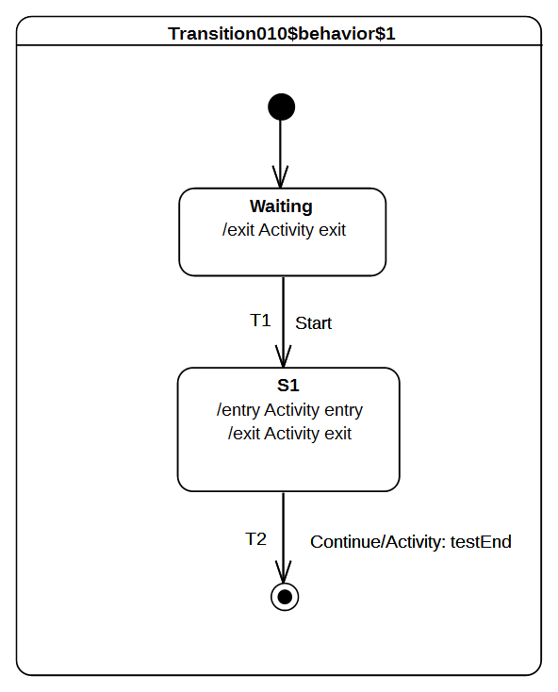Figure 9.15 - Transition 010 Test Classifier Behavior
Received event occurrence(s)
- Start - received when in configuration waiting.
- AnotherSignal – received when in configuration S1.
- AnotherSignal – received when in configuration S1.
- Continue – received when in configuration S1.
Generated trace
- waiting(exit)::S1(entry)::IT(effect)::IT(effect)::S1(exit)
Note. The trace demonstrates here that S1 is not exited and re-entered when transition IT is traversed. In the trace, one can observe that IT(effect) appears twice. This illustrates the fact that this transition is triggered for each dispatching of an occurrence of AnotherSignal. The dispatching of the Continue event occurrence implies that T2 is traversed and the state machine execution completes by reaching the final state.
RTC steps
Step | Event pool | State machine configuration | Fired transition(s)
1 | [] | [] - Initial RTC step | [InitialTransition]
2 | [Start, CE(waiting)] | [waiting] | []
3 | [Start] | [waiting] | [T1]
4 | [AnotherSignal, AnotherSignal, CE(S1)] | [S1] | []
5 | [AnotherSignal, AnotherSignal] | [S1] | [IT]
6 | [Continue, AnotherSignal] | [S1] | [IT]
7 | [Continue] | [S1] | [T2]

Transition 011 – A
Transition 011 ([UML], 14.2.3.8.1)
kind = local is the opposite of external, meaning that the Transition does not exit its containing State (and, hence, the exit Behavior of the containing State will not be executed)

Tested state machine
The state machine that is executed for that test is presented in Figure 9.16.
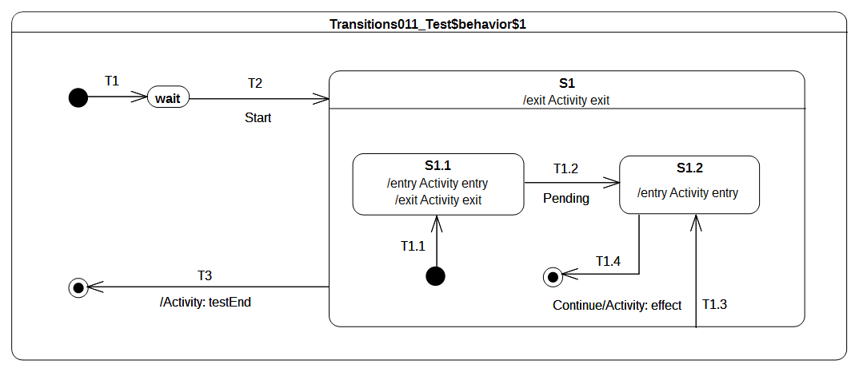Figure 9.16 - Transition 011- A Test Classifier Behavior

Test executions
Received event occurrence(s)
- Start – received when in configuration wait.
- Continue – received when in configuration S1[S1.1].
Generated trace
- S1.1(entry)::S1.1(exit)::T1.3(effect)::S1.2(entry)
Note. When T1.3 is triggered by the event occurrence Continue, the state machine is in the configuration S1[S1.1]. The traversal of T1.3 implies that S1.1 is exited, the effect behavior is executed and, finally, S1.2 is entered. Upon completion of the entry behavior a completion event is generated for S1.2. The latter is used to trigger T1.4 in the next RTC step.
RTC steps
Step | Event pool | State machine configuration | Fired transition(s)
1 | [] | [] - Initial RTC step | [T1]
2 | [Start, CE(wait)] | [wait] | []
3 | [Start] | [wait] | [T2(T1.1)]
4 | [Continue, CE(S1.1)] | [S1[S1.1]] | []
5 | [Continue] | [S1[S1.1]] | [T1.3]
6 | [CE(S1.2)] | [S1[S1.2]] | [T1.4]
7 | [CE(S1)] | [S1] | [T3]

Transition 011 – B
Transition 011 ([UML], 14.2.3.8.1)
kind = local is the opposite of external, meaning that the Transition does not exit its containing State (and, hence, the exit Behavior of the containing State will not be executed)

Tested state machine
The state machine that is executed for that test is presented in Figure 9.17.
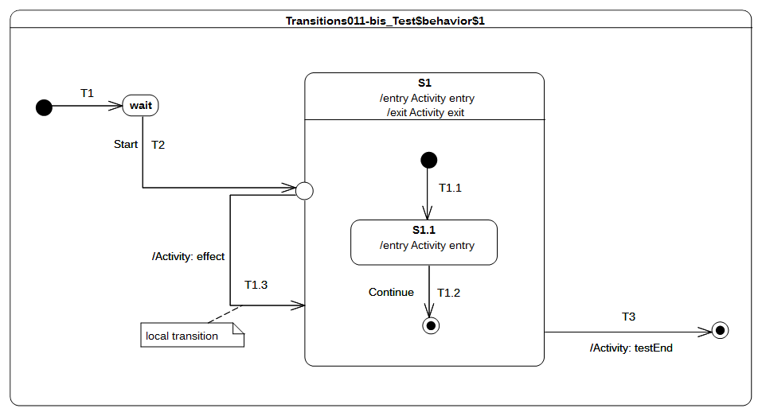
Figure 9.17 - Transition 011 - B Test Classifier behavior

Test executions
Received event occurrence(s)
- Start – received when in configuration wait.
- Continue – received when in configuration S1.
Generated trace
- S1(entry)::S1.1(entry)::T1.3(effect)
Note. When the entry point is reached, S1 is entered and its unique region is entered. The execution of the region starts from the initial pseudostate. Next, the continuation transition T1.1 is traversed, and, finally, S1.1 is entered. At this point, the RTC step initiated by the dispatching of the Start event occurrence is not finished. Indeed, the continuation transition T1.3 outgoing from the entry point is traversed. Since S1 is already active it is not re-entered. This marks the end of the current RTC step. When the Continue event occurrence is dispatched, it triggers T1.2 which leads to the region completion and hence to the completion of S1. The completion event for S1 is used to trigger T3, which leads to the completion of the state machine execution.
RTC steps
Step | Event pool | State machine configuration | Fired transition(s)
1 | [] | [] - Initial RTC step | [T1]
2 | [Start, CE(wait)] | [wait] | []
3 | [Start] | [wait] | [T2(T1.1, T1.3)]
4 | [Continue, CE(S1.1)] | [S1[S1.1]] | []
5 | [Continue] | [S1[S1.1]] | [T1.2]
6 | [CE(S1)] | [S1] | [T3]

Transition 011 – C
Transition 001
kind = external means that the Transition exits its source Vertex. If the Vertex is a State, then executing this Transition will result in the execution of any associated exit Behavior of that State.

Tested state machine
The state machine that is executed for that test is presented in Figure 9.18.
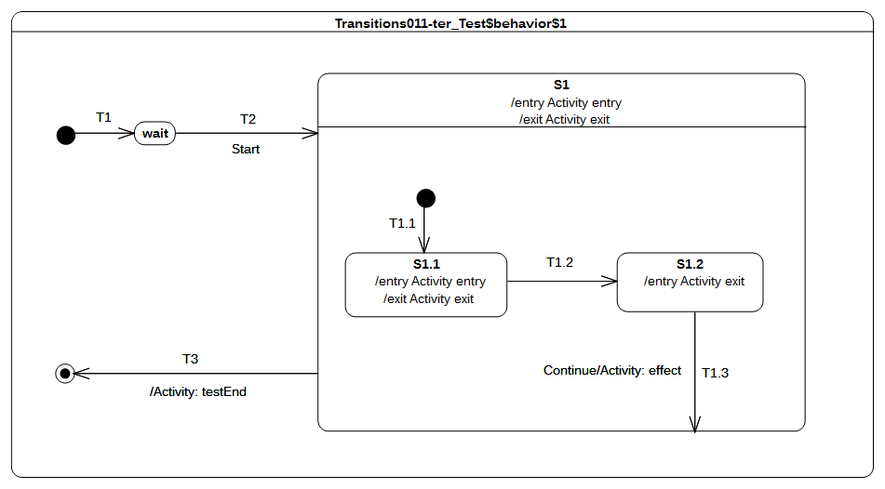
Figure 9.18 - Transition 011 - C Test Classifier Behavior

Test executions
Received event occurrence(s)
- Start – received when in configuration wait.
- Continue – received when in configuration S1[S1.2].
Generated trace
- S1(entry)::S1.1(entry)::S1.1(exit)::S1.2(exit)::T1.3(effect)::S1(exit)
Note. When T1.3 is triggered (by the dispatching of Continue), S1.2 is exited and the effect behavior is executed. However, S1 is not re-entered (it is already active) but the region which contains the last exited state is completed. The completion of the region implies the generation of a completion event for S1. This completion event is used to trigger T3.
RTC steps
Step | Event pool | State machine configuration | Fired transition(s)
1 | [] | [] - Initial RTC step | [T1]
2 | [Start, CE(wait)] | [wait] | []
3 | [Start] | [wait] | [T2(T1.1)]
4 | [CE(S1.1)] | [S1[S1.1]] | [T1.2]
5 | [Continue, CE(S1.2)] | [S1[S1.2]] | []
6 | [Continue] | [S1[S1.2]] | [T1.3]
7 | [CE(S1)] | [S1] | [T3]

Transition 011 – D
Transition 011 ([UML], 14.2.3.8.1)
kind = local is the opposite of external, meaning that the Transition does not exit its containing State (and, hence, the exit Behavior of the containing State will not be executed)

Tested state machine
The state machine that is executed for that test is presented in Figure 9.19.
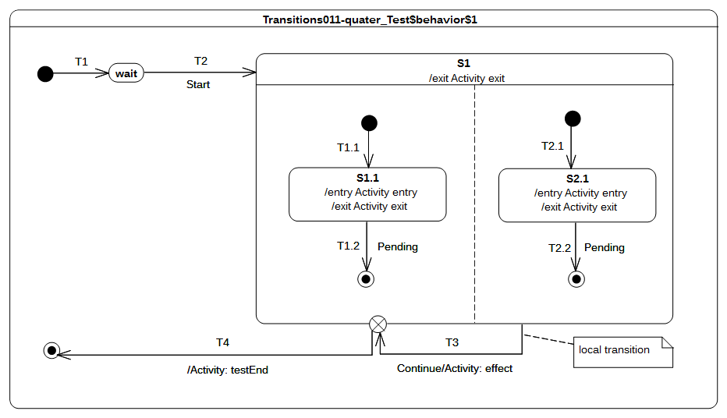
Figure 9.19 - Transition 011- D Test Classifier Behavior

Test executions
Received event occurrence(s)
- Start – received when in configuration wait.
- Continue – received when in configuration S1[S1.1, S2.1].
Generated trace
- S1.1(entry)::S2.1(entry)::T3(effect)::S1.1(exit)::S2.1(exit)::S1(exit)
Notes
- S1 has orthogonal regions; therefore, it is important to notice that the trace presented above is one possible execution path. Alternative execution paths are also possible.
- When the state machine configuration is S1[S1.1, S2.1], the event occurrence Continue is dispatched. This leads to the triggering of the local transition T3. The source state is not exited, the effect behavior is executed and, finally, the exit point is reached. Hence S1.1 and S2.1 are exited immediately, followed by S1. The continuation transition fires and leads to the completion of the state machine execution.
RTC steps
Step | Event pool | State machine configuration | Fired transition(s)
1 | [] | [] - Initial RTC step | [T1]
2 | [Start, CE(wait)] | [wait] | []
3 | [Start] | [wait] | [T2(T1.1, T2.1)]
4 | [Continue, CE(S2.1), CE(1.1)] | [S1[S1.1, S2.1]] | []
5 | [Continue, CE(S2.1)] | [S1[S1.1, S2.1]] | []
6 | [Continue] | [S1[S1.1, S2.1]] | [T3(T4)]

Transition 011 – E
Transition 001 ([UML], 14.2.3.8.1)
kind = local is the opposite of external, meaning that the Transition does not exit its containing State (and, hence, the exit Behavior of the containing State will not be executed)

Tested state machine
The state machine that is executed for that test is presented in Figure 9.20.
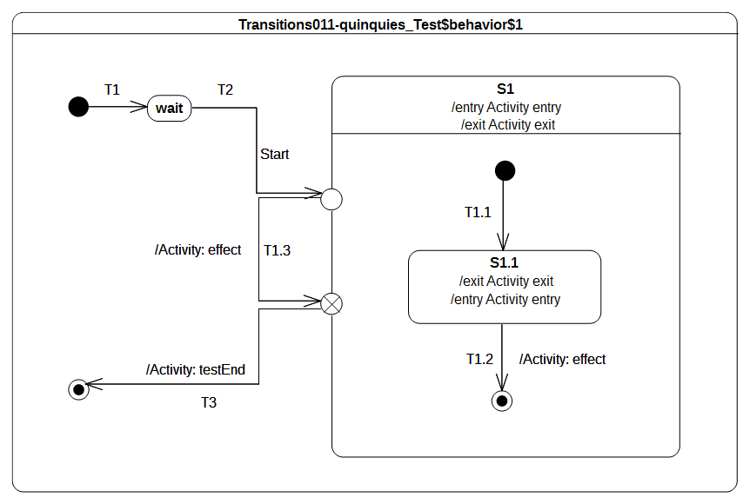
Figure 9.20 - Transition 011 - E Test Classifier Behavior

Test executions
Received event occurrence(s)
- Start – received when in configuration wait.
Generated trace
- S1(entry)::S1.1(entry)::T1.3(effect)::S1.1(exit)::S1(exit)
Note. When the entry point is reached, S1 is entered and the region is entered using the default approach (i.e., an initial transition is sought to start the execution). Hence S1.1 is entered via the transition T1.1. The RTC initiated by the dispatching of Start event occurrence is not ended. The continuation transition T1.3 is traversed and its effect behavior is executed. At the point where the exit point is reached, S1.1 is exited as well as S1. The continuation transition T3 is traversed and leads to the completion of the state machine execution. Transition T1.2 is never traversed in this test case and, consequently, the S1 region never completes.
RTC steps
Step | Event pool | State machine configuration | Fired transition(s)
1 | [] | [] - Initial RTC step | [T1]
2 | [Start, CE(wait)] | [wait] | []
3 | [Start] | [wait] | [T2(T1.1, T1.3, T3)]

Transition 015
Transition 015 ([UML], 14.2.3.8.3)
In case of simple States, a completion event is generated when the associated entry and doActivity Behaviors have completed executing

Tested state machine
The state machine that is executed for that test is presented in Figure 9.21. The doActivity which related to S1 state is exactly the same as the one presented in Figure 9.10.

Test executions
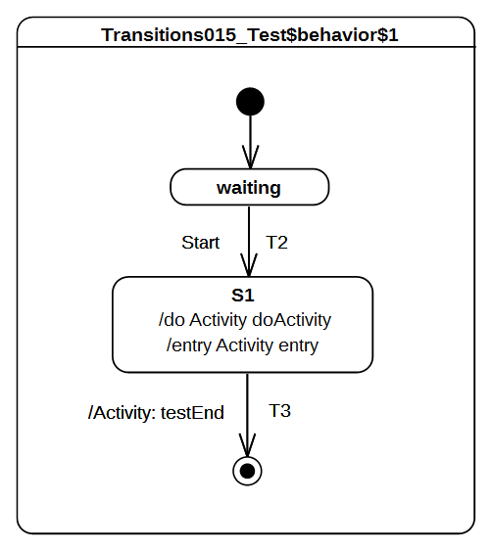Figure 9.21 - Transition 015 Test Classifier Behavior
Received event occurrence(s)
- Start – received when in configuration waiting.
Generated trace
- S1(entry)::S1(doActivity)
Note. When S1 is entered (RTC step started by disptaching Start), its entry behavior is executed. As soon as the entry terminates its execution, the doActivity is started asynchronously. When this doActivity behavior completes its execution, a completion event is generated by S1 (its entry and doActivity are now terminated). This completion event is used to trigger T3.
RTC steps
Step | Event pool | State machine configuration | Fired transition(s)
1 | [] | [] - Initial RTC step | [InitialTransiton]
2 | [Start, CE(waiting)] | [waiting] | []
3 | [Start] | [waiting] | [T2]
4 | [CE(S1)] | [S1] | [T3]

Transition 016
Transition 016 ([UML], 14.2.3.8.3)
If no such Behaviors are defined, the completion event is generated upon entry into the State

Tested state machine
The state machine that is executed for that test is presented in Figure 9.22.
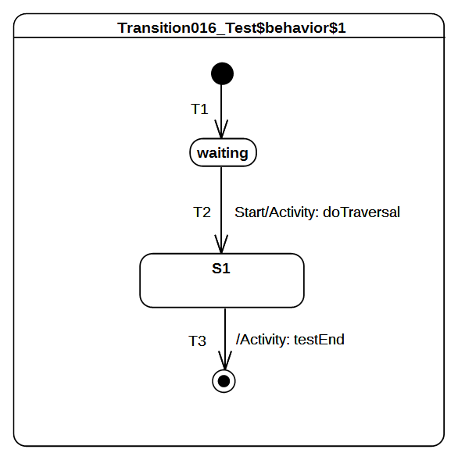Figure 9.22 - Transition 016 Test Classifier Behavior

Test executions
Received event occurrence(s)
- Start – received when in configuration waiting.
Generated trace
- T2(effect)
Note. When Start is dispatched T2 is triggered. Hence, the effect behavior of T2 is executed and S1 is entered. In this test case S1 has no entry or doActivity, so the completion event is generated when it is entered.
RTC steps
Step | Event pool | State machine configuration | Fired transition(s)
1 | [] | [] - Initial RTC step | [InitialTransiton]
2 | [Start, CE(waiting)] | [waiting] | []
3 | [Start] | [waiting] | [T2]
4 | [CE(S1.1)] | [S1] | [T3]

Transition 017
Transition 017 ([UML], 14.2.3.8.3)
For composite States, a completion event is generated under the following circumstances: All internal activities (e.g., entry and doActivity Behaviors) have completed execution, and all its orthogonal Regions have reached a FinalState

Tested state machine
The state machine that is executed for that test is presented in Figure 9.23.

Test executions
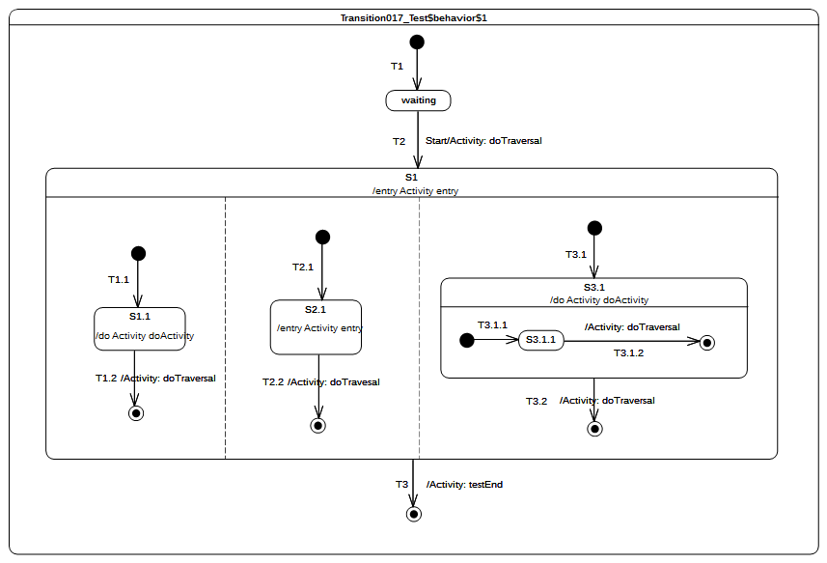Figure 9.23 - Transition 017 Test Classifier Behavior
Received event occurrence(s)
- Start – received when in configuration waiting.
Generated trace
- T2(effect)::S1(entry)::S2.1(entry)::T2.2(effect)::T3.1.2(effect)::S1.1(doActivity)::T1.2(effect)::S3.1(doActivity):: T3.2(effect)
Notes
- S1 has orthogonal regions, hence the execution trace that is presented above is one possible trace. Alternative execution traces are also possible.
- The test case presented in Figure 9.23 relies on completion event semantics. When Start is dispatched, T2 fires and implies the entrance of S1. Each region of S1 is entered concurrently using the default entry approach. Assuming that completion events for states S1.1, S2.1 and S3.1.1 are generated in this order: CE(S2.1), CE(S3.1.1) CE(S1.1), the following execution steps will occur in the following order:
- T2.2 is triggered which leads to the completion of the second region of S1. No completion event is generated.
- T3.1.2 is triggered which leads to the completion of the region owned by S3.1. A completion event is generated for this state.
- T1.2 is triggered which leads to the completion of the first region of S1. No completion event is generated
- T3.2 is triggered which leads to the completion of the last active region of S1. A completion event is generated for S1.
- T3 is triggered by the completion event generated by S1.
RTC steps
Step | Event pool | State machine configuration | Fired transition(s)
1 | [] | [] - Initial RTC step | [T1]
2 | [Start, CE(waiting)] | [waiting] | []
3 | [Start] | [waiting] | [T2(T1.1, T2.1, T3.1(T3.1.1))]
4 | [CE(S1.1), CE(S3.1.1), CE(S2.1)] | [S1[S1.1, S2.1, S3.1[S3.1.1]]] | [T2.2]
5 | [CE(S1.1), CE(S3.1.1)] | [S1[S1.1, S3.1[S3.1.1]]] | [T3.1.2]
6 | [CE(3.1), CE(S1.1)] | [S1[S3.1[S3.1.1]]] | [T1.2]
7 | [CE(3.1)] | [S1[S3.1]] | [T3.2]
8 | [CE(S1.1)] | [S1] | [T3]

Transition 019
Transition 019 ([UML], 14.2.3.8.3)
If two or more completion events corresponding to multiple orthogonal Regions occur simultaneously (i.e., as a result of the same Event occurrence), the order in which such completion occurrences are processed is not defined (p.329)

Tested state machine
The state machine that is executed for that test is presented in Figure 9.24.

Test executions
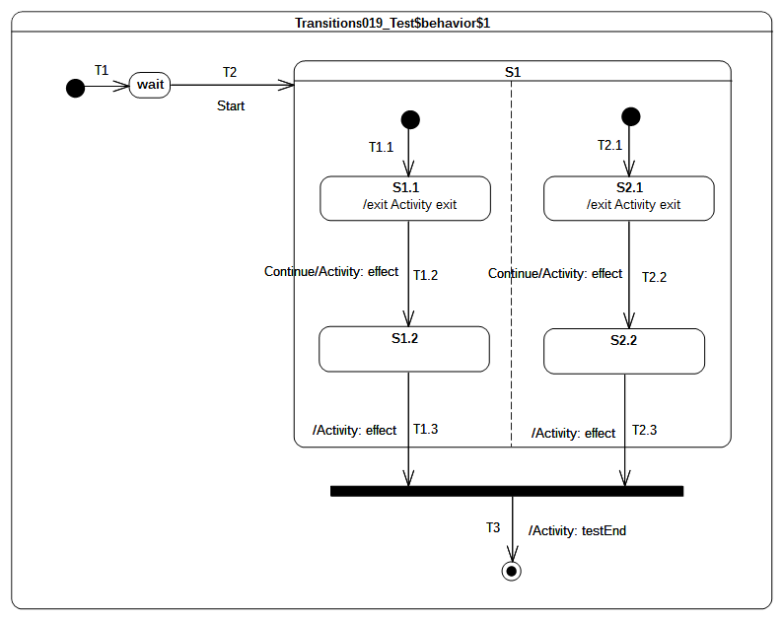Figure 9.24 - Transition 019 Test Classifier Behavior
Received event occurrence(s)
- Start – received when in configuration wait.
- Continue – received when in configuration S1[S1.1, S2.1].
Generated trace
- S1.1(exit)::T1.2(effect)::S2.1(exit)::T2.2(effect)::T1.3(effect)::T2.3(effect)
Notes
- The execution trace that is presented above is one possibility. Other valid execution traces are also possible for this test case.
- At the end of the RTC step initiated by the dispatching of the Start event occurrence, the state machine is in the following configuration: S1[S1.1, S2.1]. Dispatching of the Continue event occurrence implies a simultaneous triggering of both T1.2 and T2.2. Hence, due to the same event occurrence, two completion are generated by S1.2 and S2.2 respectively. The order in which these completion events will be dispatched is the order in which they were placed in the event pool. Assuming that CE(S1.2) is first, then T1.3 will be fired first. CE(2.1) will be triggered next and the join node prerequisite will be satisfied.
RTC steps
Step | Event pool | State machine configuration | Fired transition(s)
1 | [] | [] - Initial RTC step | [T1]
2 | [Start, CE(wait)] | [wait] | []
3 | [Start] | [wait] | [T2(T1.1, T2.1)]
4 | [Continue, CE(S1.1), CE(S2.1)] | [S1[S1.1, S2.1]] | []
5 | [Continue, CE(S1.1)] | [S1[S1.1, S2.1]] | []
6 | [Continue] | [S1[S1.1, S2.1]] | [T1.2, T2.2]
7 | [CE(S2.2), CE(S1.2)] | [S1[S1.2, S2.2]] | [T1.3]
8 | [CE(S2.2)] | [S1[S2.2]] | [T1.3(T3)]

Transition 020
Transition 020 ([UML], 14.2.3.8.3)
Completion events have dispatching priority. That is, they are dispatched ahead of any pending Event occurrences in the event pool.

Tested state machine
The state machine that is executed for that test is presented in Figure 9.25.

Test executions
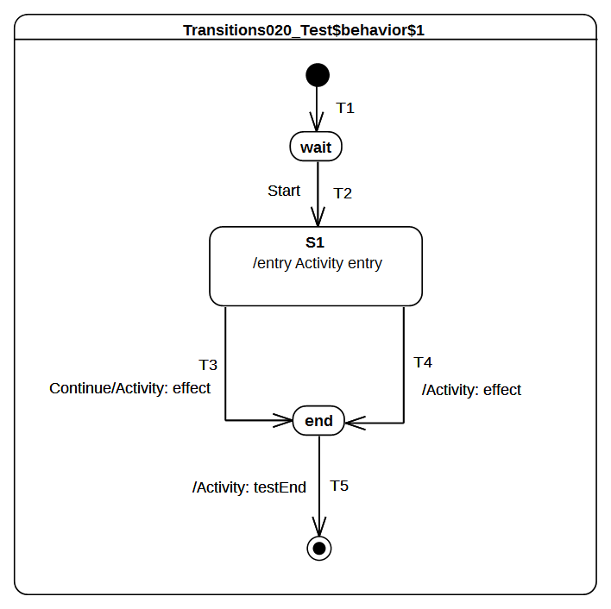Figure 9.25 - Transition 020 Test Classifier Behavior
Received event occurrence(s)
- Start – received when in configuration wait.
- Continue – received when in configuration S1.
Generated trace
- S1(entry)::T4(effect)
Note. When Start is dispatched, transition T2 is triggered. This brings the state machine into configuration S1. The entry of S1 results in the execution of its entry behavior. Upon the termination of the execution of this behavior, S1 is ready to generate a completion event. The latter is placed at the head of the event pool. Consequently, it is iven priority over non-completion event(s) already present in the pool. Therefore, the next RTC step will begin by the dispatching of the completion event generated for S1. This event will trigger transition T4. The Continue event occurrence will never be dispatched.
RTC steps
Step | Event pool | State machine configuration | Fired transition(s)
1 | [] | [] - Initial RTC step | [T1]
2 | [Start, CE(wait)] | [wait] | []
3 | [Start] | [wait] | [T2]
4 | [Continue, CE(S1.1)] | [S1] | [T4]
5 | [Continue, CE(end)] | [end] | [T5]

Transition 022
Transition 022 ([UML], 14.2.3.8)
It may have an associated effect Behavior, which is executed when the Transition is traversed.

Tested state machine
The state machine that is executed for that test is presented in Figure 9.26.
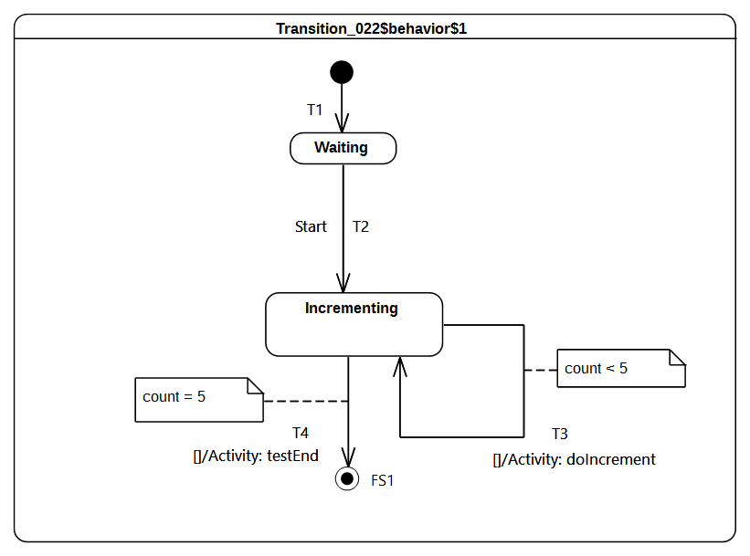Figure 9.26 - Transition 022 Test Classifier Behavior

Test executions
Received event occurrence(s)
- Start – received when in configuration waiting.
Generated trace
- T3(effect)::T3(effect)::T3(effect)::T3(effect)::T3(effect)
Note. the intent of the test is to increment the value of a property of a class that has, as its classifier behavior, the sate-machine presented in Figure 9.26. The value of the property is incremented until it reaches the value 5. The state machine that implements this behavior uses guarded transitions (see T3 and T4). When the event occurrence Start is dispatched, T2 fires and Incrementing is entered. The completion event generated for that state is used to trigger either T4 or T3 based on their guard evaluations.
RTC steps
Step | Event pool | State machine configuration | Fired transition(s)
1 | [] | [] - Initial RTC step | [T1]
2 | [Start, CE(wait)] | [wait] | []
3 | [Start] | [wait] | [T2]
4 | [CE(Incrementing)] | [Incrementing] | [T3]
5 | [CE(Incrementing)] | [Incrementing] | [T3]
6 | CE(Incrementing) | [Incrementing] | [T3]
7 | CE(Incrementing) | [Incrementing] | [T3]
8 | CE(Incrementing) | [Incrementing] | [T3]
9 | CE(Incrementing) | [Incrementing] | [T4]

Event

Overview
Test cases presented in this subclause concern the dispatching and the acceptance of event occurrences in a state machine context.

Event 001
Event 001 ([UML], 14.2.3.9.1)
Upon creation, a StateMachine will perform its initialization during which it executes an initial compound transition prompted by creation, after which it enters a wait point. In case of StateMachine Behaviors, a wait point is represented by a stable state configuration. It remains there until an Event stored in its event pool is dispatched

Tested state machine
The state machine that is executed for that test is presented in Figure 9.27.
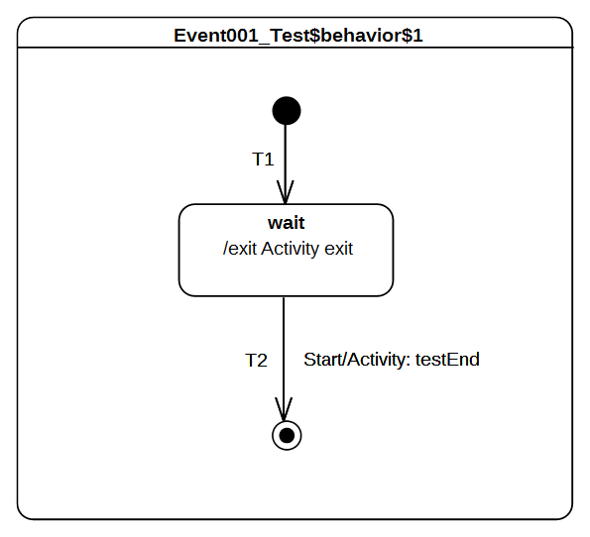Figure 9.27 - Event 001 Test Classifier Behavior

Test executions
Received event occurrence(s)
- Start – received when in configuration wait.
Generated trace
- wait(exit)
Note. The state machine execution starts from the initial pseudo state. The initial RTC step implies that continuation transition T1 is traversed and state wait is entered. At the end of this RTC step the state machine execution enters a wait point. It is only able to leave this configuration when a Start event occurrence is dispatched from the event pool.
RTC steps
Step | Event pool | State machine configuration | Fired transition(s)
1 | [] | [] - Initial RTC step | [T1]
2 | [Start, CE(wait)] | [wait] | []
3 | [Start] | [wait] | [T2]

Event 002
Event 002 ([UML], 14.2.3.9.1)
This Event is evaluated and, if it matches a valid Trigger of the StateMachine and there is at least one enabled Transition that can be triggered by that Event occurrence, a single StateMachine step is executed.

Tested state machine
The state machine that is executed for that test is presented in Figure 9.28.

Test executions
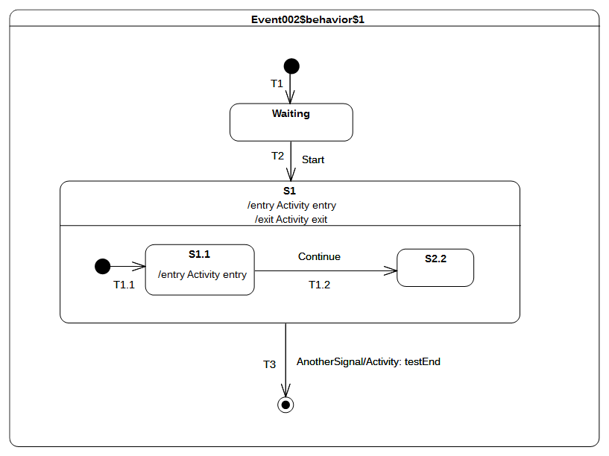Figure 9.28 - Event 002 Test Classifier Behavior
Received event occurrence(s)
- Start – received when in configuration waiting.
- AnottherSignal received when in configuration S1[S1.1].
Generated trace
- S1(entry)::S1.1(entry)::S1(exit)
Note. At the point where AnotherSignal event occurrence is dispatched, the state machine is in configuration S1[S1.1]. This implies that, when T3 is triggered, state S1.1 is exited, followed immediately by S1. The state machine execution completes by reaching the final state. This illustrates the realization of a run-to-completion step initiated by the dispatching of an event occurrence.
RTC steps
Step | Event pool | State machine configuration | Fired transition(s)
1 | [] | [] - Initial RTC step | [T1]
2 | [Start, CE(wait)] | [wait] | []
3 | [Start] | [wait] | [T2(T1.1)]
4 | [AnotherSignal, CE(S1.1)] | [S1[S1.1]] | []
5 | [AnotherSignal] | [S1[S1.1]] | [T3]

Event 008
Event 008 ([UML], 14.2.3.9.1)
When an Event occurrence is detected and dispatched, it may result in one or more Transitions being enabled for firing. If no Transition is enabled and the corresponding Event type is not in any of the deferrableTriggers lists of the active state configuration, the dispatched Event occurrence is discarded and the run-to-completion step is completed.

Tested state machine
The state machine that is executed for that test is presented in Figure 9.29.

Test executions
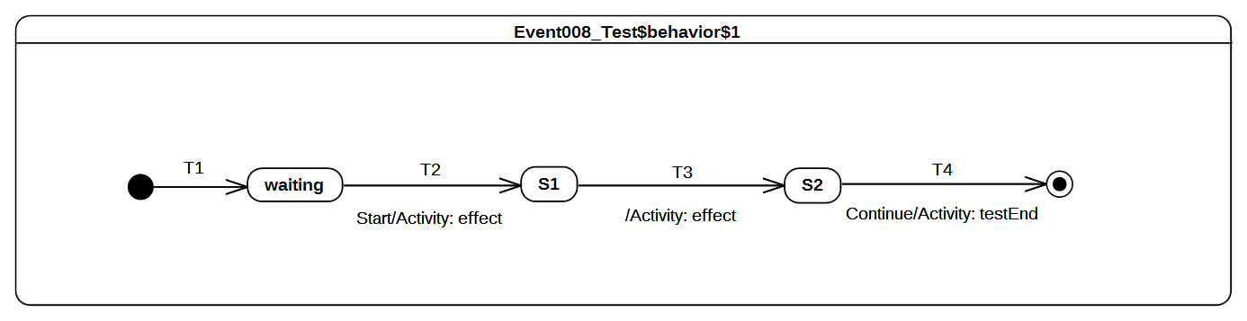Figure 9.29 - Event 008 Test Classifier Behavior
Received event occurrence(s)
- Start – when received in configuration waiting.
- Continue – when received in configuration S2.
Generated trace
- T2(effect)::T3(effect)
Note. When the Start event occurrence is dispatched, the state machine is in configuration waiting. The dispatching of this event implies that T2 is triggered and S1 is entered. Since S1 is a simple state with no entry and doActivity behaviors, a completion event is generated for that state when entered. The dispatching of this completion event triggers T3. Consequently, its effect behavior is executed and S2 is entered. The completion event generated by S2 is dropped. This occurs when there is no possibility to use it for triggering an outgoing transition from that state. The only way to exit S2 is to receive and dispatch a Continue event occurrence.
RTC steps
Step | Event pool | State machine configuration | Fired transition(s)
1 | [] | [] - Initial RTC step | [T1]
2 | [Start, CE(waiting)] | [waiting] | []
3 | [Start] | [waiting] | [T2]
4 | [CE(S1)] | [S1] | [T3]
5 | [Continue, CE(S2)] | [S2] | []
6 | [Continue] | [S2] | [T4]

Event 009
Event 009 ([UML], 14.2.3.9.1)
It is possible that multiple Transitions (in different Regions) can be triggered by the same Event occurrence. The order in which these Transitions are executed is left undefined.

Tested state machine
The state machine that is executed for that test is presented in Figure 9.30.

Test executions
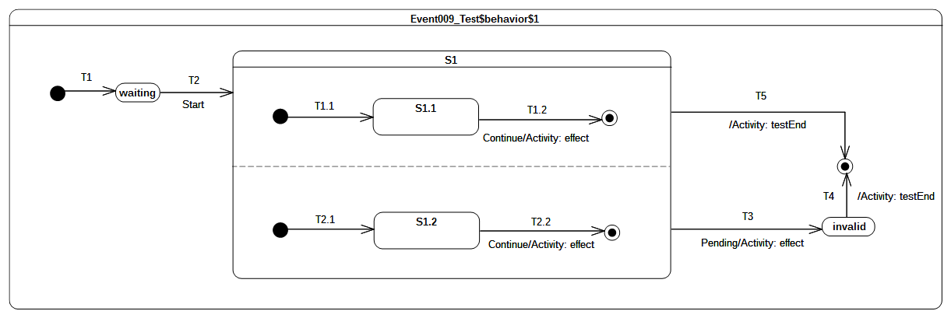Figure 9.30: Event 009 Classifier behavior
Received event occurrence(s)
- Start – received when in configuration waiting.
- Continue – received when in configuration S1[S1.1, S1.2].
- Pending – received when in configuration S1[S1.1, S1.2].
Generated trace
- T1.2(effect)::T2.2(effect)
Notes
- S1 contains orthogonal regions. Hence the trace presented above illustrates one possible execution.
- The Continue event occurrence is dispatched when the state machine execution is in configuration S1[S1.1, S1.2]. The dispatching of this event triggers simultaneously transitions T1.2 and T2.2, which are located in different orthogonal regions. This leads to the completion of the regions of S1 so that a completion event is generated for that state. The latter is used to trigger the completion transition T5. Note that, in the case where Continue just triggered either T1.2 or T2.2, S1 will not have the opportunity to complete. Consequently, T3 can only be triggered by the dispatching of the Pending event occurrence and the expected execution trace would have been invalid.
RTC steps
Step | Event pool | State machine configuration | Fired transition(s)
1 | [] | [] - Initial RTC step | [T1]
2 | [Start, CE(waiting)] | [waiting] | []
3 | [Start] | [waiting] | [T2(T1.1, T2.1)]
4 | [Pending, Continue, CE(S1.2), CE(S1.1)] | [S1[S1.1, S1.2]] | []
5 | [Pending, Continue, CE(S1.2)] | [S1[S1.1, S1.2]] | []
6 | [Pending, Continue] | [S1[S1.1, S1.2]] | [T1.2, T2.2]
7 | [Pending, CE(S1)] | [S1] | [T5]

Event 010
Event 010 ([UML], 14.2.3.9.1)
It is possible for multiple mutually exclusive Transitions in a given Region to be enabled for firing by the same Event occurrence. In those cases, only one is selected and executed.

Tested state machine
The state machine that is executed for that test is presented in Figure 9.31.
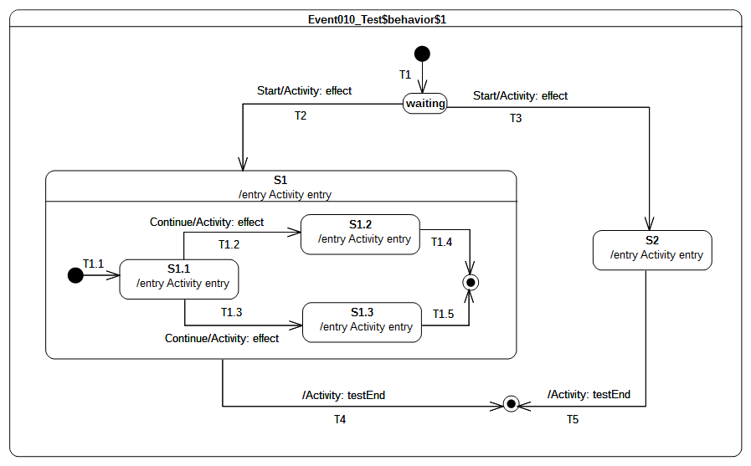Figure 9.31 - Event 010 Test Classifier Behavior

Test executions
Received event occurrence(s)
- Start – received when in configuration waiting.
- Continue – received when in configuration S1[S1.1].
Generated trace
- T1.2(effect)::S1(entry)::S1.1(entry)::T1.2(effect)::S1.2(entry).
Notes
- Note that the execution would have been completely different if a different semantic strategy was used to resolve conflicts.
- This test case highlights the resolving of transition conflicts at run time. The first conflict that is encountered happens when the event occurrence Start is accepted. Many transitions (i.e., T2 and T3) originating from the same state (i.e., waiting) can be triggered using this same event occurrence. Only one of them is chosen using a semantic strategy. Assuming that in this particular case the strategy is to always choose the first one in the list of conflicting transition, T2 will fire. A similar scenario happens when the state machine execution is in configuration S1[S1.1]. The rule is no different when this happens in a nested context. Hence, assuming our chosen semantic strategy, T1.2 will be triggered by the Continue event occurrence.
RTC steps
Step | Event pool | State machine configuration | Fired transition(s)
1 | [] | [] - Initial RTC step | [T1]
2 | [Start, CE(waiting)] | [waiting] | []
3 | [Start] | [waiting] | [T2(T1.1)]
4 | [Continue, CE(S1.1)] | [S1[S1.1]] | []
5 | [Continue] | [S1[S1.1]] | [T1.2]
6 | [CE(S1.2)] | [S1[S1.2]] | [T1.4]
7 | [CE(S1)] | [S1] | [T4]

Event 015
Event 015 ([UML], 14.2.3.9.3)
It is possible for more than one Transition to be enabled within a StateMachine. If that happens, then such Transitions may be in conflict with each other. For example, consider the case of two Transitions originating from the same State, triggered by the same event, but with different guards. If that event occurs and both guard conditions are true, then at most one of those Transition can fire in a given run-to-completion step.

Tested state machine
The state machine that is executed for that test is presented in Figure 9.32.

Test executions
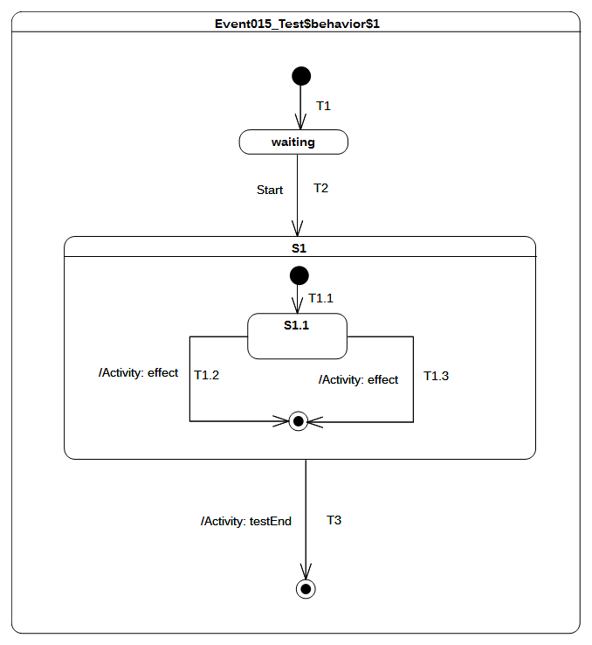Figure 9.32 - Event 015 Test Classifier Behavior
Received event occurrence(s)
- Start – received when in configuration waiting.
Generated trace
- T1.2(effect)
Notes
- Note that the execution could have been different if a different semantic strategy was used to resolve conflicts.
- This test case is similar to the one presented in section 9.3.4.6. Nevertheless it illustrates the situation in which the conflicting situation occurs when a completion event for S1.1 is accepted. The two completion transitions T1.2 and T1.3 can both be triggered using the completion event. Here again, the conflict is resolved using a semantic strategy to determine which of them is actually triggered.
RTC steps
Step | Event pool | State machine configuration | Fired transition(s)
1 | [] | [] - Initial RTC step | [T1]
2 | [Start, CE(waiting)] | [waiting] | []
3 | [Start] | [waiting] | [T2(T1.1)]
4 | [CE(S1.1)] | [S1[S1.1]] | [T1.2]
5 | [CE(S1)] | [S1] | T3

Event 016 – A
Event 016 ([UML], 14.2.3.9.4)
In situations where there are conflicting Transitions, the selection of which Transitions will fire is based in part on an implicit priority. These priorities resolve some but not all Transition conflicts, as they only define a partial ordering. The priorities of conflicting Transitions are based on their relative position in the state hierarchy. By definition, a Transition originating from a substate has higher priority than a conflicting Transition originating from any of its containing States. The priority of a Transition is defined based on its source State.

Tested state machine
The state machine that is executed for that test is presented in Figure 9.33.
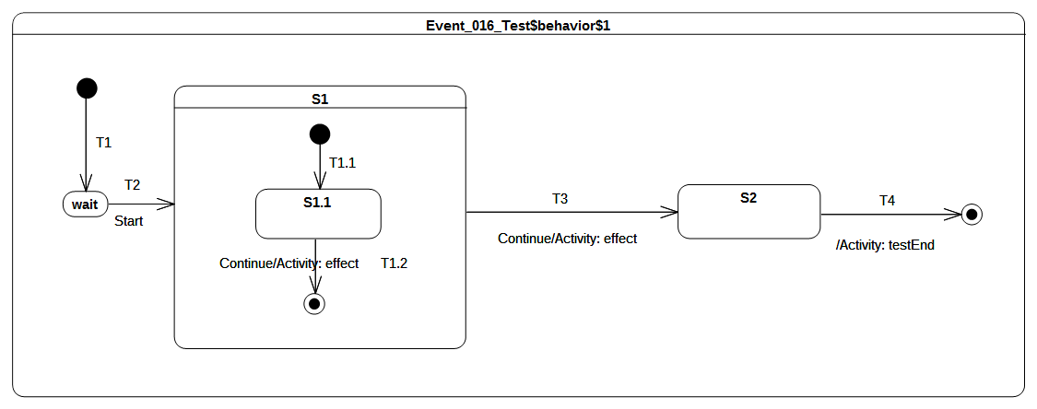Figure 9.33 - Event 016 Test Classifier Behavior

Test executions
Received event occurrence(s)
- Start – received when in configuration wait.
- Continue – received when in configuration S1[S1.1].
- Continue – received when in configuration S1.
Generated trace
- T1.2(effect)::T3(effect)
Note. This test case covers the issue of transition trigger priorities. When the RTC step initiated by accepting the Continue event occurrence starts, the state machine is in configuration S1[S1.1]. At this point, two transitions can be triggered by the same event occurrence. The resolution of this potential conflict is realized by analyzing transition priorities. Since S1.1 is the innermost state in the configuration, transitions originating from this state will have the highest priority. Hence T1.2 is triggered.
RTC steps
Step | Event pool | State machine configuration | Fired transition(s)
1 | [] | [] - Initial RTC step | [T1]
2 | [Start, CE(wait)] | [wait] | []
3 | [Start] | [wait] | [T2(T1.1)]
4 | [Continue, CE(S1.1)] | [S1[S1.1]] | []
5 | [Continue] | [S1[S1.1]] | [T1.2]
6 | [Continue, CE(S1)] | [S1] | []
7 | [Continue] | [S1] | [T3]
8 | [CE(S2)] | [S2] | [T4]

Event 016 – B
Event 016 ([UML], 14.2.3.9.4)
In situations where there are conflicting Transitions, the selection of which Transitions will fire is based in part on an implicit priority. These priorities resolve some but not all Transition conflicts, as they only define a partial ordering. The priorities of conflicting Transitions are based on their relative position in the state hierarchy. By definition, a Transition originating from a substate has higher priority than a conflicting Transition originating from any of its containing States. The priority of a Transition is defined based on its source State.

Tested state machine
The state machine that is executed for that test is presented in Figure 9.34.
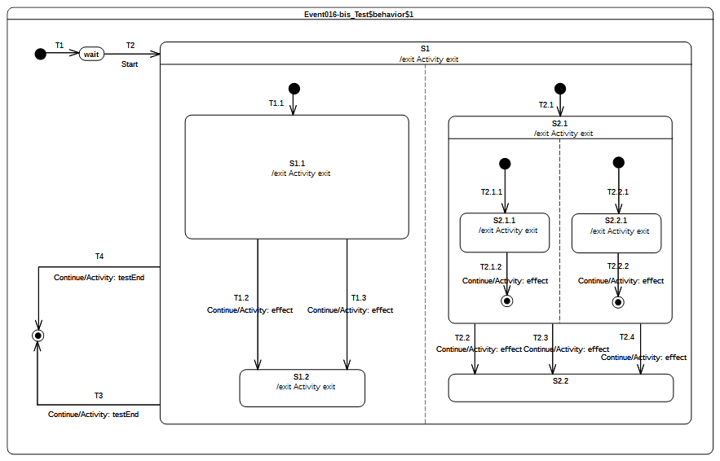Figure 9.34 - Event 016 – B Test Classifier behavior

Test executions
Received event occurrence(s)
- Start – received when in configuration wait.
- Continue – received when in configuration S1[S1.1, S2.1[S2.1.1, S2.2.1]].
- Continue – received when in configuration S1[S1.1, S2.1].
- Continue – received when in configuration S1[S1.2, S2.2].
Generated trace
- S2.1.1(exit)::T2.1.2(effect)::S2.2.1(exit)::T2.2.2(effect)::S1.1(exit)::T1.2(effect)::S2.1(exit)::T2.2(effect)::S1.2(exit)::S1(exit)
Note. The purpose of this test is to combine conflicting transitions and orthogonal regions to assess that joint usage of both parts of the state machine semantics still conforms to what is specified in UML. In this test case, the execution proceeds as follows. The RTC step initiated by the acceptance of the Start event occurrence, brings the state machine to the configuration S1[S1.1, S2.1[S2.1.1, S2.2.1]]]. Completions events generated during this RTC step (respectively for states S1.1, S2.1.1 and S2.2.1) do not trigger any transition when dispatched. The next RTC step that actually leads to transition triggering is the one initiated by the acceptance of the Continue event occurrence. During this step, the execution model shows that both T2.1.2 and T2.2.2 are fired using the same event occurrence. This is not sufficient in the context of this step. Indeed T1.2 or T1.3 should also have been fired.
RTC steps
Step | Event pool | State machine configuration | Fired transition(s)
1 | [] | [] - Initial RTC step | [T1]
2 | [Start, CE(wait)] | [wait] | []
3 | [Start] | [wait] | [T2(T1.1, T2.1(T2.1.1, T2.2.1))]
4 | [Continue, CE(2.2.1), CE(S2.1.1), CE(S1.1)] | [S1[S1.1, S2.1[S2.1.1, S2.2.1]]] | []
5 | [Continue, CE(2.2.1), CE(S2.1.1)] | [S1[S1.1, S2.1[S2.1.1, S2.2.1]]] | []
6 | [Continue, CE(2.2.1)] | [S1[S1.1, S2.1[S2.1.1, S2.2.1]]] | []
7 | [Continue] | [S1[S1.1, S2.1[S2.1.1, S2.2.1]]] | [T2.1.2, T2.2.2]
8 | [Continue, CE(S2.1)] | [S1[S1.1, S2.1]] | []
9 | [Continue] | [S1[S1.1, S2.1]] | [T1.2, T2.2]
10 | [Continue, CE(S2.2), CE(S1.2)] | [S1[S1.2, S2.2]] | []
11 | [Continue, CE(S2.2)] | [S1[S1.2, S2.2]] | []
12 | [Continue] | [S1[S1.2, S2.2]] | [T3]
Submission Note. While the trace that is produced is correct, the content of each step is not correct (see RTC step 7). This error indicates that in its current version the execution model does not fire (using the same event occurrence) transitions located in different regions if these regions are located at different level of nesting. The triggered transitions will be those with the highest priority. This limitation will be fixed in further refinement of the execution model. For the moment, this test case must be considered as being failed. The table above details the execution that is currently realized by the execution model. The table below proposes the correct execution that should be realized.
Step | Event pool | State machine configuration | Fired transition(s)
1 | [] | [] - Initial RTC step | [T1]
2 | [Start, CE(wait)] | [wait] | []
3 | [Start] | [wait] | [T2(T1.1, T2.1(T2.1.1, T2.2.1))]
4 | [Continue, CE(2.2.1), CE(S2.1.1), CE(S1.1)] | [S1[S1.1, S2.1[S2.1.1, S2.2.1]]] | []
5 | [Continue, CE(2.2.1), CE(S2.1.1)] | [S1[S1.1, S2.1[S2.1.1, S2.2.1]]] | []
6 | [Continue, CE(2.2.1)] | [S1[S1.1, S2.1[S2.1.1, S2.2.1]]] | []
7 | [Continue] | [S1[S1.1, S2.1[S2.1.1, S2.2.1]]] | [T1.2, T2.1.2, T2.2.2]
8 | [Continue, CE(S2.1), CE(S1.2)] | [S1[S1.2, S2.1]] | []
9 | [Continue, CE(S2.1)] | [S1[S1.2, S2.1]] | []
10 | [Continue] | [S1[S1.2, S2.1]] | [T2.2]
11 | [Continue, CE(S2.2)] | [S1[S1.2, S2.2]] | []
12 | [Continue] | [S1[S1.2, S2.2]] | [T3]

Event 018
Event 018 ([UML], 14.2.3.9.6)
Once a Transition is enabled and is selected to fire, the following steps are carried out in order: 1. Starting with the main source State, the States that contain the main source State are exited according to the rules of State exit (or, composite State exit if the main source State is nested) as described earlier. 2. The series of State exits continues until the first Region that contains, directly or indirectly, both the main source and main target states is reached. The Region that contains both the main source and main target states is called their least common ancestor. At that point, the effect Behavior of the Transition that connects the sub-configuration of source States to the sub-configuration of target States is executed. (A “sub-configuration” here refers to that subset of a full state configuration contained within the least common ancestor Region.) 3. The configuration of States containing the main target State is entered, starting with the outermost State in the least common ancestor Region that contains the main target State. The execution of Behaviors follows the rules of State entry (or composite State entry) described earlier.

Tested state machine
The state machine that is executed for that test is presented in Figure 9.35.

Test executions
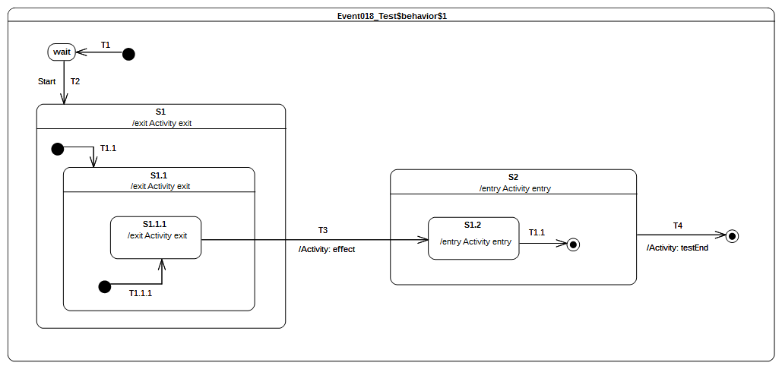Figure 9.35 - Event 018 Test Classifier Behavior
Received event occurrence(s)
- Start – received when in configuration wait.
Generated trace
- S1.1.1(exit)::S1.1(exit)::S1(exit)::T3(effect)::S2(entry)::S1.2(entry)
Note. The focus of this test case is to cover the situation in which transition T3 is triggered by the acceptance of the completion event generated for S1.1.1. The configuration of the state machine at this time is S1[S1.1[S1.1.1]]. When T3 is traversed, it results in the following set of actions:
- S1.1.1, S1.1 and S1 are exited (in this order).
- The effect behavior of the transition is executed.
- S2 and S2.1 are entered (in this order).
RTC steps
Step | Event pool | State machine configuration | Fired transition(s)
1 | [] | [] - Initial RTC step | [T1]
2 | [Start, CE(wait)] | [wait] | []
3 | [Start] | [wait] | [T2(T1.1(T1.1.1))]
4 | [CE(S1.1.1)] | [S1[S1.1[S1.1.1]]] | [T3]
5 | [CE(S1.2)] | [S2[S1.2]] | [T1.1]
6 | [CE(S2)] | [S2] | [T4]

Entering

Overview
Test cases presented in this subclause deal with entry semantics of composite states.

Entering 004
Entering 004 ([UML], 14.2.3.4.5)
If no initial Pseudostate is defined, there is no single approach defined. One alternative is to treat such a model as ill formed. A second alternative is to treat the composite State as a simple State, terminating the traversal on that State despite its internal parts.

Tested state machine
The state machine that is executed for that test is presented in Figure 9.36.

Test executions
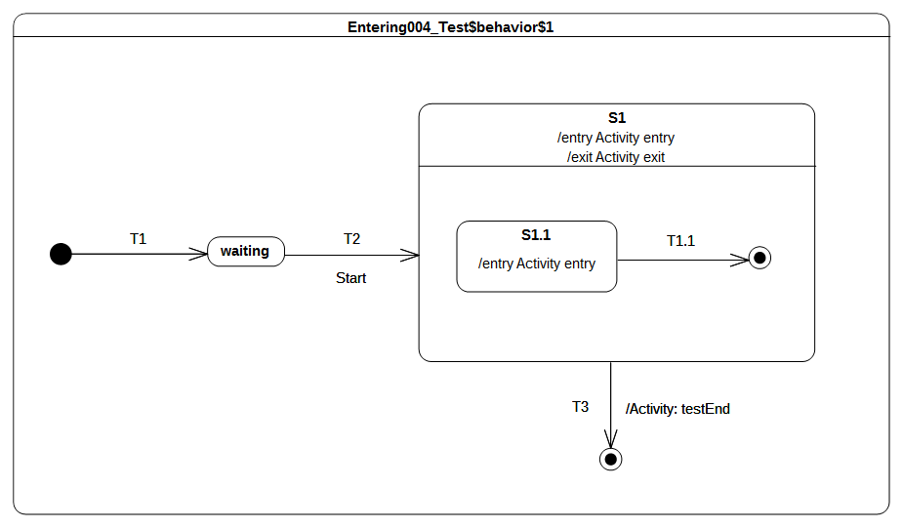Figure 9.36 - Entering 004 Classifier behavior
Received event occurrence(s)
- Start – received when in configuration waiting.
Generated trace
- S1(entry)::S1(exit)
Note. Note that this model omits the initial pseudostate and transition for the composite state S1 – a situation that is syntactically valid but not recommended. Consequently, S1 is treated as if it is a simple state upon the completion of transition T2. This means that, when S1 is entered, it completes right after the termination of its entry behavior. This completion event is used to trigger the transition T3, which leads to the completion of the state machine execution.
RTC steps
Step | Event pool | State machine configuration | Fired transition(s)
1 | [] | [] - Initial RTC step | [T1]
2 | [Start, CE(waiting)] | [waiting] | []
3 | [Start] | [waiting] | [T2]
4 | [CE(S1)] | [S1] | [T3]

Entering 005
Entering 005 ([UML], 14.2.3.4.5)
If the incoming Transition or its continuations terminate on a directly contained substate of the composite State, then that substate becomes active and its entry Behavior is executed after the execution of the entry Behavior of the containing composite State. This rule applies recursively if the Transition terminates on an indirect (deeply nested) substate.

Tested state machine
The state machine that is executed for that test is presented in Figure 9.37.

Test executions
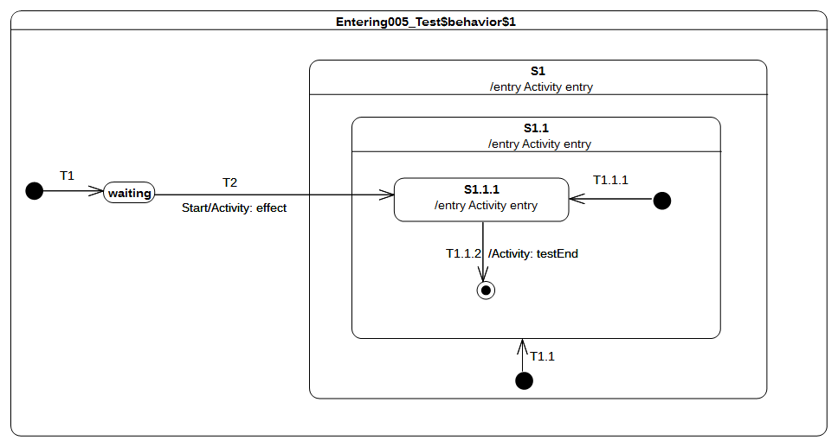Figure 9.37 - Entering 005 Test Classifier Behavior
Received event occurrence(s)
- Start – received when in configuration waiting.
Generated trace
- T2(effect)::S1(entry)::S1.1(entry)::S1.1.1(entry)
Note. This test case illustrates direct entry to the deeply nested state S1.1.1. In this situation, when T2 is triggered, its effect behavior is executed and leads to the entering of S1, S1.1, and S1.1.1 respectively. S1 and S1.1 are composite states whose unique region is entered directly (i.e., even if an initial pseudo-state and transition exist, they will not be taken).
RTC steps
Step | Event pool | State machine configuration | Fired transition(s)
1 | [] | [] - Initial RTC step | [T1]
2 | [Start, CE(waiting)] | [waiting] | []
3 | [Start] | [waiting] | [T2]
4 | [CE(S1.1.1)] | [S1[S1.1[S1.1.1]]] | [T1.1.2]
5 | [CE(S1.1)] | [S1[S1.1]] | []

Entering 009
Entering 009 ([UML], 14.2.3.4.5)
If a Transition enters a composite State through an entryPoint Pseudostate, then the effect Behavior associated with the outgoing Transition originating from the entry point and penetrating into the State (but after the entry Behavior of the composite State has been executed)

Tested state machine
The state machine that is executed for that test is presented in Figure 9.38.

Test executions
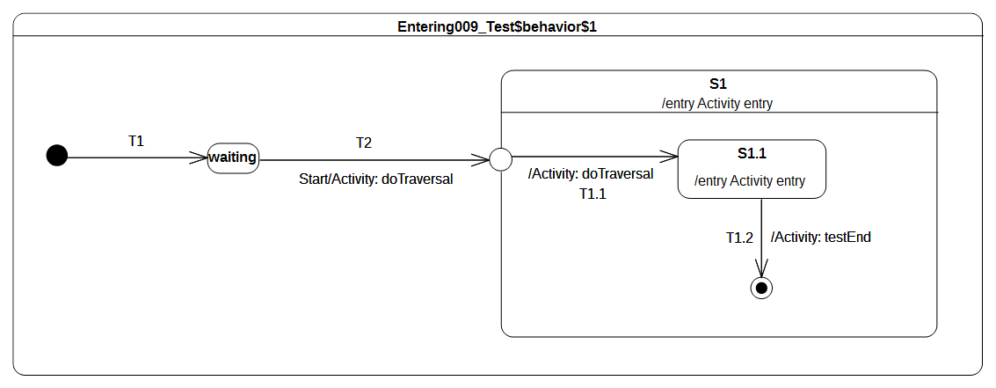Figure 9.38 - Entering 009 Test Classifier Behavior
Received event occurrence(s)
- Start – received when in configuration waiting.
Generated trace
- T2(effect)::S1(entry)::T1.1(effect)::S1.1(entry)
Note. This test case illustrates entering of a composite state through an entry point. In this case, when the entry point is reached, it leads to entering of S1 and the execution of its entry behavior. The region of S1 is then entered immediately after the entry point is reached and transitions T1.1 is traversed. This leads to the entering of S1.1. The latter completes when its entry behavior has executed, after which the completion event is used to trigger the transition T1.2.
RTC steps
Step | Event pool | State machine configuration | Fired transition(s)
1 | [] | [] - Initial RTC step | [T1]
2 | [Start, CE(waiting)] | [waiting] | []
3 | [Start] | [waiting] | [T2(T1.1)]
4 | [CE(S1.1)] | [S1[S1.1]] | [T1.2]
5 | [CE(S1)] | [S1] | []

Entering 010
Entering 010 ([UML], 14.2.3.4.5)
If the composite State is also an orthogonal State with multiple Regions, each of its Regions is also entered, either by default or explicitly.

Tested state machine
The state machine that is executed for that test is presented in Figure 9.39.

Test executions
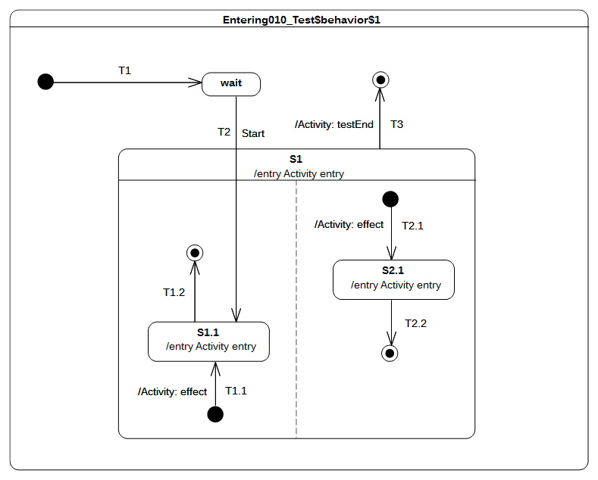Figure 9.39 - Entering 010 Test Classifier Behavior
Received event occurrence(s)
- Start – received when in configuration wait.
Generated trace
- S1(entry)::T2.1(effect)::S2.1(entry)::S1.1(entry)
Note. This test case presents the entry into a composite state with multiple regions. In this case, one region is entered directly whereas the other is entered by default. This occurs in the RTC step initiated by acceptance of the Start event occurrence. First S1 is entered, which leads to the default entry of the right-side region. Next the left hand side region is entered directly (i.e., the initial pseudo state and its outgoing transition are not traversed). This means that state S1.1 is entered. Note that this describes on possible execution, since the concurrency implied by the orthogonal regions of S1 can lead to other valid execution traces. Nevertheless, the rules for default and direct entry of regions remain unchanged.
RTC steps
Step | Event pool | State machine configuration | Fired transition(s)
1 | [] | [] - Initial RTC step | [T1]
2 | [Start, CE(wait)] | [wait] | []
3 | [Start] | [waiting] | [T2(T1.1, T2.1)]
4 | [CE(S1.1), CE(2.1)] | [S1[S1.1, S2.1]] | [T2.2]
5 | [CE(S1.1)] | [S1[S1.1]] | [T1.2]
6 | [CE(S1)] | [S1] | [T3]

Entering 011
Entering 011 ([UML], 14.2.3.4.5)
If the Transition terminates on the edge of the composite State (i.e., without entering the State), then all the Regions are entered using the default entry rule above.

Tested state machine
The state machine that is executed for that test is presented in Figure 9.40.
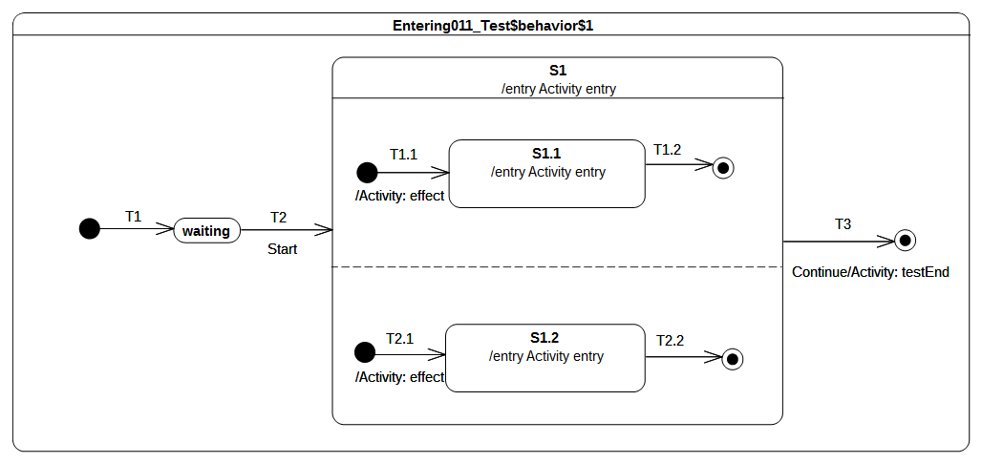Figure 9.40 - Entering 011 Test Classifier Behavior

Test executions
Received event occurrence(s)
- Start – received when in configuration waiting.
Generated trace
- S1(entry)::T2.1(effect)::S1.2(entry)::T1.1(effect)::S1.1(entry)
Note. This test case covers the situation where all regions of a composite state are entered using the default entry rule. The RTC step that was initiated by the acceptance of the Start event occurrence leads to the entering of S1, which means that, after its entry behavior is executed, all region will be started concurrently. The execution of each region starts from its initial pseudo-state. S1 completes when both of its region have completed. This occurs when completion events generated by S1.1 and S1.2 have been dispatched. The S1 completion event is then used to trigger transition T3.
RTC steps
Step | Event pool | State machine configuration | Fired transition(s)
1 | [] | [] - Initial RTC step | [T1]
2 | [Start, CE(waiting)] | [waiting] | []
3 | [Start] | [waiting] | [T2(T1.1, T2.1)]
4 | [CE(1.2), CE(S1.1)] | [S1[S1.1, S2.1]] | [T1.2]
5 | [CE(1.2)] | [S1[S2.1]] | [T2.2]
6 | [CE(S1)] | [S1] | [T3]

Exiting

Overview
Tests presented in this subclause assesses that semantics associated with state exiting rules conform to what is specified in UML.

Exiting 001
Exiting 001 ([UML], 14.2.3.4.6)
When exiting a State, regardless of whether it is simple or composite, the final step involved in the exit, after all other Behaviors associated with the exit are completed, is the execution of the exit Behavior of that State.

Tested state machine
The state machine that is executed for that test is presented in Figure 9.41.
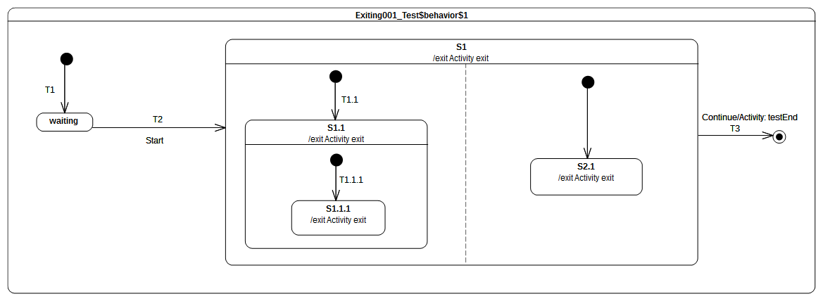Figure 9.41 - Exiting 001 Test Classifier Behavior

Test executions
Received event occurrence(s)
- Start – received when in configuration waiting.
- Continue – received when in configuration S1[S1.1[S1.1.1], S2.1].
Generated trace
- S1.1.1(exit)::S1.1(exit)::S2.1(exit)::S1(exit)
Note. This test illustrates the exit sequence of a composite state with orthogonal regions. When the Continue event occurrence is accepted, it triggers transition T3. The first action encountered by the traversal of T3 is that the exiting of S1. This requires first that all active states in all regions controlled by this state are exited. The exit sequence starts for each region with the innermost active state. Hence, assuming that the left-hand side S1.1.1 is exited first, it will be immediately followed by S1.1. Concurrently, S2.1 is exited in the right-hand region. The exit sequence is concluded by the execution of the exit behavior of S1. Finally, the effect behavior of T3 is executed and the state machine execution completes.
RTC steps
Step | Event pool | State machine configuration | Fired transition(s)
1 | [] | [] - Initial RTC step | [T1]
2 | [Start, CE(waiting)] | [waiting] | []
3 | [Start] | [waiting] | [T2(T1.1(T1.1.1), T2.1)]
4 | [Continue, CE(S2.1), CE(S1.1.1)] | [S1[S1.1[S1.1.1], S2.1]] | []
5 | [Continue, CE(S2.1)] | [S1[S1.1[S1.1.1], S2.1]] | []
6 | [Continue] | [S1[S1.1[S1.1.1], S2.1]] | [T3]

Exiting 002
Exiting 002 ([UML], 14.2.3.4.6)
If the State has a doActivity Behavior that is still executing when the State is exited, that Behavior is aborted before the exit Behavior commences execution.

Tested state machine
The state machine that is executed for that test is presented in Figure 9.42. The doActivity behavior of S1 has exactly the same behavior as the one presented in Figure 8.3 except that, instead of waiting for a Continue event occurrence, it waits for an AnotherSignal event occurrence.
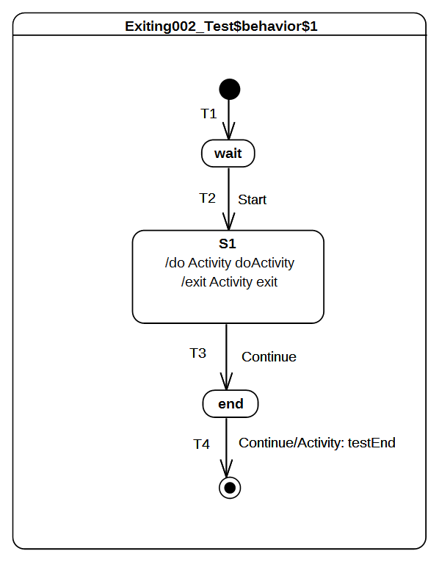Figure 9.42 - Exiting 002 Test Classifier Behavior
The exit behavior is specified as shown in Figure 9.43. It contributes to the trace production by adding a the fragment 'S1(exit)' and sends a signal AnotherSignal to the current context object executing this behavior
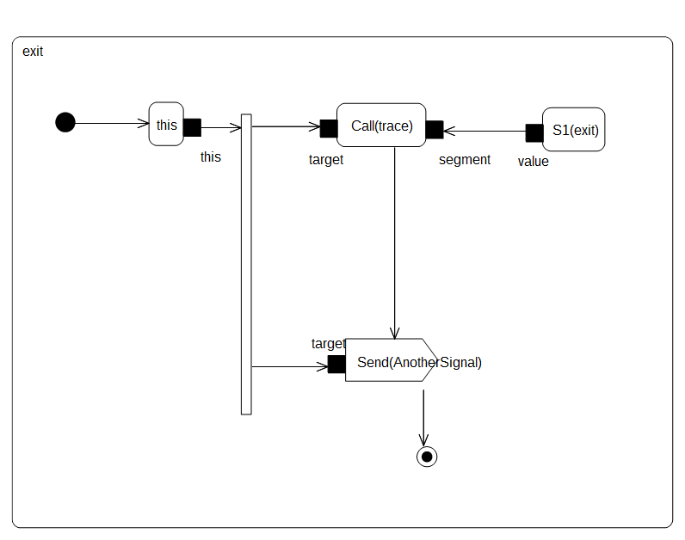Figure 9.43 - S1 exit behavior

Test executions
Received event occurrence(s)
- Start – received when in configuration wait.
- Continue – received when in configuration S1.
- AnotherSignal – received when in configuration S1.
- Continue – received when in configuration end.
Generated trace
- S1(doActivityPartI)::S1(exit)
Note. The purpose of this test is to demonstrate that the doActivity behavior (if it is still running) is aborted before the exit behavior is actually executed. In this test case, the doActivity behavior is started asynchronously after S1 is entered. It is the very last action that takes place during the RTC step initiated by the acceptance of the Start event occurrence.
In this case, when the Continue event occurrence is dispatched, the doActivity behavior is still running. Indeed it waits for an AnotherSignal occurrence. However S1 is now forced to be exited using the transition T3 (due to the acceptance of the Continue event occurrence). Hence, its doActivity behavior is aborted and its exit behavior is executed. To verify that doActivity was effectively aborted before the execution the exit, the exit behavior of S1 sends an AnotherSignal occurrence to the context object. If the doActivity was not aborted, then it would have used this event occurrence to continue its execution and it would have completed the execution trace with the message S1(doActivityPartII).
RTC steps
Step | Event pool | State machine configuration | Fired transition(s)
1 | [] | [] - Initial RTC step | [T1]
2 | [Start, CE(wait)] | [wait] | []
3 | [Start] | [wait] | [T2]
4 | [AnotherSignal, Continue] | [S1] | [T3]
5 | [Continue, AnotherSignal, CE(end)] | [end] | []
6 | [Continue, AnotherSignal] | [end] | []
7 | [Continue] | [end] | [T4]

Exiting 003
Exiting 003 ([UML], 14.2.3.4.6)
When exiting from a composite State, exit commences with the innermost State in the active state configuration. This means that exit Behaviors are executed in sequence starting with the innermost active State.

Tested state machine
The state machine that is executed for that test is presented in Figure 9.44.
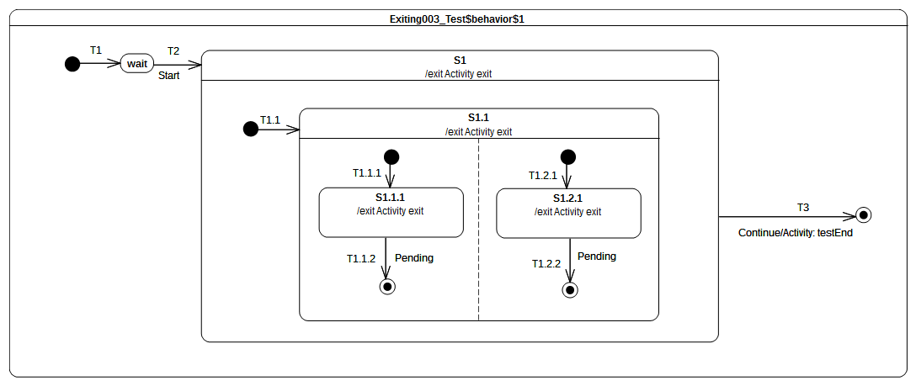Figure 9.44 - Exiting 003 Test Classifier Behavior

Test executions
Received event occurrence(s)
- Start – received when in configuration wait.
- Continue – received when in configuration S1[S1.1[S1.1.1, S1.2.1]].
Generated trace
- S1.1.1(exit)::S1.2.1(exit)::S1.1(exit)::S1(exit)
Note. The purpose of this test is to demonstrate that when a composite state is exited, the exit behaviors that are executed first are those owned by the innermost active state(s). Here when the Continue event occurrence is accepted, the state machine is in configuration S1[S1.1[S1.1.1, S1.2.1]]. This means that to conform to UML state machine semantics, our execution model must start the exit sequence of S1 by first exiting S1.1.1 and S1.2.1. Next, S1.1 is exited and finally this is S1 turn.
RTC steps
Step | Event pool | State machine configuration | Fired transition(s)
1 | [] | [] - Initial RTC step | [T1]
2 | [Start, CE(wait)] | [wait] | []
3 | [Start] | [wait] | [T2(T1.1(T1.1.1, T1.2.1))]
4 | [Continue, CE(S1.2.1), CE(S1.1.1)] | [S1[S1.1[S1.1.1, S1.2.1]]] | []
5 | [Continue, CE(S1.2.1)] | [S1[S1.1[S1.1.1, S1.2.1]]] | []
6 | [Continue] | [S1[S1.1[S1.1.1, S1.2.1]]] | [T3]

Exiting 004
Exiting 004 ([UML], 14.2.3.4.6)
If the exit occurs through an exitPoint Pseudostate, then the exit Behavior of the State is executed after the effect Behavior of the Transition terminating on the exit point.

Tested state machine
The state machine that is executed for that test is presented in Figure 9.45.
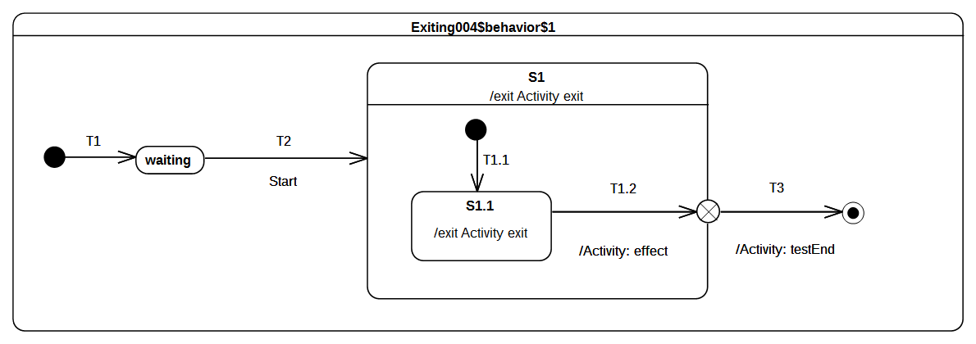Figure 9.45 - Exiting 004 Test Classifier Behavior

Test executions
Received event occurrence(s)
- Start – received when in configuration wait.
Generated trace
- S1.1(exit)::T1.2(effect)::S1(exit)
Note. The purpose of this test is to validate that, when a composite state is left using an exit point, then the effect behavior of the transition entering this pseudo-state is executed before the exit behavior of the state. At the point where the state machine is in configuration S1[S1.1], the completion event generated for S1.1 is dispatched and accepted. This initiates an RTC step during which S1.1 is exited, the effect behavior is of T1.2 is executed, S1 is exited and finally the continuation transition T3 is traversed.
RTC steps
Step | Event pool | State machine configuration | Fired transition(s)
1 | [] | [] - Initial RTC step | [T1]
2 | [Start, CE(waiting)] | [waiting] | []
3 | [Start] | [waiting] | [T2(T1.1)]
4 | [CE(S1.1)] | [S1[S1.1]] | [T1.2(T3)]

Exiting 005
Exiting 005 ([UML], 14.2.3.4.6)
When exiting from an orthogonal State, each of its Regions is exited. After that, the exit Behavior of the State is executed.

Tested state machine
The state machine that is executed for that test is presented in Figure 9.46.
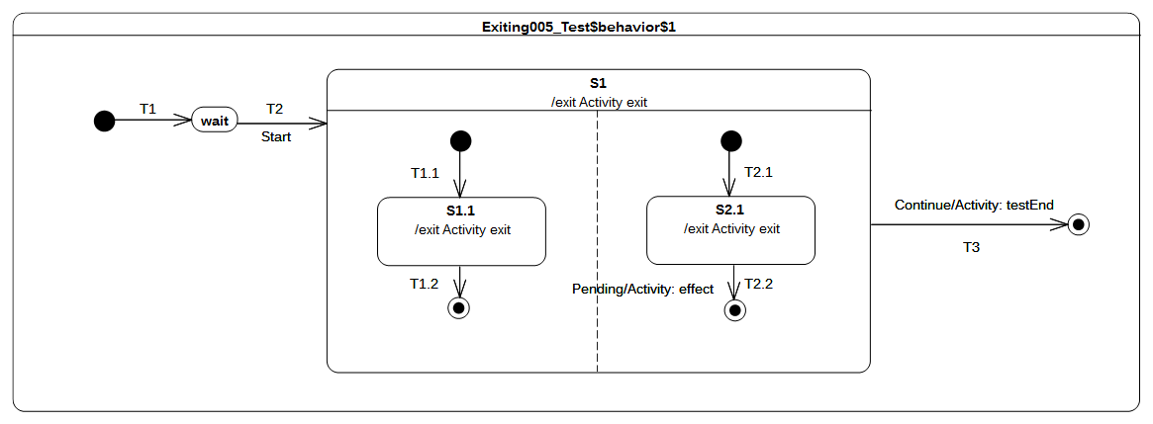Figure 9.46 - Exiting 005 Test Classifier behavior

Test executions
Received event occurrence(s)
- Start – received when in configuration wait.
- Continue – received when in configuration S1[S1.1].
Generated trace
- S1.1(exit)::S2.1(exit)::S1(exit)
Note. The purpose of the test is to ensure that, when exiting S1, which has orthogonal regions, the exit behaviors of S1.1 and S2.1 are executed before the exit behavior of S1. When the Continue event occurrence is dispatched, the state machine is in the configuration S1[S1.1] (the left-hand region has already completed due to the acceptance of the S1.1 completion event). Transition T3 is triggered next and the exit sequence starts with the execution of S2.1 exit behavior followed by the exit behavior of S1.
RTC steps
Step | Event pool | State machine configuration | Fired transition(s)
1 | [] | [] - Initial RTC step | [T1]
2 | [Start, CE(waiting)] | [waiting] | []
3 | [Start] | [waiting] | [T2(T1.1, T2.1)]
4 | [Continue, CE(S2.1), CE(S1.1)] | [S1[S1.1, S2.1]] | [T1.2]
5 | [Continue, CE(S2.1)] | [S1[S2.1]] | []
6 | [Continue] | [S1] | [T3]

Exit

Overview
Tests presented in this subclause assesses that semantics associated with exit points conform to what is specified in UML.

Exit 001
Exit 001 ([UML], 14.2.3.7)
Transitions terminating on an exit point within any Region of the composite State implies exiting of this composite (with execution of its associated exit Behavior)

Tested state machine
The state machine that is executed for that test is presented in Figure 9.47.
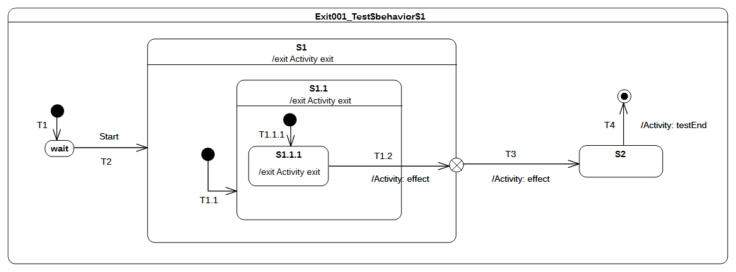Figure 9.47 - Exit 001 Test Classifier behavior

Test executions
Received event occurrence(s)
- Start – received when in configuration wait.
Generated trace
- S1.1.1(exit)::S1.1(exit)::T1.2(effect)::S1(exit)::T3(effect)
Note. The purpose of this test case is to demonstrate the support of exit point pseudostate for exiting a composite state. The completion event generated by S1.1.1 is dispatched and accepted when the state machine is in configuration S1[S1.1[S1.1.1]]. At this point T1.2 is triggered. When traversed, this transition implies first that S1.1.1 is exited as well as S1.1. Next, its effect behavior is executed and, finally, the exit point placed on S1 is reached. The semantics of the exit point requires S1 to be exited and transition T3 to be traversed.
RTC Steps
Step | Event pool | State machine configuration | Fired transition(s)
1 | [] | [] - Initial RTC step | [T1]
2 | [Start, CE(wait)] | [wait] | []
3 | [Start] | [wait] | [T2(T1.1(T1.1.1))]
4 | [CE(S1.1.1)] | [S1[S1.1[S1.1.1]]] | [T1.2(T3)]
5 | [CE(S2)] | [S2] | [T4]

Exit 002
Exit 002 ([UML], 14.2.3.7)
If multiple Transitions from orthogonal Regions within the State terminate on this Pseudostate, then it acts like a join Pseudostate

Tested state machine
The state machine that is executed for that test is presented in Figure 9.48.
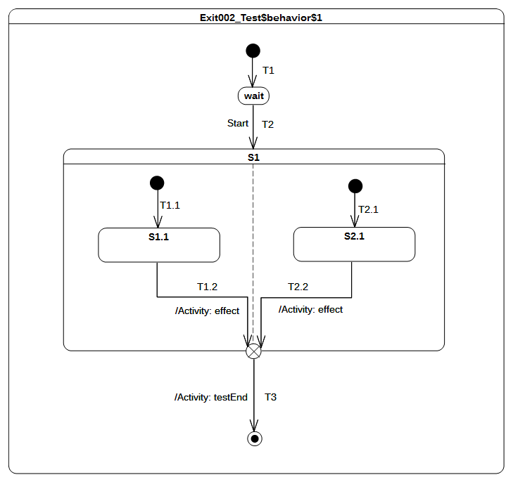Figure 9.48 - Exit 002 Test Classifier Behavior

Test executions
Received event occurrence(s)
- Start – received when in configuration wait.
Generated trace
- T1.2(effect)::T2.2(effect)
Note. The purpose of this test is to demonstrate that, if multiple transitions originating from states located in different orthogonal regions terminate on an exit pseudostate, then this acts (in addition to original semantics) as a join pseudo state.
When the completion event generated by S1.1 is dispatched and accepted by the state machine, then T1.2 is triggered and traversed. This is the first time that the exit point is reached. It cannot be traversed since its prerequisites are not satisfied (i.e., all of its incoming transition have not already been traversed). The next RTC step is initiated by the acceptance of the S2.1 completion event. T2.2 is triggered, after which the execution reaches the exit point for the second time. The latter is traversed and its outgoing transition is taken. The state machine execution completes when the final state is reached.
RTC Steps
Step | Event pool | State machine configuration | Fired transition(s)
1 | [] | [] - Initial RTC step | [T1]
2 | [Start, CE(wait)] | [wait] | []
3 | [Start] | [wait] | [T2(T1.1, T2.1)]
4 | [CE(S2.1), CE(S1.1)] | [S1[S1.1, S2.1]] | [T1.2]
5 | [CE(S2.1)] | [S1[S2.1]] | [T2.2(T3)]

Exit 003
Exit 003
UML does not provide any constraint on the number of transitions that can originate from an exit point. Hence it means we can have more than one transition that is ready to be traversed. This situation may lead to a conflict.

Tested state machine
The state machine that is executed for that test is presented in Figure 9.49.

Test executions
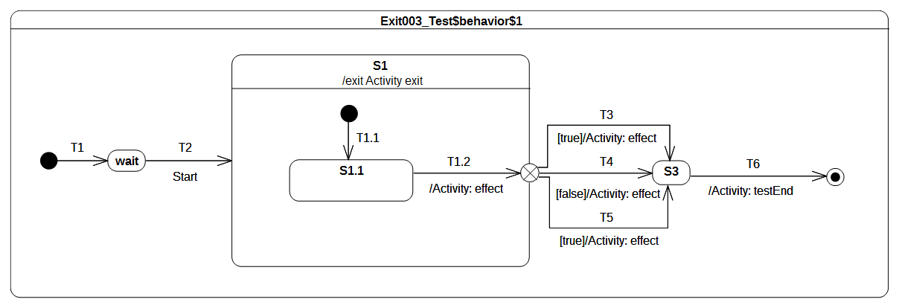Figure 9.49 - Exit 003 Classifier Behavior
Received event occurrence(s)
- Start – received when in configuration wait.
Generated trace
- T1.2(effect)::S1(exit)::T3(effect)
Note. The purpose of this test case is to ensure that, in a situation where multiple transitions outgoing an exit point are ready to be traversed, only one of them will actually be selected for firing. At some point of the execution (acceptance of S1.1 completion event), the exit point that is placed on S1 is reached. The guard placed on transitions originating from this exit point are evaluated. The set of enabled transitions is now composed of T3 and T5. A semantic strategy is used to determine which transition is going to be traversed. Under the assumption that T3 is chosen, it is taken and S3 is entered. The completion event generated by S3 will be dispatched in the next RTC step and the state machine will complete its execution.
RTC Steps
Step | Event pool | State machine configuration | Fired transition(s)
1 | [] | [] - Initial RTC step | [T1]
2 | [Start, CE(wait)] | [wait] | []
3 | [Start] | [wait] | [T2(T1.1)]
4 | [CE(S1.1)] | [S1[S1.1]] | [T1.2(T3)]
5 | [CE(S3)] | [S3] | [T6]

Entry

Overview
Tests presented in this subclause assesses that semantics associated with entry points conform to what is specified in UML

Entry 002 – A
Entry 002
If the owning State has an associated entry Behavior, this Behavior is executed before any behavior associated with the outgoing Transition. If multiple Regions are involved, the entry point acts as a fork Pseudostate.

Tested state machine
The state machine that is executed for that test is presented in Figure 9.50.
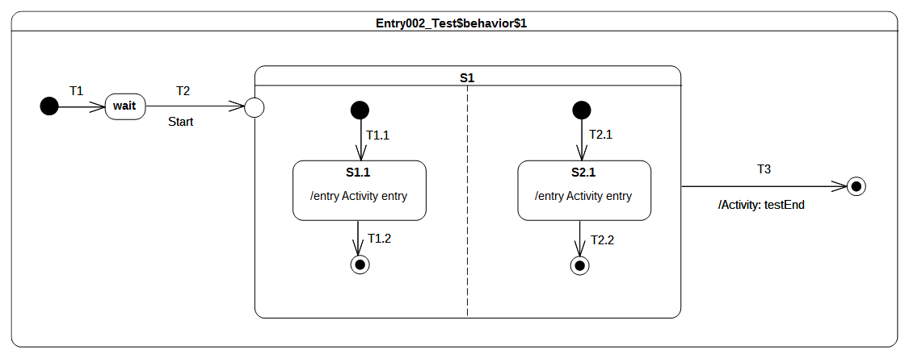Figure 9.50 - Entry 002 - A Test Classifier Behavior

Test execution
Received event occurrence(s)
- Start – received when in configuration wait.
Generated trace
- S1.1(entry)::S2.1(entry)
Note. The fact that the entry behavior of the state owning the entry point is executed before the effect behavior of the transition outgoing the exit point was demonstrated in the test case presented in section 9.3.5.4. The purpose of this test is to demonstrate that, if an entry point is placed on a composite state with orthogonal regions, then this entry point behaves as a fork. When the Start event occurrence is accepted by the state machine, T2 is triggered. At the end of T2 traversal, the entry point is reached, which implies the entry of S1. Since there are no transitions originating from the pseudostate and penetrating into the state, all regions of S1 are entered using the default entry rule (i.e, each region starts is execution using the its initial pseudo state). Hence, both continuation transitions T1.1 and T2.1 are traversed resulting in states S1.1 and S2.1 executing their entry behaviors. At the end of each entry behavior execution, a completion event is generated. This is is the end of the RTC step initiated by the dispatching of the Start event occurrence . The two following RTC steps are related to the dispatching and the acceptance of these completion events. As soon as both regions have completed, a completion event is generated for S1. The last RTC step consist of accepting this completion event to trigger T3 and completing the state machine execution when the final state is reached.
RTC steps
Step | Event pool | State machine configuration | Fired transition(s)
1 | [] | [] - Initial RTC step | [T1]
2 | [Start, CE(wait)] | [wait] | []
3 | [Start] | [wait] | [T2(T1.1, T2.1)]
4 | [CE(S2.1), CE(S1.1)] | [S1[S1.1, S2.1]] | [T1.2]
5 | [CE(S2.1)] | [S1[S2.1]] | [T2.2]
6 | [CE(S1)] | [S1] | [T3]

Entry 002 – B

Tested state machine
The state machine that is executed for that test is presented in Figure 9.51.
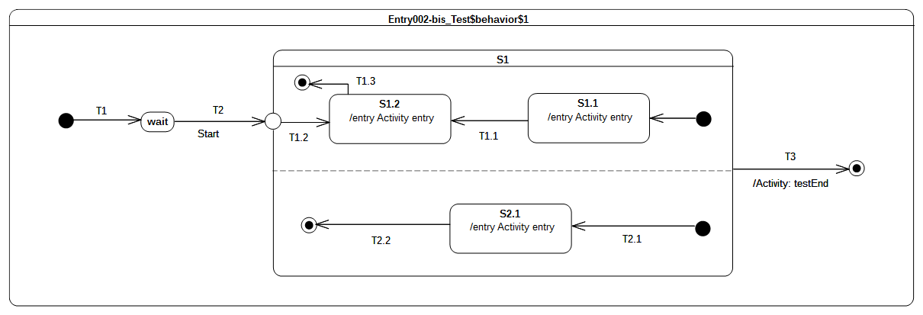Figure 9.51 - Entry 002 - B Test Classifier behavior

Test execution
Received event occurrence(s)
- Start – received when in configuration wait.
Generated trace
- S2.1(entry)::S1.2(entry)
Note. The test case presented in section 9.3.8.4 demonstrates that when a transition outgoing from entry point and penetrating a composite state is traversed then the region containing the targeted state is entered explicitly (i.e., without using the initial pseudo-state). The purpose of this test is to demonstrate that, if orthogonal regions exist in that composite state, then these are entered using the default approach, whereas the first one (i.e., the one containing the target vertex) is entered explicitly. As we can see from the generated execution trace, the S1.1(entry) message does not appear, which indicates the entrance of the upper region of S1 was realized explicitly. In addition, S2.1(entry) is part of the trace, indicating that the other region of S1 was entered using the default entry approach.
RTC Steps
Step | Event pool | State machine configuration | Fired transition(s)
1 | [] | [] - Initial RTC step | [T1]
2 | [Start, CE(wait)] | [wait] | []
3 | [Start] | [wait] | [T2(T2.1, T1.2)]
4 | [CE(S1.2), CE(S2.1)] | [S1[S1.2, S2.1]] | [T2.2]
5 | [CE(S1.2)] | [S1[S1.2]] | [T1.3]
6 | [CE(S1)] | [S1] | T3

Entry 002 – C
Entry 002
If the owning State has an associated entry Behavior, this Behavior is executed before any behavior associated with the outgoing Transition.

Tested state machine
The state machine that is executed for that test is presented in Figure 9.52.
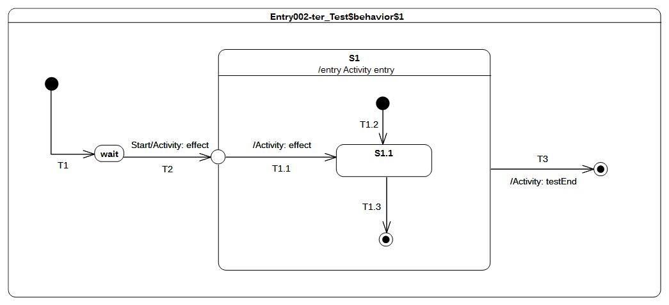Figure 9.52 - Entry 002 - C Test Classifier Behavior

Test execution
Received event occurrence(s)
- Start – received when in configuration wait.
Generated trace
- T2(effect)::S1(entry)::T1.1(entry)
Note. The purpose of this test is to demonstrate that the entry behavior of the state owning the entry point is always executed before the effect behavior(s) of the transition(s) originating from this entry point. When the Start event occurrence is dispatched and accepted by the state machine, T2 is triggered and traversed. This traversal implies the execution of the effect behavior as well as the entrance of the entry point pseudostate. When the entry point is entered, S1 is entered and its entry behavior is executed. As soon as the previous actions have completed, the continuation transition T1.1 can be traversed. Hence its effect behavior is executed and S1.1 is entered.
RTC Steps
Step | Event pool | State machine configuration | Fired transition(s)
1 | [] | [] - Initial RTC step | [T1]
2 | [Start, CE(wait)] | [wait] | []
3 | [Start] | [wait] | [T2(T1.1)]
4 | [CE(S1.1)] | [S1[S1.1]] | [T1.3]
5 | [CE(S1)] | [S1] | [T3]

Entry 002 – D

Tested state machine
The state machine that is executed for that test is presented in Figure 9.53.

Test execution
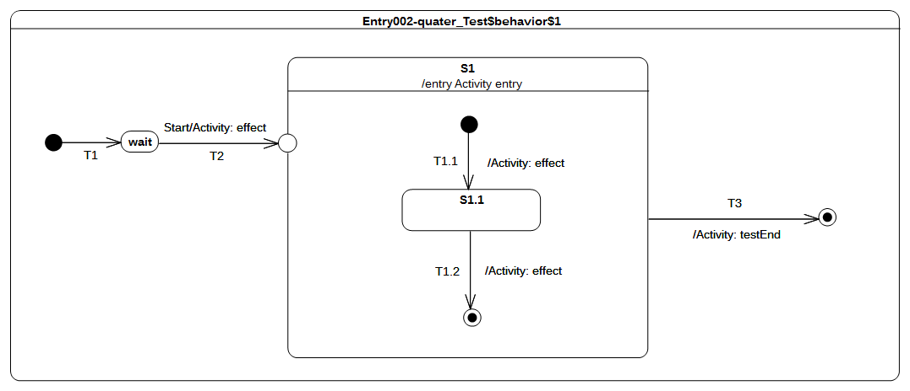Figure 9.53 - Entry 002 - D Test Classifier Behavior
Received event occurrence(s)
- Start – received when in configuration wait.
Generated trace
- T2(effect)::S1(entry)::T1.1(effect)::T1.2(effect)
Note. The purpose of this test is to consolidate what was shown in previous test-cases presented in section 9.3.8. It demonstrates that, if the composite has a single region and is entered through an entry with no outgoing transitions, then the region is entered using the default entry approach. When the Start event occurrence is dispatched and accepted by the state machine, T2 is triggered and traversed. This is manifested in the trace by the message T2(effect). Next, S1 is entered and its entry behavior is executed (see message S1(entry) in the trace). Finally, we see the region is entered using the default approach, since the execution of the T1.1 effect behavior adds message T1.1(effect) to the trace.
RTC Steps
Step | Event pool | State machine configuration | Fired transition(s)
1 | [] | [] - Initial RTC step | [T1]
2 | [Start, CE(wait)] | [wait] | []
3 | [Start] | [wait] | [T2(T1.1)]
4 | [CE(S1.1)] | [S1[S1.1]] | [T1.2]
5 | [CE(S1)] | [S1] | [T3]

Entry 002 – E

Tested state machine
The state machine that is executed for that test is presented in Figure 9.54.

Test execution
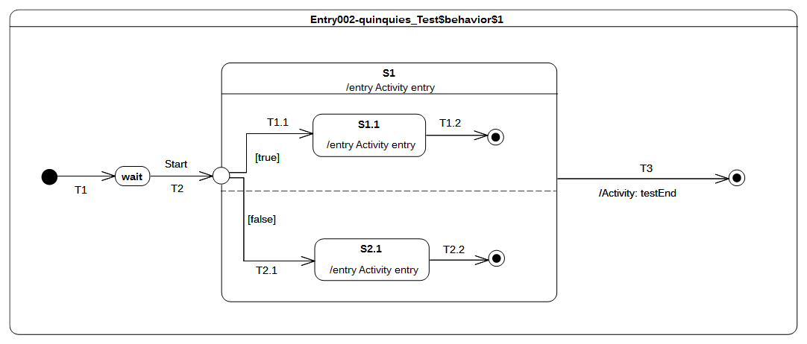Figure 9.54 - Entry 002 - E Test Classifier Behavior
Received event occurrence(s)
- Start – received when in configuration wait.
Generated trace
- S1(entry)::S1.1(entry)
Note. The purpose of this test is to consolidate what was shown in previous test-cases presented in section 9.3.8. It demonstrates the impact of guard evaluation for transitions originating from an entry point on region execution. When the Start event occurrence is dispatched, T2 is traversed and the entry point is entered. Next, the S1 entry behavior is executed and the guards of continuation transition T1.1 and T1.2 are evaluated. Only the T1.1 guard evaluates to true. This means that only the upper region of S1 is entered. The other region is not since it could not be entered either using the default or the explicit entry. This ends the RTC step that was initiated by the acceptance of the Start event occurrence. The next RTC step is initiated by the acceptance of the completion event generated by S1.1. This event is used to trigger T1.2, whose traversal leads to the completion of the region and, conseqeuntly, the completion of S1. The last RTC step consists in accepting the completion event generated for S1. This triggers T3 and enables the state machine to reach the final state.
RTC Steps
Step | Event pool | State machine configuration | Fired transition(s)
1 | [] | [] - Initial RTC step | [T1]
2 | [Start, CE(wait)] | [wait] | []
3 | [Start] | [wait] | [T2(T1.1)]
4 | [CE(S1.1)] | [S1[S1.1]] | [T1.2]
5 | [CE(S1)] | [S1] | [T3]

Choice

Overview
Tests presented in this subclause assesses that semantics associated with choice pseudostate conform to what is specified in UML.

Choice 001
Choice 001 ([UML], 14.2.3.7)
The guard Constraints on all outgoing Transitions are evaluated dynamically, when the compound transition traversal reaches this Pseudostate

Tested state machine
The state machine that is executed for that test is presented in Figure 9.55.
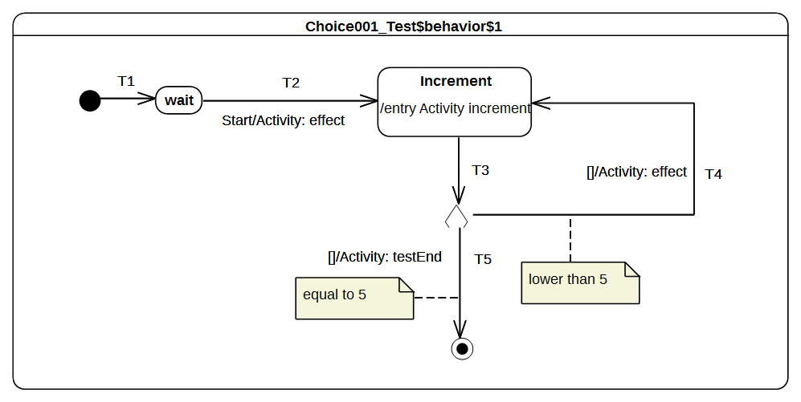Figure 9.55 - Choice 001 Test Classifier Behavior

Test execution
Received event occurrence(s)
- Start – received when in configuration wait.
Generated trace
- T4(effect)::T4(effect)::T4(effect)::T4(effect)
Note. The purpose of this test is to demonstrate how evaluation of transition guards of transitions originating from a choice pseudostate has an impact on the execution flow. When the Start event occurrence is dispatched and accepted by the state machine, T2 is triggered. The execution of its associated effect behavior implies the initialization of the value property of the class for which the state machine plays the role of a classifier behavior. The Increment state is entered and its entry behavior increments the value of property value . Right after the termination of the entry behavior, a completion event is generated for the state Increment. This is the end of the RTC step initiated by the acceptance of the Start event occurrence. The next RTC step is initiated by the acceptance of the completion event generated by the Increment state. This triggers T3, which is the incoming transition of the choice pseudostate. When it is reached, all guards placed on outgoing transitions are evaluated. Only the guard placed on T4 evaluates to true, so that this continuation transition is taken. This leads to re-entering of the Increment state. The next for four RTC steps repeat this execution path. The fifth consists in traversing T5, whose guard now evaluates to true. When the final state is reached the state machine completes its execution.
RTC Steps
Step | Event pool | State machine configuration | Fired transition(s)
1 | [] | [] - Initial RTC step | [T1]
2 | [Start, CE(wait)] | [wait] | []
3 | [Start] | [wait] | [T2]
4 | [CE(Increment)] | [Increment] | [T3(T4)]
5 | [CE(Increment)] | [Increment] | [T3(T4)]
6 | [CE(Increment)] | [Increment] | [T3(T4)]
7 | [CE(Increment)] | [Increment] | [T3(T4)]
8 | [CE(Increment)] | [Increment] | [T3(T5)]

Choice 002
Choice 002 ([UML], 14.2.3.7)
If more than one guard evaluates to true, one of the corresponding Transitions is selected. The algorithm for making this selection is not defined.

Tested state machine
The state machine that is executed for that test is presented in Figure 9.56.

Test execution
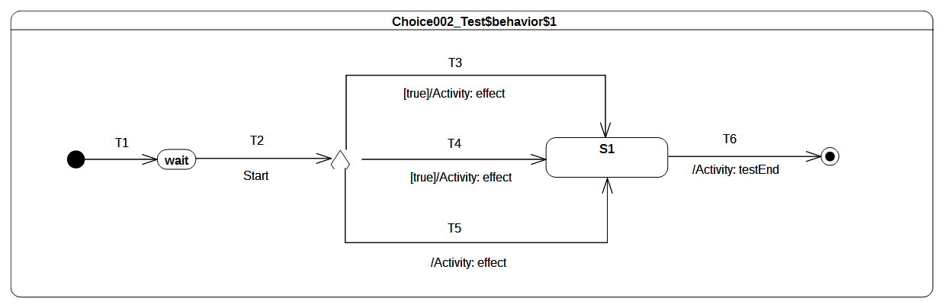Figure 9.56 - Choice 002 Test Classifier Behavior
Received event occurrence(s)
- Start – received when in configuration wait.
Generated trace
- T4(effect)
Note. The purpose of this test is to demonstrate that, if many transitions originating from a choice pseudostate are enabled, then at most one of them is chosen to be traversed. When the Start event occurrence is dispatched and accepted by the state machine, T2 is triggered. The choice pseudostate reached at this point has outgoing transitions. Each guard of each transition is evaluated. It happens at this point that T3, T4 and T5 are all ready to be traversed (a transition with no explicit guard is considered to have a guard that always evaluates to true). Hence a semantic strategy is used to elect the transition that will be fired. Assuming that a first choice strategy is used and that the list of enabled transition is organized with the following order [T4, T5, T3], transition T4 is elected to be traversed.
RTC Steps
Step | Event pool | State machine configuration | Fired transition(s)
1 | [] | [] - Initial RTC step | [T1]
2 | [Start, CE(wait)] | [wait] | []
3 | [Start] | [wait] | [T2(T4)]
4 | [CE(S1)] | [S1] | [T6]

Choice 003
Choice 003 ([UML], 14.2.3.7)
If none of the guards evaluates to true, then the model is considered ill formed. To avoid this, it is recommended to define one outgoing Transition with the predefined “else” guard for every choice Pseudostate.

Tested state machine
The state machine that is executed for that test is presented in Figure 9.57.

Test execution
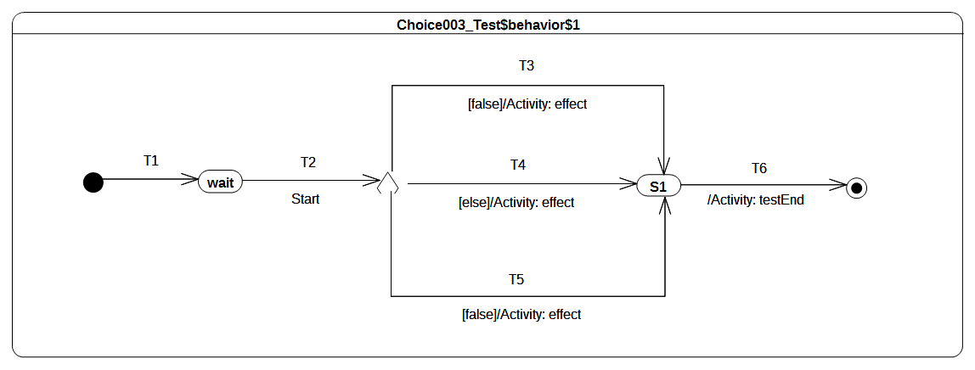Figure 9.57 - Choice 003 Test Classifier Behavior
Received event occurrence(s)
- Start – received when in configuration wait.
Generated trace
- T4(effect)
Note. The purpose of this test is to demonstrate that, if a choice point has an else outgoing transition and all of other outgoing transitions have guards that evaluate to false, then the else transition is chosen and traversed. When the Start event occurrence is dispatched and accepted, T2 is triggered which enables the state machine to reach the choice point. At this point, the guards of transitions T3 and T5 are evaluated. None of them evaluates to true, but there also exists an else transition T4. This transition (i.e., T4) is traversed and S1 is entered. The completion event generated by S1 is used to trigger T6, which leads to the completion of the state machine execution.
RTC Steps
Step | Event pool | State machine configuration | Fired transition(s)
1 | [] | [] - Initial RTC step | [T1]
2 | [Start, CE(wait)] | [wait] | []
3 | [Start] | [wait] | [T2(T4)]
4 | [CE(S1)] | [S1] | [T6]

Fork

Overview
Test cases presented in this subclause assesses that Fork semantics conforms to what is specified in UML.

Fork 001
Fork 001 ([UML], 14.2.3.4.5 and 14.2.3.2)
If the Transition explicitly enters one or more Regions (in case of a fork), these Regions are entered explicitly and the others by default.
An explicit activation occurs when a Region is entered by a Transition terminating on one of the Region’s contained Vertices. When one Region of an orthogonal State is activated explicitly, this will result in the default activation of all of its orthogonal Regions, unless those Regions are also entered explicitly (multiple orthogonal Regions can be entered explicitly in parallel through Transitions originating from the same fork Pseudostate)

Tested state machine
The state machine that is executed for that test is presented in Figure 9.58.
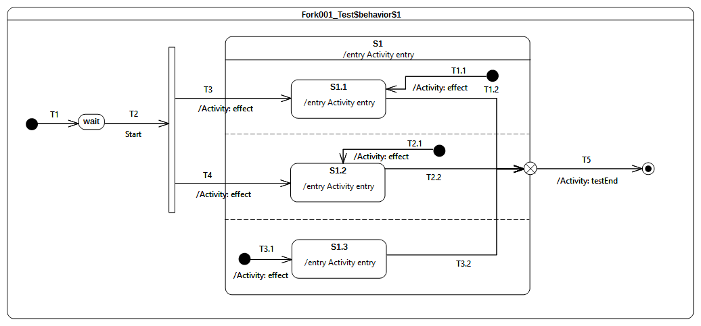Figure 9.58 - Fork 001 Test Classifier Behavior

Test execution
Received event occurrence(s)
- Start – received when in configuration wait.
Generated trace
- T3(effect)::S1(entry)::T3.1(effect)::S1.3(entry)::S1.1(entry)::T4(effect)::S1.2(entry). It is important to note that the trace generated by this execution is just one possible trace from the set of possible traces.
Note. The purpose of this test is to demonstrate the support for Fork pseudostate semantics, as well as the preservation of region entry rules, when this pseudostate is used. When the Start event occurrence is dispatched and accepted by the state machine, it triggers T2. Traversal of this transition brings the state machine to the Fork pseudostate. Both of its outgoing transitions are fired concurrently. However neither S1.1 nor S1.2 are entered immediately. S1 is entered first, its entry behavior is executed, and all regions that are not entered explicitly are started concurrently. This implies that the third region (i.e., the one containing S1.3) starts its execution starting from the initial pseudo state. Hence T3.1 is traversed and S1.3 is entered (a completion event is generated for that state when its entry behavior has finished). Finally both S1.1 and S1.2 are entered. This concludes the RTC step that was initiated by the acceptance of the Start event occurrence. The three completion events generated by S1.3, S1.1 and S2.1 will be used in next RTC steps to trigger T3.2, T1.2 and T2.2.
RTC Steps
Step | Event pool | State machine configuration | Fired transition(s)
1 | [] | [] - Initial RTC step | [T1]
2 | [Start, CE(wait)] | [wait] | []
3 | [Start] | [wait] | [T2(T3.1, T3, T4)]
4 | [CE(S1.2), CE(S1.1), CE(S1.3)] | [S1[S1.1, S1.2, S1.3]] | [T3.2]
5 | [CE(S1.2), CE(S1.1)] | [S1[S1.1, S1.2]] | [T1.2]
6 | [CE(S1.2)] | [S1[S1.2]] | [T2.2(T5)]

Fork 002

Tested state machine
The state machine that is executed for that test is presented in Figure 9.59.
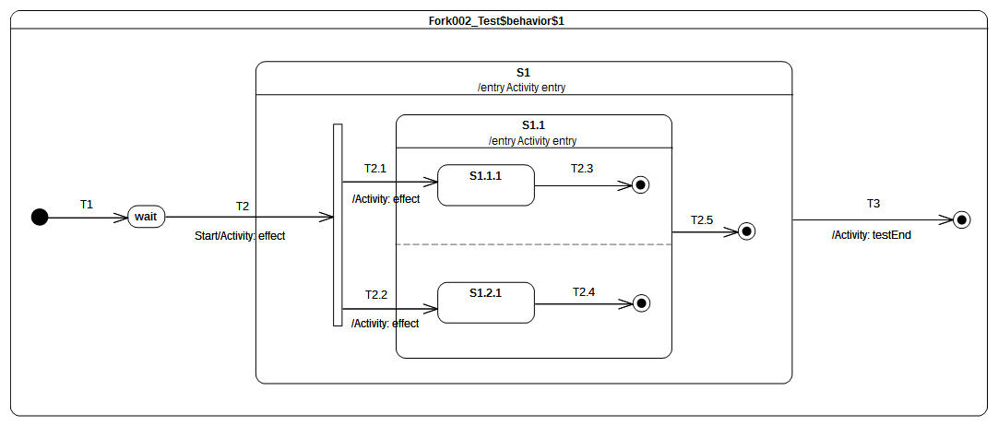Figure 9.59 - Fork 002 Test Classifier Behavior

Test execution
Received event occurrence(s)
- Start – received when in configuration wait.
Generated trace
- T2(effect)::S1(entry)::T2.1(effect)::S1.1(entry)::T2.2(effect). It is important to note that the trace generated by the execution is just one possible trace from the set of possible traces.
Note. The purpose of this test is to consolidate Fork semantics by evaluating that, if it is used in a nested context, the composite state explicit entry rule is preserved. When the Start event occurrence is dispatched and accepted by the state machine, T2 is triggered and its effect behavior is executed. This brings the state machine to the Fork pseudostate. As the Fork pseudostate is located within a composite state that is not already active, the latter is entered first. Hence S1 entry behavior is executed. Next, the Fork pseudostate outgoing transitions are traversed. The attempt to enter a state that is not already active leads to entering of that state and the execution of its entry behavior. Only at this point can explicit entry of both regions of S1.1 proceed.
RTC Steps
Step | Event pool | State machine configuration | Fired transition(s)
1 | [] | [] - Initial RTC step | [T1]
2 | [Start, CE(wait)] | [wait] | []
3 | [Start] | [wait] | [T2(T2.1, T2.2)]
4 | [CE(1.2.1), CE(S1.1.1)] | S1[S1.1[S1.1.1, S1.2.1]] | [T2.3]
5 | [CE(1.2.1)] | S1[S1.1[ S1.2.1]] | [T2.4]
6 | [CE(S1.1)] | [S1[S1.1]] | [T2.5]
7 | [CE(S1)] | [S1] | [T3]

Join

Overview
Test cases presented in this sub-clause assesses that Join semantics conforms to what is specified in UML.

Join 001
Join 001 ([UML], 14.2.3.7)
All incoming Transitions have to complete before execution can continue through an outgoing Transition.

Tested state machine
The state machine that is executed for that test is presented in Figure 9.60.
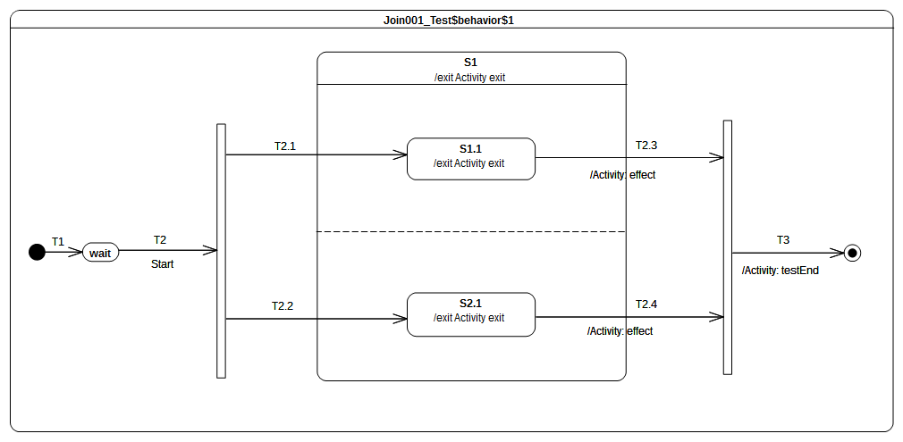Figure 9.60 - Join 001 Test Classifier Behavior

Test execution
Received event occurrence(s)
- Start – received when in configuration wait.
Generated trace
- S1.1(exit)::T2.3(effect)::S2.1(exit)::S1(exit)::T2.4(effect)
Note. The purpose of this test is to demonstrate that the Join pseudo state can only be traversed when all incoming transitions have been traversed. Lets consider the situation where the state machine is currently in configuration S1[S1.1, S2.1]. Two completion events (one for S1.1 and the other one for S2.1) are available in the pool. When the completion event generated by S1.1 is dispatched and accepted, it triggers T2.3. Next, S1.1 is exited, the effect behavior of T2.3 is executed but S1 is not exited and the join pseudostate is not traversed. The next step consists in accepting the S2.1 completion event. This means that T2.4 is triggered, so that S2.1 is exited and T2.4 is executed. In addition, S1 is exited and the join pseudo state is traversed. The continuation transition T3 is traversed. When the final state is reached, the state machine execution completes.
RTC Steps
Step | Event pool | State machine configuration | Fired transition(s)
1 | [] | [] - Initial RTC step | [T1]
2 | [Start, CE(wait)] | [wait] | []
3 | [Start] | [wait] | [T2(T2.1, T2.2)]
4 | [CE(S2.1), CE(S1.1)] | [S1[S1.1, S2.1]] | [T2.3]
5 | [CE(S2.1)] | [S1[S2.1]] | [T2.4(T3)]

Join 002

Tested state machine
The state machine that is executed for that test is presented in Figure 9.61.

Test execution
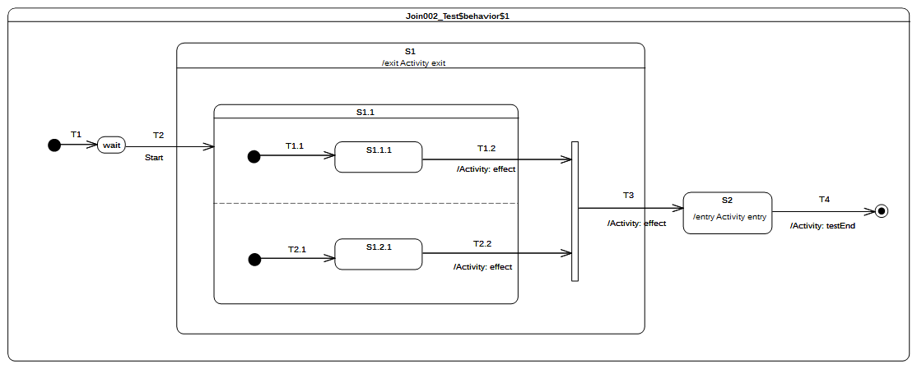Figure 9.61 - Join 002 Test Classifier behavior
Received event occurrence(s)
- Start – received when in configuration wait.
Generated trace
- T2.2(effect)::T1.2(effect)::S1(exit)::T3(effect)::S2(entry)
Note. The purpose of this test is to consolidate Join semantics and demonstrate that, if used in a nested context, the exit rule of a composite state is still preserved. Consider the situation where the state machine is in configuration S1[S1.1[S1.1.1]]. The completion event generated by S1.1.1 is dispatched and accepted. Next, T1.2 is traversed, its effect behavior is executed, S1.1 is exited, and the join pseudostate is reached. All incoming transitions have been fired so the join pseudostate can be traversed. When continuation transition T3 is traversed, S1 is exited, the effect behavior of the transition is executed, and, finally, S2 is entered.
RTC Steps
Step | Event pool | State machine configuration | Fired transition(s)
1 | [] | [] - Initial RTC step | [T1]
2 | [Start, CE(wait)] | [wait] | []
3 | [Start] | [wait] | [T2(T1.1, T2.1)]
4 | [CE(S1.2.1), CE(S1.1.1)] | [S1[S1.1[S1.1.1, S1.2.1]]] | [T1.2]
5 | [CE(S1.2.1)] | [S1[S1.1[S1.2.1]]] | [T2.2(T3)]
6 | [CE(S2)] | [S2] | [T4]

Terminate

Overview
Test cases presented in this sub-clause assesses that Terminate semantics conforms to what is specified in UML.

Terminate 001
Terminate 001 ([UML], 14.2.3.7)
Entering a terminate Pseudostate implies that the execution of the StateMachine is terminated immediately. The StateMachine does not exit any States nor does it perform any exit Behaviors.

Tested state machine
The state machine that is executed for that test is presented in Figure 9.62.
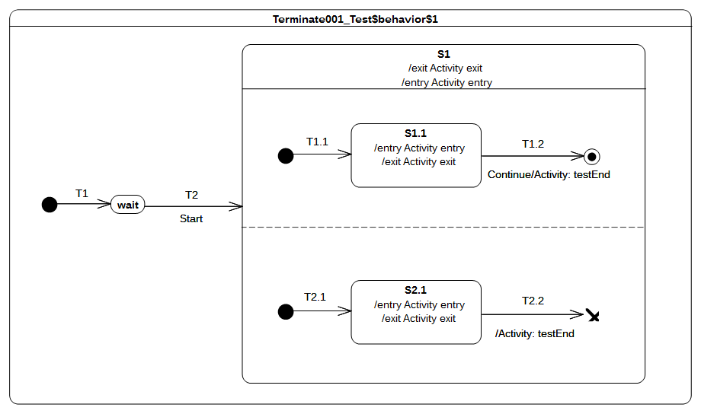Figure 9.62 - Terminate 001 Test Classifier behavior

Test execution
Received event occurrence(s)
- Start – received when in configuration wait.
Generated trace
- S1(entry)::S1.1(entry)::S2.1(entry)::S2.1(exit)
Note. The purpose of this test is to demonstrate support for terminate semantics. Consider the situation where the state machine is in configuration S1[S1.1, S2.1]. Two completion events are in the event pool, one of for S2.1 and the other one for S1.1. When the S2.1 completion event is accepted, it triggers T2.2. The traversal of this transition leads the state machine to reach the terminate pseudostate. To be conformant with UML, no state can be exited when the terminate pseudo-state is entered since the state machine terminates its execution. This behavior can be observed in the generated trace. Indeed neither S1.1 nor S1 have executed their exit behaviors after the execution of the terminate pseudostate.
RTC Steps
Step | Event pool | State machine configuration | Fired transition(s)
1 | [] | [] - Initial RTC step | [T1]
2 | [Start, CE(wait)] | [wait] | []
3 | [Start] | [wait] | [T2(T1.1, T2.1)]
4 | [CE(S2.1), CE(S1.1)] | [S1[S1.1, S2.1]] | []
5 | [CE(2.1)] | [S1[S1.1, S2.1]] | [T2.2]

Terminate 002
Terminate 002 ([UML], 14.2.3.7)
Any executing doActivity Behaviors are automatically aborted. Entering a terminate Pseudostate is equivalent to invoking a DestroyObjectAction.

Tested state machine
The state machine that is executed for that test is presented in Figure 9.63.
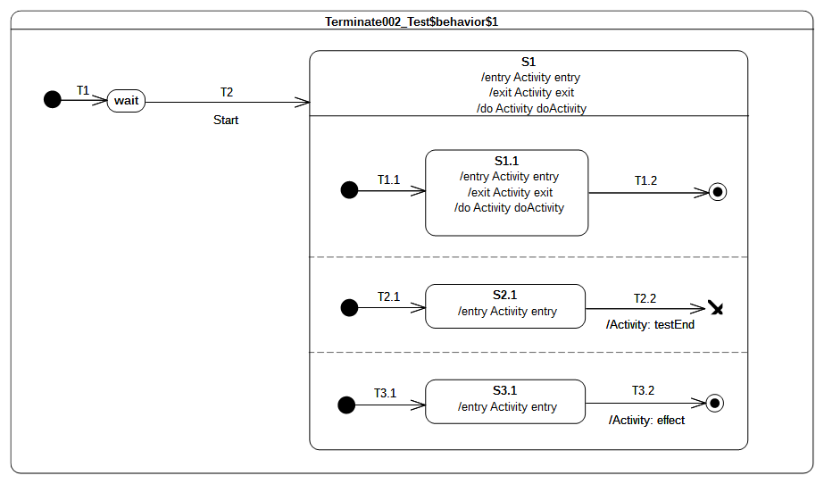Figure 9.63 - Terminate 002 Test Classifier Behavior

Test execution
Received event occurrence(s)
- Start – received when in configuration wait.
Generated trace
- S1(entry)::S1.1(entry)::S2.1(entry)::S3.1(entry)
Notes
- The purpose of this test is to demonstrate that running doActivity behaviors are aborted if a terminate pseudostate is reached. At the end of the RTC step initiated by the acceptance of the Start event occurrence, the state machine is in configuration S1[S1.1, S2.1, S3.1]. The doActivity behaviors of S1 and S1.1 have been invoked (which does not mean that they have already started) and two completion events are waiting in the pool: one for S2.1 and the other one for S3.1. Assuming that the completion event generated by S2.1 is accepted first, T2.2 fires and the state machine execution is terminated. In addition, the doActivity behaviors of S1 and S1.1 are aborted and no exit behavior is executed.
- Here it is important to note that it alternative valid execution traces are possible. Indeed, the S3.1 completion might be dispatched and accepted first before the termination, so that T3.2 would have been traversed and the message T3.2(effect) would have appeared in the trace. As another example, it also possible that two doActivity behaviors were invoked. These behaviors may have already started their execution, so that the messages S1(doActivityPartI) and S1.1(doActivityPartI) would also have been in the trace.
RTC Steps
Step | Event pool | State machine configuration | Fired transition(s)
1 | [] | [] - Initial RTC step | [T1]
2 | [Start, CE(wait)] | [wait] | []
3 | [Start] | [wait] | [T2(T1.1, T2.1, T3.1)]
4 | [CE(S3.1), CE(S2.1), CE(S1.1)] | [S1[S1.1, S2.1, S3.1]] | [T1.2]
5 | [CE(S3.1), CE(S2.1)] | [S1[S2.1, S3.1]] | [T2.2]

Terminate 003

Tested state machine
The state machine that is executed for that test is presented in Figure 9.64.
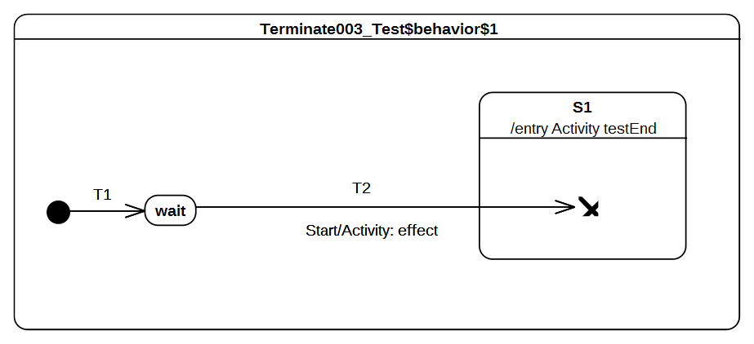Figure 9.64 - Terminate 003 Test Classifier Behavior

Test execution
Received event occurrence(s)
- Start – received when in configuration wait.
Generated trace
- T2(effect)
Note. The purpose of this test is to ensure that, when a terminate pseudostate is used in a nested context, the composite state entry rule is preserved. When the Start event occurrence is dispatched and accepted by the state machine, T2 is triggered. Next, wait is exited, the effect behavior of the transition is executed, S1 is entered, and, finally, the terminate pseudostate is reached. The execution of this pseudostate implies the termination of the state machine. Note that if the entry behavior of S1 was not executed, then the semantic test would not have been notified of the termination of the test target. Hence the test would not have been considered as passed.
RTC Steps
Step | Event pool | State machine configuration | Fired transition(s)
1 | [] | [] - Initial RTC step | [T1]
2 | [Start, CE(wait)] | [wait] | []
3 | [Start] | [wait] | [T2]

Final

Overview
Test cases presented in this sub-clause assesses that final state semantics conforms to what is specified in UML.

Final 001
Final 001
FinalState is a special kind of State signifying that the enclosing Region has completed. Thus, a Transition to a FinalState represents the completion of the behaviors of the Region containing the FinalState.

Tested state machine
The state machine that is executed for that test is presented in Figure 9.65.
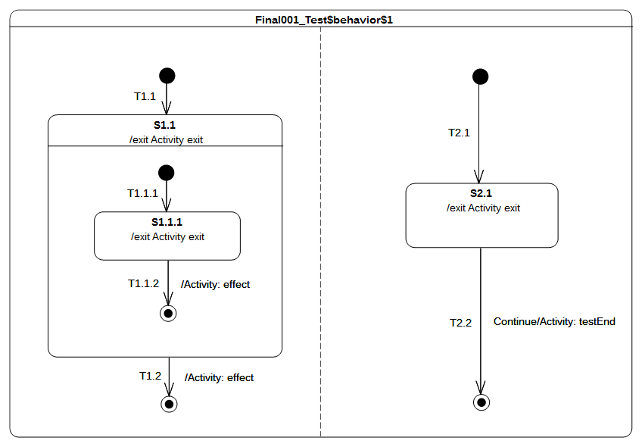Figure 9.65 - Final 001 Test Classifier Behavior

Test execution
Received event occurrence(s)
- Start – received when in configuration wait.
- Continue – received when in configuration [S1[S1.1.1], S2.1].
Generated trace
- S1.1.1(exit)::T1.1.2(effect)::S1.1(exit)::T1.2(effect)::S2.1(exit)
Note. The purpose of this test is to demonstrate support for the Final state, both at the state machine and composite state levels. When the state machine starts its execution, both regions starts their executions concurrently. The initial RTC step ends up with the following configuration: [S1.1[S1.1.1], S2.1]. At this point, there are two completion events placed in the pool. The completion events were generated when S2.1 and S1.1.1 were entered. Assuming that the S2.1 completion event is at the head of the event pool, it is dispatched first. However, it does not initiate an RTC step. Since S2.1 has no completion transition the completion event is lost. The next RTC step consists of dispatching and accepting the S1.1.1 completion event. It triggers traversal of T1.1.2 and leads the state machine to reach the final state located in the S1.1 region. This region completes and a completion event is generated for S1.1. This completion event is dispatched and accepted in the next RTC step. It triggers T1.2 so that the final state is reached, and the left-hand region of the state machine completes. When the Continue event occurrence is dispatched and accepted, T2.2 is triggered. The state machine execution completes when the target final state is reached.
RTC Steps
Step | Event pool | State machine configuration | Fired transition(s)
1 | [] | [] - Initial RTC step | [T1]
2 | [Start, CE(wait)] | [wait] | []
3 | [Start] | [wait] | [T1.1(T1.1.1), T2.1]
4 | [Continue, CE(S2.1), CE(S1.1.1)] | [S1.1[S1.1.1], S2.1] | [T1.1.2]
5 | [Continue, CE(S1.1), CE(S2.1)] | [S1.1, S2.1] | []
6 | [Continue, CE(S1.1)] | [S1.1, S2.1] | [T1.2]
7 | [Continue] | [S2.1] | [T2.2]

Deferred

Overview
Test cases presented in this sub-clause assesses that deferred event semantics conform to what is specified in UML.

Deferred 001
Deferred 001 ([UML], 14.2.3.4.4)
A State may specify a set of Event types that may be deferred in that State. This means that Event occurrences of those types will not be dispatched as long as that State remains active. Instead, these Event occurrences remain in the event pool until a state configuration is reached where these Event types are no longer deferred.

Tested state machine
The state machine that is executed for that test is presented in Figure 9.66.
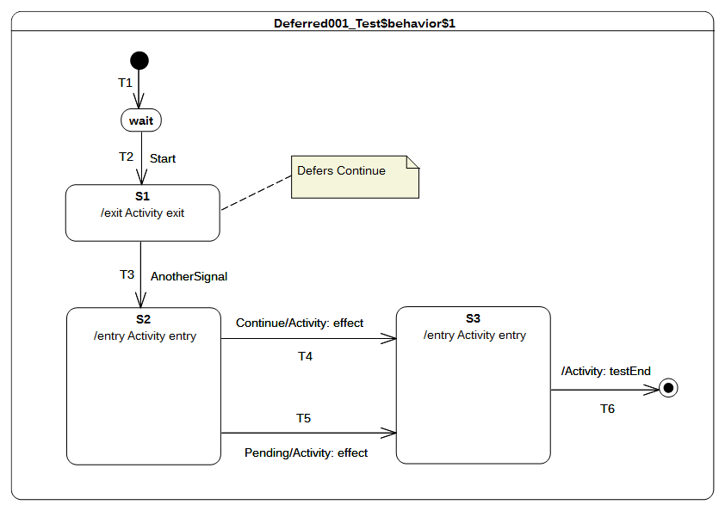Figure 9.66 - Deferred 001 Test Classifier Behavior

Test execution
Received event occurrence(s)
- Start – received when in configuration wait.
- Continue – received when in configuration S1.
- AnotherSignal – received when in configuration S1.
- Pending – received when in configuration S2.
Generated trace
- S1(exit)::S2(entry)::T4(effect)::S3(entry)
Note. The purpose of this test is to demonstrate support for event deferral in the context of simple states. Consider the situation where the state machine is in configuration S1. S1 has no completion transitions, hence its completion event is lost when it is dispatched. The Continue event occurrence is dispatched and can be accepted since it is indicated as being deferred in configuration S1. The acceptance of the event occurrence does not change the state machine configuration. The next RTC step consists of dispatching and accepting AnotherSignal. This leads to the triggering of T3. S1 is exited, which means that the Continue event occurrence is no longer deferred so that S2 is entered. At this point, three event occurrences are available in the pool. The one at the head of the pool is the completion event for S2, the second is the Continue event occurrence, and the last is the Pending event occurrence. The dispatching of the completion event does not trigger a new RTC step since S2 has no completion transition. The next event to be dispatched (i.e., the one that was originally deferred) matches the trigger declared in T4. Hence T4 is taken, its effect behavior is executed, and S3 is entered. As the completion event generated by S3 has priority over the Pending event occurrence, it is dispatched first. The S3 completion transition is traversed and the state machine execution completes when the final state is reached. Note that in this execution the Pending event occurrence is never dispatched. However, if the Continue event occurrence was actually not deferred, a different execution path would have occurred. That is, T5 would have been taken instead of T4.
RTC Steps
Step | Event pool | State machine configuration | Fired transition(s)
1 | [] | [] - Initial RTC step | [T1]
2 | [Start, CE(wait)] | [wait] | []
3 | [Start] | [wait] | [T2]
4 | [AnotherSignal, Continue, CE(S1)] | [S1] | []
5 | [AnotherSignal, Continue] | [S1] | []
6 | [AnotherSignal] | [S1] | [T3]
7 | [Pending, Continue] | [S2] | [T4]
8 | [Pending, CE(S3)] | [S3] | [T6]

Deferred 002
Deferred 002 ([UML], 14.2.3.4.4)
If a deferred Event type is used explicitly in a Trigger of a Transition whose source is the deferring State (i.e., a kind of override option).

Tested state machine
The state machine that is executed for that test is presented in Figure 9.67.
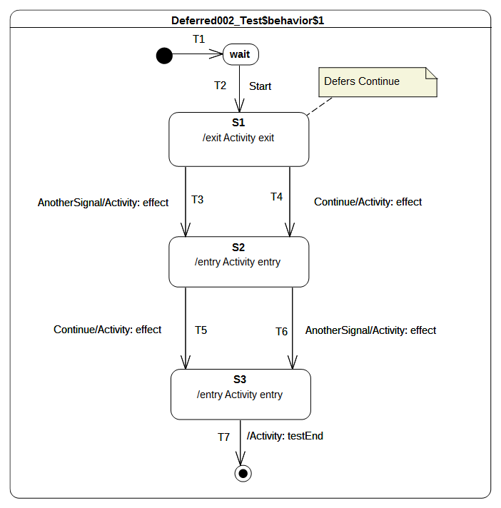Figure 9.67 - Deferred 002 Test Classifier Behavior

Test execution
Received event occurrence(s)
- Start – received when in configuration wait.
- Continue – received when in configuration S1.
- AnotherSignal – received when in configuration S1.
- Continue – received when in configuration S2.
Generated trace
- S1(exit)::T4(effect)::S2(entry)::T6(effect)::S3(entry)
Note. The purpose of this test is to demonstrate that, in a specific situation, an event that is declared as being deferred is not actually deferred. Consider the situation where the state machine is in configuration S1 and the completion event of S1 was dispatched but did not trigger any RTC step. The event pool contains, at this time, two event occurrences. The first one is a Continue event occurrence and the second is an AnotherSignal event occurrence. When the Continue event occurrence is accepted, it is not deferred. Indeed a transition originating from the deferring state has a trigger which explicitly refers to the Continue event type. This overrides the deferring constraint and transition T4 is triggered. Next, S1 is exited, the effect behavior of the transition is executed, and S2 is entered. The completion event generated by S2 will not trigger an RTC step since this state has no completion transition. The next RTC step consists of dispatching and accepting the AnotherSignal event occurrence. This means that T6 is triggered, so that S2 is exited, the effect behavior is executed, and S3 is entered. The completion event of S3 is used to initiate the next RTC step, which leads the state machine to reach the final state and to completing its execution.
RTC Steps
Step | Event pool | State machine configuration | Fired transition(s)
1 | [] | [] - Initial RTC step | [T1]
2 | [Start, CE(wait)] | [wait] | []
3 | [Start] | [wait] | [T2]
4 | [AnotherSignal, Continue, CE(S1)] | [S1] | []
5 | [AnotherSignal, Continue] | [S1] | [T4]
6 | [Continue, AnotherSignal, CE(S2)] | [S2] | []
7 | [Continue, AnotherSignal] | [S2] | [T6]
8 | [Continue, CE(S3)] | [S3] | [T7]

Deferred 003
Deferred 003 ([UML], 14.2.3.4.4)
An Event may be deferred by a composite State or submachine States, in which case it remains deferred as long as the composite State remains in the active configuration.

Tested state machine
The state machine that is executed for that test is presented in Figure 9.68.
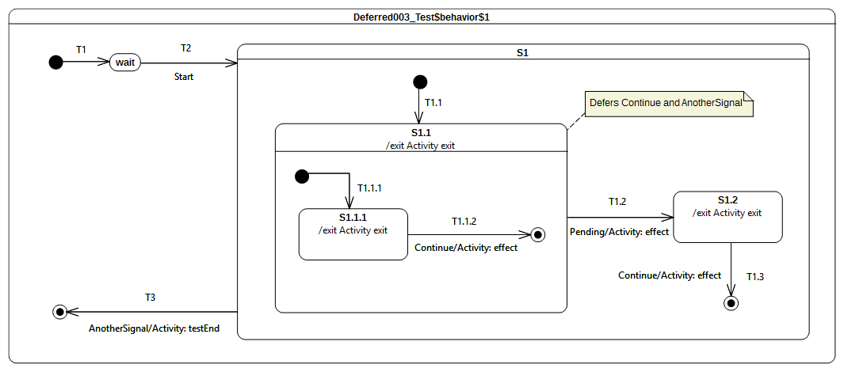Figure 9.68 - Deferred 003 Test Classifier Behavior

Test execution
Received event occurrence(s)
- Start – received when in configuration wait.
- Continue – received when in configuration S1[S1.1[S1.1.1]].
- Continue – received when in configuration S1[S1.1].
- AnotherSignal – received when in configuration S1[S1.1].
- Pending – received when in configuration S1[S1.1].
Generated trace
- S1.1.1(exit)::T1.1.2(effect)::S1.1(exit)::T1.2(effect)::S1.2(exit)::T1.3(effect)
Note. The purpose of this test is to demonstrate the support for deferred event semantics when the deferred event type is declared by a composite state. Consider the situation where the state machine is in the configuration S1[S1.1[S1.1.1]]. There are, at this time, two events occurrence ready to be dispatched: the first is a completion event for state S1.1.1 and the second is a Continue event occurrence. The completion event is lost since S1.1.1 has no completion transition. Next, the Continue event occurrence is dispatched and accepted. Transition T1.1.2 is triggered by this event occurrence. This transition has priority over the deferring constraint added by S1.1 since it is more deeply nested in the state hierarchy. Therefore, T1.1.2 is triggered and S1.1.1 leaves the state machine configuration so that S1.1 region completes. The completion event generated by S1.1 cannot be used to trigger any transition so that it is lost. The next RTC step consists of dispatching a new Continue event occurrence. This event occurrence is accepted and deferred due to the constraint required by S1.1. The next event occurrence to be dispatched and accepted is of type AnotherSignal. S1.1 also defers this type of event occurrences. Since the state machine configuration did not change, the event occurrence is deferred. To summarize, at this point of the execution two events occurrences are deferred: one Continue event occurrence and one AnotherSignal event occurrence. The next RTC step is initiated by the acceptance of the Pending event occurrence. As T1.2 can be triggered using this event occurrence, state S1.1 is exited (the deferred events are released), the effect behavior of the transition is executed and S1.2 is entered. The S1.2 completion event does not trigger an RTC step since it has no completion transitions. The Continue event occurrence that was originally deferred is used to trigger T1.3, which leads the S1 region to complete. The S1 completion event is lost, however. The final RTC step is initiated by the dispatching of the AnotherSignal event occurrence. It triggers T3, which enables the state machine to reach the final state and to complete its execution.
RTC Steps
Step | Event pool | State machine configuration | Fired transition(s)
1 | [] | [] - Initial RTC step | [T1]
2 | [Start, CE(wait)] | [wait] | []
3 | [Start] | [wait] | [T2(T1.1, T1.1.1)]
4 | [Continue, CE(S1.1.1)] | [S1[S1.1[S1.1.1]]] | []
5 | [Continue] | [S1[S1.1]] | [T1.1.2]
6 | [Pending, AnotherSignal, Continue, CE(S1.1)] | [S1[S1.1]] | []
7 | [Pending, AnotherSignal, Continue] | [S1[S1.1]] | []
8 | [Pending, AnotherSignal] | [S1[S1.1]] | []
9 | [Pending] | [S1[S1.1]] | [T1.2]
10 | [AnotherSignal, Continue, CE(S1.2)] | [S1.2] | []
11 | [AnotherSignal, Continue] | [S1.2] | [T1.3]
12 | [AnotherSignal, CE(S1)] | [S1] | []
13 | [AnotherSignal] | [S1] | [T3]

Deferred 004 – A

Tested state machine
The state machine that is executed for that test is presented in Figure 9.69.
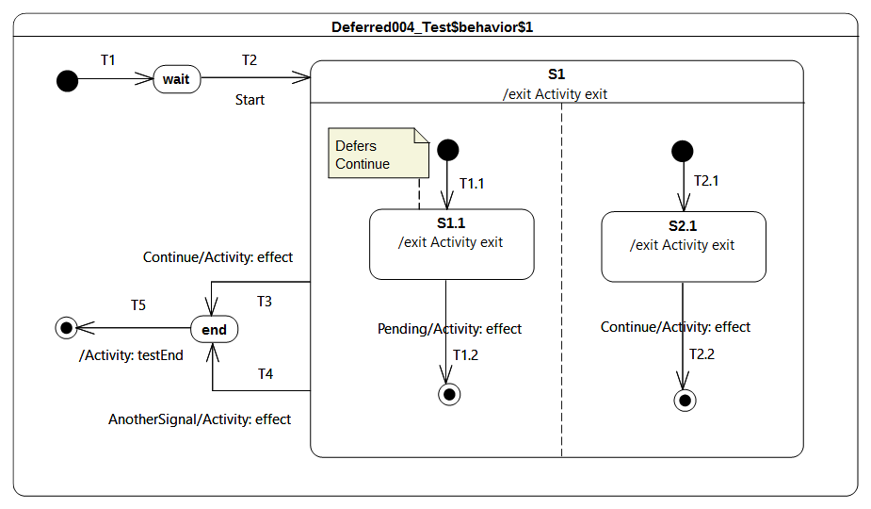Figure 9.69 - Deferred 004 - A Test Classifier Behavior

Test execution
Received event occurrence(s)
- Start – received when in configuration wait.
- Continue – received when in configuration S1[S1.1, S2.1].
- Pending – received when in configuration S1[S1.1, 2.1].
- AnotherSignal – received when in configuration S1.
Generated trace
- S1.1(exit)::T1.2(effect)::S2.1(exit)::T2.2(effect)::S1(exit)::T4(effect)
Note. The purpose of this test is to assess deferred events semantics when used in the context of orthogonal regions. Consider the situation where the state machine is in configuration S1[S1.1, S2.1]. After dispatching of completion events for S1.1 and S2.1, there remains one event occurrence in the pool that is ready to be dispatched: a Continue event occurrence. When the Continue event occurrence is dispatched and accepted by the state machine, it is deferred by S1.1. The current state machine configuration remains S1[S1.1, S2.1]. The next RTC step is initiated by the acceptance of the Pending event occurrence. This starts by triggering T1.2. As S1.1 leaves the state machine configuration, the Continue event occurrence is now available in the pool. The left-hand region completes. T2.2 is triggered by the RTC step initiated by the dispatching of the Continue event occurrence. This leads S1 to generate a completion event. The completion event is lost since S1 has no outgoing completion transition. S1 is exited when AnotherSignal event is dispatched.
Submission Note. [UML] 14.2.3.4.4 states that “if a deferred Event type is used explicitly in a Trigger of a Transition whose source is the deferring State (i.e., a kind of override option)”. In the situation presented in the test case, S1.1 has no outgoing transitions with a trigger using the Continue event type. Consequently, the S1.1 deferring constraint is not overridden. Nevertheless, it also reasonable to think that the outgoing transition of S2.1 (i.e., T2.2) should have overridden S1.1 constraint. Hence in an alternative execution S2.1 is exited first and T2.2 is traversed. The generated execution trace would have been: S2.1(exit)::T2.2(effect)::S1.1(exit)::T1.2(effect)::S1(exit)::T4(effect). This part of the state machine semantics is still under discussion.
RTC Steps
Step | Event pool | State machine configuration | Fired transition(s)
1 | [] | [] - Initial RTC step | [T1]
2 | [Start, CE(wait)] | [wait] | []
3 | [Start] | [wait] | [T2(T1.1, T2.1)]
4 | [Pending, Continue, CE(S2.1), CE(S1.1)] | [S1[S1.1, S2.1]] | []
5 | [Pending, Continue, CE(S2.1)] | [S1[S1.1, S2.1]] | []
6 | [Pending, Continue] | [S1[S1.1, S2.1]] | []
7 | [Pending] | [S1[S1.1, S2.1]] | [T1.2]
8 | [Continue] | [S1[S2.1]] | [T2.2]
9 | [AnotherSignal, CE(S1)] | [S1] | []
10 | [AnotherSignal] | [S1] | [T4]
11 | [CE(end)] | [end] | [T5]

Deferred 004 – B

Tested state machine
The state machine that is executed for that test is presented in Figure 9.70.
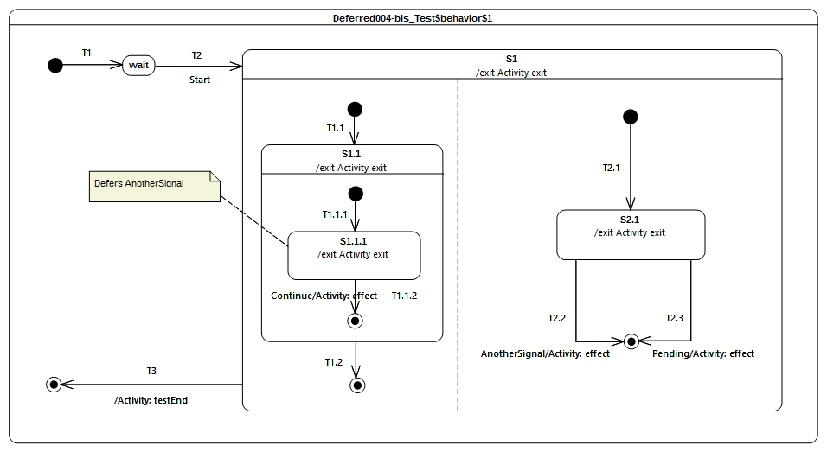Figure 9.70 - Deferred 004 - B Classifier behavior

Test execution
Received event occurrence(s)
- Start – received when in configuration wait.
- AnotherSignal – received when in configuration S1[S1.1[S1.1.1], S2.1].
- Continue – received when in configuration S1[S1.1[S1.1.1], S2.1].
- Pending – received when in configuration S1.
Generated trace
- S1.1.1(exit)::T1.1.2(effect)::S1.1(exit)::S2.1(exit)::T2.2(effect)::S1(exit)
Note. The purpose of this test is is to assess deferred events semantics when used in the context of orthogonal regions. Consider the situation where the state machine is in configuration S1[S1.1[S1.1.1], S2.1]. After dispatching of completion events for S1.1.1 and S2.1, there remain two event occurrences in the pool: an AnotherSignal event occurrence and a Continue event occurrence. When accepted, the AnotherSignal event occurrence is deferred by S1.1.1. The next RTC step is initiated by the acceptance of the Continue event occurrence. T1.1.2 is triggered, which means that S1.1.1 leaves the state machine configuration, so that the event occurrence that was previously deferred becomes available. The unique region of S1.1 completes, and a completion event is generated for S1.1. In the next RTC step, this completion event is dispatched and accepted. This means that T1.2 is triggered, which leads to the completion of the left region of S1. At this point, one event occurrence (i.e., AnotherSignal) remains in the pool. When dispatched, it triggers T2.2 which forces and exit of S2.1, and the final state is reached leading to the completion of the S1 region.
Submission Note. Here again the semantics can be different regarding the interpretation of the overriding transition rule. Indeed, if we consider that when the AnotherSignal event occurrence is dispatched, the event will not be deferred because T2.2 in the right region can fire. In that case the execution trace would be different.
RTC Steps
Step | Event pool | State machine configuration | Fired transition(s)
1 | [] | [] - Initial RTC step | [T1]
2 | [Start, CE(wait)] | [wait] | []
3 | [Start] | [wait] | [T2(T1.1(T1.1.1), T2.1)]
4 | [Continue, AnotherSignal, CE(S1.1.1)] | [S1[S1.1[S1.1.1], S2.1]] | []
5 | [Continue, AnotherSignal] | [S1[S1.1[S1.1.1], S2.1]] | []
6 | [Continue] | [S1[S1.1[S1.1.1], S2.1]] | [T1.1.2]
7 | [AnotherSignal, CE(S1.1)] | [S1[S1.1, S2.1]] | [T1.2]
8 | [AnotherSignal] | [S1[2.1]] | [T2.2]
9 | [Pending, CE(S1)] | [S1] | [T3]

Standalone

Overview
This subclause includes tests related the execution of a standalone state machines, that is, state machines that are themselves active behaviors, as opposed to being the classifier behaviors of other classes.

Standalone 001

Tested state machine
The state machine that is executed for that test is presented in Figure 9.71. Given that a UML state machine is a kind of UML Class, it is legal for this state machine to specialize the Target abstract class (see section 9.2.2.2.2). Hence the state machine itself is the test target, which means that it is able to receive any signals that a Target can receive. Note that the standalone state machine is active (as is required by fUML in order for it to specialize an active class), but it does not have a classifier behavior, meaning that, dynamically, it acts as the context for its own execution.
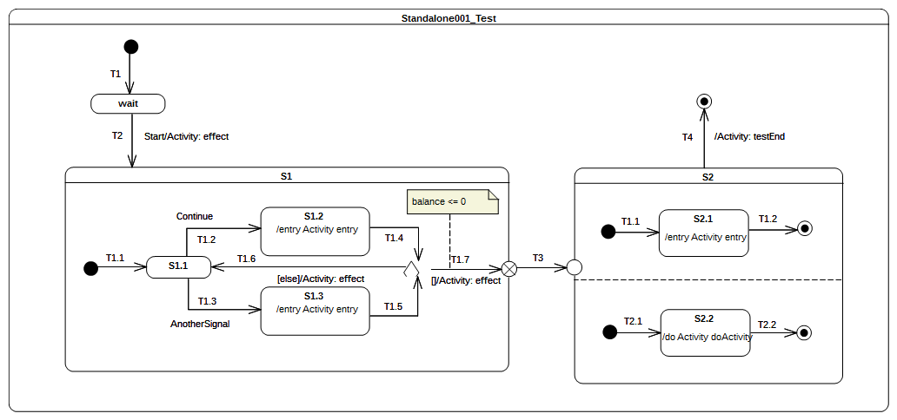
Figure 9.71 - Standalone 001 Test

Test execution
Received event occurrence(s)
- Start – received when in configuration wait.
- Continue – received when in configuration S1[S1.1].
- Continue – received when in configuration S1[S1.1].
Generated trace
- T2(effect)::S1.2(entry)::T1.6(effect)::S1.2(entry)::T1.7(effect)::S2.1(entry)::S2.2(doActivity)
Note. The Start event occurrence is dispatched and accepted while the state machine is in configuration wait. Hence, T2 is triggered (see message T2(effect) in the trace) and S1 is entered using the default entry approach. The S1 region starts executing from the initial pseudo state, T1.1 is traversed, and S1.1 is entered. The next RTC step is initiated by the acceptance of the Continue event occurrence, which triggers T1.2 and whose tarversal leads to S1.2 being entered. The execution of the S1.2 entry behavior updates a property balance owned by the state machine. When this behavior has terminated its execution, a completion event is generated for S1.2. The completion event is used to trigger T1.4. The state machine reaches the choice point and evaluates the guard of T1.7 . The balance (initial value 150) is not lower than or equal to 0, hence the else transition T1.6 is taken, and a completion event is generated upon S1.1 entry. A second Continue event occurrence is dispatched and accepted, and the state machine returns to S1.2 generating a completion event for that state. This time, when T1.4 is triggered, the choice point is reached and the T1.7 guard is true, so it can be traversed. When the exit point is reached, S1 is exited. The continuation transition T3 is then traversed, and S2 is entered through the entry point. Conseqeuntly, both orthogonal regions are entered using the default entry approach. S2.1 generates a completion event when this entry behavior terminated its execution, and S2.2 generates a completion event when its doActivity has completed. Completion events generated by these states are used to trigger T1.2 and T2.2. When both completion events have been dispatched and accepted, S2 can complete. The completion event will be used to trigger T4 and the final state is reached, which will complete the state machine execution.
RTC Steps
Step | Event pool | State machine configuration | Fired transition(s)
1 | [] | [] - Initial RTC step | [T1]
2 | [Start, CE(wait)] | [wait] | []
3 | [Start] | [wait] | [T2(T1.1)]
4 | [Continue, CE(S1.1)] | [S1[S1.1]] | []
5 | [Continue] | [S1[S1.1]] | [T1.2]
6 | [CE(S1.2)] | [S1[S1.2]] | [T1.4(T1.6)]
7 | [Continue, CE(S1.1)] | [S1[S1.1]] | []
8 | [Continue] | [S1[S1.1]] | [T1.2]
9 | [CE(S1.2)] | [S1[S1.2]] | [T1.4(T1.7, T3, T1.1, T2.1))]
10 | [CE(2.1)] | [S2[S2.1, S2.2]] | [T1.2]
11 | [CE(S2.2)] | [S2[S2.2]] | [T2.2]
12 | [CE(S2)] | [S2] | [T4]

Other Tests

Overview
This subclause includes some additional tests based on examples from the UML specification. These tests assess that the intended execution semantics of each example are captured by the PSSM execution model.

Transition Execution Algorithm Test

Tested state machine
This test is based on the example from [UML], Figure 14.2. The state machine that is executed for the test is presented in Figure 9.72.
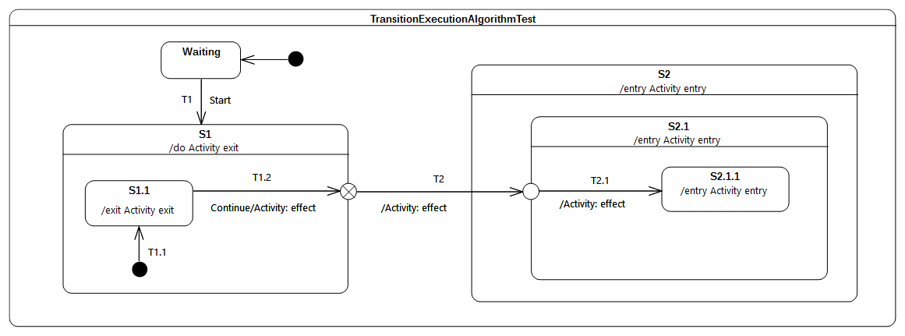Figure 9.72 - TransitionExecutionAlgorithmTest Classifier behavior

Test execution
Received event occurrence(s)
- Start – received when in configuration wait.
- Continue – received when in configuration S1[S1.1].
Generated trace
- S1.1(exit)::T1.2(effect)::S1(exit)::T2(effect)::S2(entry)::S2.1(entry)::T2.1(effect)
Note. Consider the situation where the state machine is in configuration S1[S1.1]. There are two events available in the pool: the first one is the completion event for S1.1 and the second is a Continue event occurrence. The completion event gets dispatched first. It does not initiate an RTC step, since S1.1 has no completion transition and, therefore, the event occurrence is lost. When the completion event occurrence is dispatched, it triggers T1.2. State S1.1 is exited, the T1.2 effect behavior is executed, and the exit point placed on the edge of S1 is reached. This exit point implies exiting S1 and traversal of the continuation transition T2. This leads the state machine to reach the entry point placed on the edge of S2.1. At this point, S2 is entered first and the continuation transition T2.1 is traversed. This means that at the conclusion of the RTC step, S2.1.1 is entered and its entry behavior is executed.
RTC Steps
Step | Event pool | State machine configuration | Fired transition(s)
1 | [] | [] - Initial RTC step | [IntialTransitin]
2 | [Start, CE(wait)] | [wait] | []
3 | [Start] | [wait] | [T1(T1.1)]
4 | [Continue, CE(S1.1)] | [S1[S1.1]] | []
5 | [Continue] | [S1[S1.1]] | [T1.2(T2, T2.1)]
6 | [CE(2.1.1)] | [S2[S2.1[S2.1.1]]] | []

Test Coverage and Traceability

Overview
The purpose of this subclause is to provide a full description of the semantic requirements identified for PSSM. The requirements are grouped into categories (Behavior, Transition, etc). Each category is presented as a table composed of the following columns:
- ID – The identifier of a requirement within a category.
- Description – The requirement description. This is directly extracted from the UML 2.5 specification.
- Satisfied – Identify if the requirement is captured within the semantic model.
- Verified – Identify if the requirement is captured within the semantic model and tested by the PSSM test suite.
- Related Tests – Identify the tests that verify the requirements or explain why a requirement is not satisfied.
Possible values for columns Satisfied and Verified are:
- YES – The requirement is satisfied / verified.
- NO – The requirement is not satisfied / verified.
- NEUTRAL – The requirement is out of the PSSM scope or simply cannot be verified through the test suite model.

Behaviors
ID | Description (UML 2.5 specification) | Satisfied | Verified | Related test(s) / Notes
Behaviors 001 | A State may have an associated entry Behavior. This Behavior, if defined, is executed whenever the State is entered through an external Transition. | YES | YES | The test verifying this requirement is presented in section 9.3.2.2.
Behaviors 002 | A State may also have an associated exit Behavior, which, if defined, is executed whenever the State is exited. | YES | YES | The test verifying this requirement is presented in section 9.3.2.3
Behaviors 003 | A State may also have an associated doActivity Behavior. This Behavior commences execution when the State is entered (but only after the State entry Behavior has completed) and executes concurrently with any other Behaviors that may be associated with the State, until it completes (in which case a completion event is generated) or the State is exited, in which case execution of the doActivity Behavior is aborted. | YES | YES | The tests verifying this requirement are presented in sections 9.3.2.4 and 9.3.2.5.
Behaviors 004 | The execution of a doActivity Behavior of a State is not affected by the firing of an internal Transition of that State. | YES | YES | The test verifying this requirement is presented in section 9.3.2.6

Choice
ID | Description (UML 2.5 specification) | Satisfied | Verified | Related test(s) / Notes
Choice 001 | The guard Constraints on all outgoing Transitions are evaluated dynamically, when the compound transition traversal reaches this Pseudostate. | YES | YES | The test verifying this requirement is presented in section 9.3.9.2.
Choice 002 | If more than one guard evaluates to true, one of the corresponding Transitions is selected. The algorithm for making this selection is not defined. | YES | YES | The test verifying this requirement is presented in section 9.3.9.3.
Choice 003 | If none of the guards evaluates to true, then the model is considered ill formed. To avoid this, it is recommended to define one outgoing Transition with the predefined “else” guard for every choice Pseudostate. | YES | YES | The test verifying this requirement is presented in section 9.3.9.4.

Deferred
ID | Description (UML 2.5 specification) | Satisfied | Verified | Related test(s) / Notes
Deferred 001 | A State may specify a set of Event types that may be deferred in that State. This means that Event occurrences of those types will not be dispatched as long as that State remains active. Instead, these Event occurrences remain in the event pool until a state configuration is reached where these Event types are no longer deferred. | YES | YES | The test verifying this requirement is presented in section 9.3.14.2.
Deferred 002 | if a deferred Event type is used explicitly in a Trigger of a Transition whose source is the deferring State. | YES | YES | The test verifying this requirement is presented in section 9.3.14.3.
Deferred 003 | An Event may be deferred by a composite State, in which case it remains deferred as long as the composite State remains in the active configuration | YES | YES | The test verifying this requirement is presented in section 9.3.14.4.
Submission notes: It exists two additional tests for deferred event semantics which are not directly related to a requirement. These tests are respectively included in sections 9.3.14.5 and 9.3.14.6. They assess the usage of deferred events in the context of orthogonal regions. Execution sequences produced by both tests are still under discussion.

Encapsulated
ID | Description (UML 2.5 specification) | Satisfied | Verified | Related test(s) / Notes
Encaps 001 | Entry points represent termination points (sources) for incoming Transitions and origination points (targets) for Transitions that terminate on some internal Vertex of the composite State. In effect, the latter is a continuation of the external incoming Transition, with the proviso that the execution of the entry Behavior of the composite State (if defined) occurs between the effect Behavior of the incoming Transition and the effect Behavior of the outgoing Transition. | YES | YES | There does not exist a dedicated test for this requirement. Nevertheless, support for this requirement is shown in the test presented in section 9.3.8.4
Encaps 002 | If there is no outgoing Transition inside the composite State, then the incoming Transition simply performs a default State entry. | YES | YES | There does not exist a dedicated test for this requirement. Nevertheless, support for this requirement is shown in the test presented in section 9.3.8.5.
Encaps 003 | Exit points are the inverse of entry points. That is, Transitions originating from a Vertex within the composite State can terminate on the exit point. In a well-formed model, such a Transition should have a corresponding external Transition outgoing from the same exit point, representing a continuation of the terminating Transition. If the composite State has an exit Behavior defined, it is executed after any effect Behavior of the incoming inside Transition and before any effect Behavior of the outgoing external Transition. | YES | YES | There does not exist a dedicated test for this requirement. Nevertheless, support for this requirement is shown in the test presented in section 9.3.7.2.

Entering
ID | Description (UML 2.5 specification) | Satisfied | Verified | Related test(s) / Notes
Entering 001 | The rule for this case is the same as for shallow history except that the target Pseudostate is of type deepHistory and the rule is applied recursively to all levels in the active state configuration below this one. | NO | NO | Shallow history is currently not supported.
Entering 002 | if a doActivity Behavior is defined for the State, this Behavior commences execution immediately after the entry Behavior is executed. It executes concurrently with any subsequent Behaviors associated with entering the State, such as the entry Behaviors of substates entered as part of the same compound transition. | YES | YES | There does not exist a dedicated test for this requirement. Nevertheless, support for this requirement is shown in the tests presented in sections 9.3.2.4 and 9.3.2.5.
Entering 003 | If the incoming Transition terminates on a shallowHistory Pseudostate of a Region of the composite State, the active substate becomes the substate that was most recently active prior to this entry. | NO | NO | Shallow history is currently not supported.
Entering 004 | If no initial Pseudostate is defined, there is no single approach defined. One alternative is to treat such a model as ill formed. A second alternative is to treat the composite State as a simple State, terminating the traversal on that State despite its internal parts. | YES | YES | The test verifying this requirement is presented in section 9.3.5.2.
Entering 005 | If the incoming Transition or its continuations terminate on a directly contained substate of the composite State, then that substate becomes active and its entry Behavior is executed after the execution of the entry Behavior of the containing composite State. This rule applies recursively if the Transition terminates on an indirect (deeply nested) substate. | YES | YES | The test verifying this requirement is presented in section 9.3.5.3
Entering 006 | The rule for this case is the same as for shallow history except that the target Pseudostate is of type deepHistory and the rule is applied recursively to all levels in the active state configuration below this one. | NO | NO | Shallow and deep history are currently not supported.
Entering_007 | Rules described in Entering_006 do not apply in the case where the most recently active substate is the FinalState, or this is the first entry into this State. In the latter two cases, if a default shallow history Transition is defined originating from the shallowHistory Pseudostate, it will be taken. Otherwise, default State entry is applied. | NO | NO | Shallow history is currently not supported.
Entering 009 | If a Transition enters a composite State through an entryPoint Pseudostate, then the effect Behavior associated with the outgoing Transition originating from the entry point and penetrating into the State (but after the entry Behavior of the composite State has been executed). | YES | YES | The test verifying this requirement is presented in section 9.3.5.4.
Entering 010 | If the composite State is also an orthogonal State with multiple Regions, each of its Regions is also entered, either by default or explicitly. | YES | YES | The test verifying this requirement is presented in section 9.3.5.5.
Entering 011 | If the Transition terminates on the edge of the composite State (i.e., without entering the State), then all the Regions are entered using the default entry rule above. | YES | YES | The test verifying this requirement is presented in section 9.3.5.6. Note that support for this requirement can also be found in section 9.3.3.11.
Entering 012 | If the Transition explicitly enters one or more Regions (in case of a fork), these Regions are entered explicitly and the others by default. | YES | YES | There is no dedicated test for this requirement. Nevertheless, support for this requirement is shown in the test presented in section 9.3.10.2.
Entering 013 | Regardless of how a State is entered, the StateMachine is deemed to be “in” that State even before any entry Behavior or effect Behavior (if defined) of that State start executing. | YES | NEUTRAL | This requirement cannot be tested via the test suite model. However, it can be validated by a Junit test executed against the current implementation of the execution model.

Entry
ID | Description (UML 2.5 specification) | Satisfied | Verified | Related test(s) / Notes
Entry 001 | If the owning State has an associated entry Behavior, this Behavior is executed before any behavior associated with the outgoing Transition. | YES | YES | There does not exist a dedicated test for this requirement. Nevertheless, support for this requirement is shown in the test presented in sections 9.3.2.4, 9.3.2.5. Note that many of the tests involve entry behavior on states and effect behavior on transitions.
Entry 002 | In addition to Entry_001, if multiple Regions are involved, the entry point acts as a fork Pseudostate. | YES | YES | The test verifying this requirement is presented in section 9.3.8.2.

Event
ID | Description (UML 2.5 specification) | Satisfied | Verified | Related test(s) / Notes
Event_001 | Upon creation, a StateMachine will perform its initialization during which it executes an initial compound transition prompted by the creation, after which it enters a wait point. In case of StateMachine Behaviors, a wait point is represented by a stable state configuration. It remains thus until an Event stored in its event pool is dispatched. | YES | YES | The test verifying this requirement is presented in section 9.3.4.2. Note that all tests start executing as described in this requirement.
Event 002 | This Event is evaluated and, if it matches a valid Trigger of the StateMachine and there is at least one enabled Transition that can be triggered by that Event occurrence, a single StateMachine step is executed. | YES | YES | The test verifying this requirement is presented in section 9.3.4.3.
Event 003 | A step involves executing a compound transition and terminating on a stable state configuration. | YES | YES | There does not exist a dedicated test for this requirement. Nevertheless, support for this requirement is shown in tests presented in sections 9.3.7.2 and 9.3.5.6.
Event 004 | It is possible for multiple mutually exclusive Transitions in a given Region to be enabled for firing by the same Event occurrence. In those cases, only one is selected and executed. Which of the enabled Transitions is chosen is determined by the Transition selection algorithm described below. The set of Transitions that will fire are the Transitions in the Regions of the current state configuration that satisfy the following conditions: All Transitions in the set are enabled. There are no conflicting Transitions within the set. There is no Transition outside the set that has higher priority than a Transition in the set (that is, enabled Transitions with highest priorities are in the set while conflicting Transitions with lower priorities are left out). | YES | YES | There does not exist a dedicated test for this requirement. Nevertheless, support for this requirement is shown in tests presented in sections 9.3.4.7 and 9.3.4.9.
Event 005 | StateMachines can respond to any of the Event types described in Clause 13 as well as to completion events. | NO | NO | Call events triggers for state machines are not covered in fUML.
Event 006 | Event occurrences are detected, dispatched, and processed by the StateMachine execution, one at a time. | YES | NEUTRAL | This does not need to be tested since it is ensured by fUML semantics, which are unchanged by PSSM Nevertheless, this type of event-by-event dispatching can be observed in all the tests.
Event 007 | Run-to-completion means that, in the absence of exceptions or asynchronous destruction of the context Classifier object or the StateMachine execution, a pending Event occurrence is dispatched only after the processing of the previous occurrence is completed and a stable state configuration has been reached. That is, an Event occurrence will never be dispatched while the StateMachine execution is busy processing the previous one. | YES | NEUTRAL | This does not need to be tested since it is ensured by fUML semantics, which are unchanged by PSSM. Nevertheless, such event-by-event dispatching can be observed in all the tests.
Event 008 | When an Event occurrence is detected and dispatched, it may result in one or more Transitions being enabled for firing. If no Transition is enabled and the corresponding Event type is not in any of the deferrableTriggers lists of the active state configuration, the dispatched Event occurrence is discarded and the run-to-completion step is completed trivially. | YES | YES | The test verifying this requirement is presented in section 9.3.4.4.
Event 009 | It is possible that multiple Transitions (in different Regions) can be triggered by the same Event occurrence. The order in which these Transitions are executed is left undefined. | YES | YES | The test verifying this requirement is presented in section 9.3.4.5. Nevertheless, the test presented in section 9.3.4.9 highlights limitations regarding the support of this requirement.
Event 010 | it is possible for multiple mutually exclusive Transitions in a given Region to be enabled for firing by the same Event occurrence. In those cases, only one is selected and executed. Which of the enabled Transitions is chosen is determined by the Transition selection algorithm described below. | YES | YES | The test verifying this requirement is presented in section 9.3.4.6.
Event 011 | When all orthogonal Regions have finished executing the Transition, the current Event occurrence is fully consumed, and the run-to-completion step is completed. | YES | YES | There does not exist a dedicated test for this requirement. Nevertheless, support for this requirement is shown in the test presented in section 9.3.4.5.
Event 013 | During a Transition, a number of actions Behaviors may be executed. If such a Behavior includes a synchronous invocation call on another object executing a StateMachine, then the Transition step is not completed until the invoked object method completes its run-to-completion step. (p.330). | NO | NO | Call events are not supported in fUML.
Event 014 | A Transition is enabled if and only if: 1 All of its source States are in the active state configuration. 2 At least one of the triggers of the Transition has an Event that is matched by the Event type of the dispatched Event occurrence. In case of Signal Events, any occurrence of the same or compatible type as specified in the Trigger will match. If one of the Triggers is for an AnyReceiveEvent, then either a Signal or CallEvent satisfies this Trigger, provided that there is no other Signal or CallEvent Trigger for the same Transition or any other Transition having the same source Vertex as the Transition with the AnyReceiveEvent trigger (see also 13.3.1). 3 If there exists at least one full path from the source state configuration to either the target state configuration or to a dynamic choice Pseudostate in which all guard conditions are true (Transitions without guards are treated as if their guards are always true). | NO | NO | Call events and AnyReceiveEvent are not supported in fUML.
Event 015 | It is possible for more than one Transition to be enabled within a StateMachine. If that happens, then such Transitions may be in conflict with each other. For example, consider the case of two Transitions originating from the same State, triggered by the same event, but with different guards. If that event occurs and both guard conditions are true, then at most one of those Transition can fire in a given run-to-completion step | YES | YES | The test verifying this requirement is presented in section 9.3.4.7.
Event 016 | In situations where there are conflicting Transitions, the selection of which Transitions will fire is based in part on an implicit priority. These priorities resolve some but not all Transition conflicts, as they only define a partial ordering. The priorities of conflicting Transitions are based on their relative position in the state hierarchy. By definition, a Transition originating from a substate has higher priority than a conflicting Transition originating from any of its containing States. The priority of a Transition is defined based on its source State. | YES | YES | The test verifying this requirement is presented in section 9.3.4.8.
Event 017 | The priority of Transitions chained in a compound transition is based on the priority of the Transition with the most deeply nested source State. | NO | NO | There is no test to demonstrate support for transitions chained in a compound transition.
Event 018 | Once a Transition is enabled and is selected to fire, the following steps are carried out in order: 1. Starting with the main source State, the States that contain the main source State are exited according to the rules of State exit (or, composite State exit if the main source State is nested) as described earlier. 2. The series of State exits continues until the first Region that contains, directly or indirectly, both the main source and main target states is reached. The Region that contains both the main source and main target states is called their least common ancestor. At that point, the effect Behavior of the Transition that connects the sub-configuration of source States to the sub-configuration of target States is executed. (A “sub-configuration” here refers to that subset of a full state configuration contained within the least common ancestor Region.) 3. The configuration of States containing the main target State is entered, starting with the outermost State in the least common ancestor Region that contains the main target State. The execution of Behaviors follows the rules of State entry (or composite State entry) described earlier. | YES | YES | Tests verifying this requirement are presented in sections 9.3.4.10 and 9.3.16.2.

Exit
ID | Description (UML 2.5 specification) | Satisfied | Verified | Related test(s) / Notes
Exit 001 | Transitions terminating on an exit point within any Region of the composite State implies exiting of this composite (with execution of its associated exit Behavior). | YES | YES | The test verifying this requirement is presented in section 9.3.7.2.
Exit 002 | If multiple Transitions from orthogonal Regions within the State terminate on this Pseudostate, then it acts like a join Pseudostate. | YES | YES | The test verifying this requirement is presented in section 9.3.7.3.

Exiting
ID | Description (UML 2.5 specification) | Satisfied | Verified | Related test(s) / Notes
Exiting 001 | When exiting a State, regardless of whether it is simple or composite, the final step involved in the exit, after all other Behaviors associated with the exit are completed, is the execution of the exit Behavior of that State. | YES | YES | The test verifying this requirement is presented in section 9.3.6.2.
Exiting 002 | If the State has a doActivity Behavior that is still executing when the State is exited, that Behavior is aborted before the exit Behavior commences execution | YES | YES | The test verifying this requirement is presented in section 9.3.6.3.
Exiting 003 | When exiting from a composite State, exit commences with the innermost State in the active state configuration. This means that exit Behaviors are executed in sequence starting with the innermost active State. | YES | YES | The test verifying this requirement is presented in section 9.3.6.4.
Exiting 004 | If the exit occurs through an exitPoint Pseudostate, then the exit Behavior of the State is executed after the effect Behavior of the Transition terminating on the exit point. | YES | YES | The test verifying this requirement is presented in section 9.3.6.5.
Exiting 005 | When exiting from an orthogonal State, each of its Regions is exited. After that, the exit Behavior of the State is executed | YES | YES | The test verifying this requirement is presented in section 9.3.6.6.
Exiting 006 | Regardless of how a State is exited, the StateMachine is deemed to have “left” that State only after the exit Behavior (if defined) of that State has completed execution. | YES | NEUTRAL | This requirement cannot be tested via the test suite model. However, it can be validated by a Junit test executed against the current implementation of the execution model.

Final
ID | Description (UML 2.5 specification) | Satisfied | Verified | Related test(s) / Notes
Final 001 | FinalState is a special kind of State signifying that the enclosing Region has completed. Thus, a Transition to a FinalState represents the completion of the behaviors of the Region containing the FinalState. | YES | YES | The test verifying this requirement is presented in section 9.3.13.2.

History
ID | Description (UML 2.5 specification) | Satisfied | Verified | Related test(s) / Notes
History 001 | Deep history (deepHistory) represents the full state configuration of the most recent visit to the containing Region. The effect is the same as if the Transition terminating on the deepHistory Pseudostate had, instead, terminated on the innermost State of the preserved state configuration, including execution of all entry Behaviors encountered along the way | NO | NO | Deep history is not supported.
History 002 | In cases where a Transition terminates on a history Pseudostate when the State has not been entered before (i.e., no prior history) or it had reached its FinalState, there is an option to force a transition to a specific substate, using the default history mechanism. This is a Transition that originates in the history Pseudostate and terminates on a specific Vertex (the default history state) of the Region containing the history Pseudostate. This Transition is only taken if execution leads to the history Pseudostate and the State had never been active before. Otherwise, the appropriate history entry into the Region is executed (see above) | NO | NO | Deep history is not supported.
History 003 | If no default history Transition is defined, then standard default entry of the Region is performed | NO | NO | History pseudostates are not supported.
History 004 | A Transition terminating on this Pseudostate implies restoring the Region to that same state configuration, but with all the semantics of entering a State (see the Subclause describing State entry). The entry Behaviors of all States in the restored state configuration are performed in the appropriate order starting with the outermost State | NO | NO | History pseudostates are not supported.
History 005 | Represents the most recent active substate of its containing Region, but not the substates of that substate. A Transition terminating on this Pseudostate implies restoring the Region to that substate with all the semantics of entering a State. A single outgoing Transition from this Pseudostate may be defined terminating on a substate of the composite State. This substate is the default shallow history state of the composite State. | NO | NO | History pseudostates are not supported.

Join
ID | Description (UML 2.5 specification) | Satisfied | Verified | Related test(s) / Notes
Join 001 | All incoming Transitions have to complete before execution can continue through an outgoing Transition. | YES | YES | Tests verifying this requirement are presented in sections 9.3.11.2 and 9.3.11.3.

Junction
ID | Description (UML 2.5 specification) | Satisfied | Verified | Related test(s) / Notes
Junction 001 | Junction pseudo state can be used to split an incoming Transition into multiple outgoing Transition segments with different guard Constraints. Such guard Constraints are evaluated before any compound transition containing this Pseudostate is executed | NO | NO | Junction pseudostate is not supported.
Junction 002 | It may happen that, for a particular compound transition, the configuration of Transition paths and guard values is such that the compound transition is prevented from reaching a valid state configuration. In those cases, the entire compound transition is disabled even though its Triggers are enabled | NO | NO | Junction pseudostate is not supported.
Junction 003 | If more than one guard evaluates to true, one of these is chosen. The algorithm for making this selection is not defined. | NO | NO | Junction pseudostate is not supported.

Region
ID | Description (UML 2.5 specification) | Satisfied | Verified | Related test(s) / Notes
Region 001 | A Region becomes active (i.e., it begins executing) either when its owning State is entered or, if it is directly owned by a StateMachine (i.e., it is a top level Region), when its owning StateMachine starts executing. | YES | YES | There does not exist a dedicated test for this requirement. Nevertheless, support for this requirement is shown for instances in the tests presented in sections 9.3.5.6 and 9.3.13.2.
Region 002 | A default activation of a Region occurs if the Region is entered implicitly, that is, it is not entered through an incoming Transition that terminates on one of its component Vertices (e.g., a State or a history Pseudostate), but either through a (local or external) Transition that terminates on the containing State or, in case of a top level Region, when the StateMachine starts executing. Default activation means that execution starts with the Transition originating from the initial Pseudostate of the Region, if one is defined. no specific approach is defined if there is no initial Pseudostate exists within the Region. One possible approach is to deem the model ill defined. An alternative is that the Region remains inactive, although the State that contains it is active. In other words, the containing composite State is treated as a simple (leaf) State. | YES | YES | There does not exist a dedicated test for this requirement. Nevertheless, support for this requirement is shown, for instance, in the tests presented in sections 9.3.5.6 and 9.3.8.5.
Region 003 | An explicit activation occurs when a Region is entered by a Transition terminating on one of the Region’s contained Vertices. When one Region of an orthogonal State is activated explicitly, this will result in the default activation of all of its orthogonal Regions, unless those Regions are also entered explicitly (multiple orthogonal Regions can be entered explicitly in parallel through Transitions originating from the same fork Pseudostate). | YES | YES | There does not exist a dedicated test for this requirement. Nevertheless, support for this requirement is shown, for instance, in the tests presented in sections 9.3.8.3 and 9.3.10.2.

Configuration
ID | Description (UML 2.5 specification) | Satisfied | Verified | Related test(s) / Notes
Config 001 | A particular “state” of an executing StateMachine instance is represented by one or more hierarchies of States, starting with the topmost Regions of the StateMachine and down through the composition hierarchy to the simple, or leaf, States. Similarly, we can talk about such a hierarchy of substates within a composite State. This complex hierarchy of States is referred to as a state configuration (of a State or a StateMachine) | YES | NEUTRAL | This requirement cannot be tested via the test suite model. However, it can be validated by a Junit test executed against the current implementation of the execution model.
Config 002 | An executing StateMachine instance can only be in exactly one state configuration at a time, which is referred to as its active state configuration | YES | NEUTRAL | This requirement cannot be tested via the test suite model. However, it can be validated by a Junit test executed against the current implementation of the execution model.
Config 003 | A State is said to be active if it is part of the active state configuration. | YES | NEUTRAL | This requirement cannot be tested via the test suite model. However, it can be validated by a Junit test executed against the current implementation of the execution model.
Config 004 | A state configuration is said to be stable when no further Transitions from that state configuration are enabled and all the entry Behaviors of that configuration, if present, have completed (but not necessarily the doActivity Behaviors of that configuration, which, if defined, may continue executing). A configuration is deemed stable even if there are deferred, completion, or any other types of Event occurrences pending in the event pool of that StateMachine | YES | NEUTRAL | This requirement cannot be tested via the test suite model. However, it can be validated by a Junit test executed against the current implementation of the execution model.
Config 005 | After it has been created and completed its initial Transition, a StateMachine is always “in” some state configuration. However, because States can be hierarchical and because there can be Behaviors associated with both Transitions and States, “entering” a hierarchical state configuration involves a dynamic process that terminates only after a stable state configuration (as defined above) is reached. | YES | NEUTRAL | This requirement cannot be tested via the test suite model. However, it can be validated by a Junit test executed against the current implementation of the execution model.

Terminate
ID | Description (UML 2.5 specification) | Satisfied | Verified | Related test(s) / Notes
Terminate 001 | Entering a terminate Pseudostate implies that the execution of the StateMachine is terminated immediately. The StateMachine does not exit any States nor does it perform any exit Behaviors. | YES | YES | Tests verifying this requirement are presented in sections 9.3.12.2 and 9.3.12.4.
Terminate 002 | Any executing doActivity Behaviors are automatically aborted. Entering a terminate Pseudostate is equivalent to invoking a DestroyObjectAction. | YES | YES | The test verifying this requirement is presented in section 9.3.12.3.

Transition
ID | Description (UML 2.5 specification) | Satisfied | Verified | Related test(s) / Notes
Transition 001 | It may have an associated effect Behavior, which is executed when the Transition is traversed (executed) | YES | YES | The test verifying this requirement is presented in section 9.3.3.1.
Transition 002 | The duration of a Transition traversal is undefined, allowing for different semantic interpretations, including both “zero” and non-“zero” time. | NO | NO | There is no semantic variation point included in the PSSM execution model that satisfies this requirement.
Transition 003 | Transitions are executed as part of a more complex compound transition that takes a StateMachine execution from one stable state configuration to another. | YES | YES | There does not exist a dedicated test for this requirement. Nevertheless, support for this requirement is shown in the test presented in section 9.3.3.11.
Transition 004 | A transition is said to be reached, when execution of its StateMachine execution has reached its source Vertex (i.e., its source State is in the active state configuration). | YES | NEUTRAL | This requirement cannot be tested via the test suite model. However, it can be validated by a Junit test executed against the current implementation of the execution model.
Transition 005 | A transition is said to be traversed, when it is being executed (along with any associated effect Behavior) | YES | NEUTRAL | This requirement cannot be tested via the test suite model. However, it can be validated by a Junit test executed against the current implementation of the execution model.
Transition 006 | A transition is said to be completed, after it has reached its target Vertex | YES | NEUTRAL | This requirement cannot be tested via the test suite model. However, it can be validated by a Junit test executed against the current implementation of the execution model.
Transition 007 | A Transition may own a set of Triggers, each of which specifies an Event whose occurrence, when dispatched, may trigger traversal of the Transition. | YES | YES | The test verifying this requirement is presented in section 9.3.3.2.
Transition 008 | A Transition trigger is said to be enabled if the dispatched Event occurrence matches its Event type | YES | YES | There does not exist a dedicated test for this requirement. Nevertheless, support for this requirement is shown, for instance, in the tests presented in sections 9.3.3.2 and 9.3.4.8.
Transition 009 | When multiple triggers are defined for a Transition, they are logically disjunctive, that is, if any of them are enabled, the Transition will be triggered | YES | YES | There does not exist a dedicated test for this requirement. Nevertheless, support for this requirement is shown, for instance, in the test presented in section 9.3.3.2.
Transition 010 | kind = external means that the Transition exits its source Vertex. If the Vertex is a State, then executing this Transition will result in the execution of any associated exit Behavior of that State | YES | YES | Tests verifying this requirement are presented in sections 9.3.3.3 and 9.3.3.6. Note that a number of other tests also use external transitions.
Transition 011 | kind = local is the opposite of external, meaning that the Transition does not exit its containing State (and, hence, the exit Behavior of the containing State will not be executed) | YES | YES | Tests verifying this requirement are presented in sections 9.3.3.4, 9.3.3.5, 9.3.3.7 and 9.3.3.8.
Transition 012 | kind = internal is a special case of a local Transition that is a self-transition (i.e., with the same source and target States), such that the State is never exited (and, thus, not re-entered), which means that no exit or entry Behaviors are executed when this Transition is executed. | YES | YES | There does not exist a dedicated test for this requirement. Nevertheless, support for this requirement is shown, for instance, in the test presented in section 9.3.2.6.
Transition 013 | Transitions whose source Vertex is a composite States are called high-level or group Transitions. If they are external, group Transitions result in the exiting of all substates of the composite State, executing any defined exit Behaviors starting with the innermost States in the active state configuration. | YES | YES | There does not exist a dedicated test for this requirement. Nevertheless, support for this requirement is shown, for instance, in the test presented in section 9.3.6.4.
Transition 014 | In case of local Transitions, the exit Behaviors of the source state and the entry Behaviors of the target State will be executed, but not those of the containing State | YES | YES | There does not exist a dedicated test for this requirement. Nevertheless, support for this requirement is shown, for instance, in the test presented in section 9.3.3.4.
Transition 015 | In case of simple States, a completion event is generated when the associated entry and doActivity Behaviors have completed executing | YES | YES | The test verifying this requirement is presented in section 9.3.3.9.
Transition 016 | If no such Behaviors are defined, the completion event is generated upon entry into the State. | YES | YES | The test verifying this requirement is presented in section 9.3.3.10.
Transition 017 | For composite States, a completion event is generated under the following circumstances: All internal activities (e.g., entry and doActivity Behaviors) have completed execution, and all its orthogonal Regions have reached a FinalState | YES | YES | The test verifying this requirement is presented in section 9.3.3.11.
Transition 019 | If two or more completion events corresponding to multiple orthogonal Regions occur simultaneously (i.e., as a result of the same Event occurrence), the order in which such completion occurrences are processed is not defined. | YES | YES | The test verifying this requirement is presented in section 9.3.3.12.
Transition 020 | Completion events have dispatching priority. That is, they are dispatched ahead of any pending Event occurrences in the event pool. | YES | YES | The test verifying this requirement is presented in section 9.3.3.13.
Transition 021 | Completion of all top level Regions in a StateMachine corresponds to a completion of the Behavior of the StateMachine and results in its termination. | YES | YES | There does not exist a dedicated test for this requirement. Nevertheless, support for this requirement is shown for instance in the tests presented in sections 9.3.3.11 and 9.3.13.1.
Transition 022 | A Transition may have an associated guard Constraint. Transitions that have a guard which evaluates to false are disabled. | YES | YES | The test verifying this requirement is presented in section 9.3.3.14.
Transition 023 | Guards are evaluated before the compound transition that contains them is enabled, unless they are on Transitions that originate from a choice Pseudostate | NO | NO | This is currently not supported by the execution model.
Transition 024 | In the latter case, the guards are evaluated when the choice point is reached | YES | YES | There does not exist a dedicated test for this requirement. Nevertheless, support for this requirement is shown, for instance, in the tests presented in sections 9.3.9.2, 9.3.9.3 and 9.3.9.4.
Transition 025 | A Transition that does not have an associated guard is treated as if it has a guard that is always true. | YES | YES | There does not exist a dedicated test for this requirement. Nevertheless, support for this requirement is shown, for instance, in the tests presented in sections 9.3.3.2 and 9.3.3.11.
Transition 026 | Branching in a compound transition execution occurs whenever an executing Transition performs a default entry into a State with multiple orthogonal Regions, with a separate branch created for each Region, or when a fork Pseudostate is encountered. The overall behavior that results from the execution of a compound transition is a partially ordered set of executions of Behaviors associated with the traversed elements, determined by the order in which the elements (Vertices and Transitions) are encountered | YES | YES | There does not exist a dedicated test for this requirement. Nevertheless, support for this requirement is shown, for instance, in the tests presented in sections 9.3.3.11 and 9.3.5.6.
Transition 027 | If a choice or join point is reached with multiple outgoing Transitions with guards, a Transition whose guard evaluates to true will be taken. If more than one guard evaluates to true, one of these Transitions is chosen for continuing the traversal. The algorithm for making this selection is undefined. (p.329) | YES | NO | The case of the choice pseudostate is tested (see test in section 9.3.9.3) but this one is related to the join.

- Protocol State Machines
(informative)
  - Overview
ProtocolStateMachines are intended to specify some constraints on sequences of interactions supported by an associated classifier behavior together with their expected outcomes.
According to the UML 2.5 specification, violation of a constraint specified by a ProtocolStateMachine at run time shall result in an exception to be raised. However, since the fUML version upon which this specification is built [fUML] does not support exceptions, it is not possible to define an executable semantics for ProtocolStateMachines. Instead, this annex provides a precise but non-normative interpretation of the UML semantics for ProtocolStateMachines.
This interpretation assumes the following restrictions:
- ProtocolConformance is excluded since the real conformance of one protocol to another depends the valid interaction sequences actually allowed be each of them and cannot simply be claimed.
- Protocols specify contracts constraining all the involved entities. ProtocolsStateMachines are given semantics only in the case where they control binary interactions. This specification constrains them to be associated with an Interface
- There can be more than one protocol defined for given Classifier. The precise semantics specified below assumes that only one protocol is controlling a given interaction. ProtocolsStateMachines are constrained to be associated with a Port, which identifies an interaction point where the protocol applies.
- Neither Operation::precondition nor Operation::postcondition are derived. Therefore, it is not possible to compute them according to the preconditions and the postconditions of enabled ProtocolTransitions they are associated with. Instead, this specification assumes that the constraint implied by an enabled ProtocolTransition is the result of a logical “and” between the preconditions and the postconditions, respectively, of both the protocol transition and its associated operation.
  - Abstract Syntax
Figure A.1 shows classes related to protocol state machines in the StateMachines package from the UML abstract syntax. ProtocolConformance has been excluded from this subset, since it is a declarative statement that can be derived from the actual definition of the involved ProtocolStateMachine.
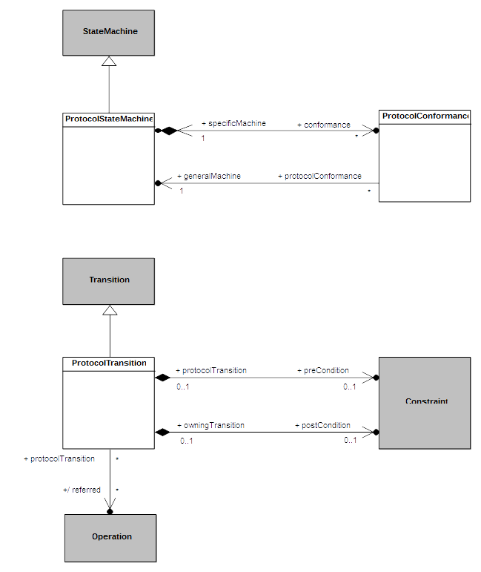Figure A.1 - ProtocolStateMachines
  - Semantics
    - Controlled Events
Interactions controlled by a ProtocolStateMachine are restricted to event occurrences for which this state machine has at least one trigger defined. An occurrence of such a controlled event violates the protocol specified by a ProtocolStateMachine if it is not explicitly allowed according to the current state of the protocol.
    - Protocol States Configuration
The initial state configuration of the protocol is defined according the initial Pseudostate of each active Region within the ProtocolStateMachine. For each occurrence of an event controlled by the ProtocolStateMachine which is not invalid, the corresponding ProtocolTransition is fired, which result in the target State to become the active protocol state.
    - Protocol Violation
A protocol violation shall result in an exception being raised. This occurs in the following cases:
- An occurrence of a controlled event is received while it is invalid. That is, there is no enabled ProtocolTransition for that event for which the precondition is satisfied. In cases where that event is a CallEvent, this precondition is computed as a logical “and” between the ProtocolTransition::precondition and the CallEvent::operation::precondition.
- The postcondition of the ProtocolTransition activated following the occurrence of a controlled event linked o the invocation of a BehavioralFeature is not met when the execution of the corresponding method ends. In cases where that event is a CallEvent, this postcondition is computed as a logical “and” between the ProtocolTransition:: postcondition and the CallEvent::operation::postcondition.

- State Machines for Passive Classes
(Informative)
  - Background and Rationale
The precise execution semantics for StateMachines in the main body of this specification covers the cases in which a StateMachine is either used as the classifierBehavior of an active Class or executes itself as a “standalone” active Behavior. However, StateMachines have also been used to specify the behavior of passive Classes, and support for this can be found in existing UML tools. This annex discusses the semantics of this usage, which are different than the semantics of StateMachines used with active Classes.
To help understand how the behavior of passive classes can be described using StateMachines, it is useful to recall that an essential characteristic of StateMachine behavior is that a response to a particular stimulus (e.g., a CallEvent occurrence) depends on the object’s history; that is, the nature and order of preceding stimuli received by that object. In StateMachines for active Classes, this information is captured concisely by the current State of an object’s classifierBehavior. However, when dealing with passive objects, which do not have a classifierBehavior, this means that, in the general case, each method of the Class of the object needs to include a conditional branch to handle the different responses based on some internal value that, in effect, represents the history of the object.
Consider, for example, the simplest case of a Stack Class shown in Figure B.1. Note that the response to a “pop” Operation will depend on whether the stack is empty or not. Similarly, assuming that the stack is of limited capacity, the response to a “push” Operation will differ when the stack is full compared to when it is not full.
Of course, this can be coded explicitly by defining a suitable local variable of the object (e.g., “stack size”) and using appropriate action language conditional statements. However, this not only obscures the true nature of the behavior in question, but, because it relies on relatively low-level (i.e., “manual”) coding, it is also more error prone and requires more effort by the modeler. This approach becomes increasingly more problematic as the complexity of the behavior grows.

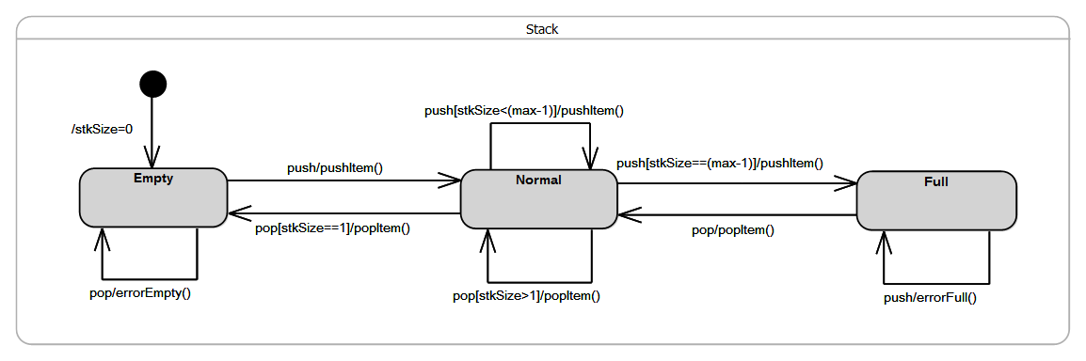Figure B.1 - Stack Example

Hence, the motivations behind supporting StateMachine specifications of passive Class behaviors are to reduce the burden on the modeler, to more clearly describe an object’s behavior using a higher-level formalisms, and to increase both reliability and productivity.
  - Semantics
To avoid gratuitous differences from the familiar semantics of active StateMachines, the general strategy taken here is to be fully consistent with those semantics wherever possible. Note that this approach covers both passive Classes as well as stand-alone passive StateMachines (which are, after all, Classes as well).
The core idea behind the approach is straightforward: map the StateMachine specification into an equivalent set of behavioral fragments and conditional statements distributed across the appropriate methods. For example, all three transitions triggered by the “pop” CallEvent in the Stack example above, would be mapped to appropriate conditional statement cases of a single “pop” Operation method. The control variable of such a statement would correspond to the current state of the StateMachine. This is illustrated by the following pseudocode for the method of the “pop” Operation:
operation pop(): Item {
case (state) {
'Empty': errorEmpty();
'Normal': if (stkSize == 1) then
{popItem();
nextState('Empty');}
else
popItem();
'Full': {popItem();
nextState('Normal');}
};
}
Furthermore, any action associated with the initial Transition would be mapped to the method of the Class constructor.
Of course, in addition to the lack of a classifierBehavior, one key difference between active and passive Class semantics is in how the Transition triggering mechanism works. For active Classes, triggering is realized by a dedicated scheduling and dispatch mechanism, which is external to the StateMachine instance. Among other responsibilities, this mechanism also ensures that run-to-completion semantics are enforced. In contrast, no such mechanism exists for passive Classes; the methods of a passive Class are executed synchronously when some calling behavior invokes the corresponding Operation. Consequently, if two or more concurrently executing behaviors make overlapping calls to the same passive object, there is a possibility of concurrency conflicts that would violate the run-to-completion semantics. (Note that this can occur even if all of the Operations of the passive class are declared as “guarded”, since that only prevents a given Operation being invoked concurrently. However, it would still be possible to concurrently invoke two or more different Operations of the passive class.)
Therefore, to ensure run-to-completion semantics of a passive-Class StateMachine, it is necessary that, for any passive Class whose behavior is defined by a StateMachine, at most one Operation call can be executed (to completion) at a time. This restriction avoids unsafe and error prone designs, and it is consistent the core semantic tenets of UML StateMachines.

The code for this prototype is publicly available in the Eclipse Git repository, at http://git.eclipse.org/c/papyrus/org.eclipse.papyrus.git/tree/extraplugins/moka/org.eclipse.papyrus.moka.fuml.statemachines?h=bugs/465888-SMExecPrototype.
See https://wiki.eclipse.org/Papyrus/UserGuide/ModelExecution.
The exact type and format of such a variable are of no concern here; implementers are free to chose their own.
To simplify the example, we assume here that there are no entry, exit, or do behaviors associated with any of the states.

